Sample Paper – 2010
Class – IX
Subject – Mathematics

TIME : 3 hours - 3½ hours Maximum Marks : 80

General Instructions :
1. All questions are compulsory.
2. The question paper consists of 34 questions divided into 4 sections, section A, B, C, and D.
3. Section A contains 12 multiple choice type questions, first 8 of which carries 1 mark each and the next 4 carries two marks each. Section B contains 7 questions of 2 marks each, section C contains 10 questions of 3 marks each and section D contains 5 questions of 4 marks each.
4. Use of calculators is not permitted.

SECTION – A
(1 to 8 carry 1 mark each, 9 to 12 carry 2 marks each)

1.The decimal expansion of the number √2 is
- A finite decimal | - 1.41
- Non-terminating repeating | - Non-terminating non-repeating

2.The value of 249²-248²
- 1 | - 477
- 487 | - 497

3.Angles of a triangle are in the ratio 2:4:3.the smallest angle of the triangle is
- 60° | - 40°
- 80° | - 20°

4. Which of the following is not a criterion for congruence of triangles?
- SAS | - ASA
- SSA | - SSS

5.Three angles of a quadrilateral are 75°,90° and 75°.The fourth angle is
90° | 95°
105° | 120°

6. The median of a triangle divides it into two
Triangles of equal area | Congruent triangles
Right triangles | Isosceles triangles.

7. From three non collinear point we can draw:
Many circle | Only one circle
At least one circle | At most 2 circle

8. The length of the longest rod that can be put in a room of dimensions 10m x 10 m x 5m is
15m | 16m
10m | 12m

9. The median of first 10 prime numbers.
12.9 | 12
10 | 13

10. In figure if x+y = w+z, then prove that AOB is a :

C
B
A
y
x
w
z
0

- Straight line. | - Parallel line
- Intersecting line | - None of the options are correct

11. AD is a diameter of a circle and AB is a chord.If AD=34cm,AB=30cm,the distance of AB from the centre of the circle is:
17cm | 15cm
4cm | 8cm

12. For what value of$x$, the mode of the following data is 13.
13, 24, 13, 27, 17, 16, 17, $x$, 22, 21, 13, 17.

13 | 24
17 | 22

SECTION – B
(Questions 13 to 19 carry 2 marks each)

    - If $\frac{7−4\sqrt{3}}{7+4\sqrt{3}}$ = $a+b\sqrt{3}$, find the values of a and b
    - Factorise : x³-23x²+142x-120
    - In the given figure, B < A and C < D. Show that AD < BC.
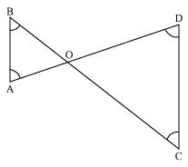

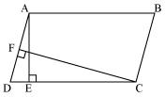
- In the given figure, ABCD is parallelogram, AE  DC and CF  AD. If AB = 16 cm, AE = 8 cm and CF = 10 cm, find AD.

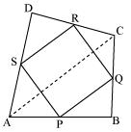
- ABCD is a quadrilateral in which P, Q, R and S are mid-points of the sides AB, BC, CD and DA (see the given figure). AC is a diagonal. Show that PQRS is a parallelogram

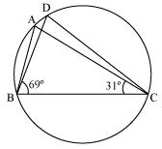
- In the given figure, ABC = 69°, ACB = 31°, find BDC.

- Curved surface area of a right circular cylindrical is 4.4m². If the radius of the base of the cylinder is 0.7m. Find its height.
SECTION – C
(Questions 20 to 29 carry 3 marks each)
- Represent $\sqrt{5}$ on the number line.
- Divide x³-1 by x²+x+1 and verify Dividend = (Divisor $\text{Quotient})+\text{Re}\text{mainder}$
OR
If x+y+z=0, show that x³+y³+z³=3xyz and hence find (-10)³+(2)³+(8)³
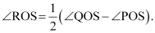
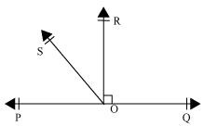
  - In the given figure, POQ is a line. Ray OR is perpendicular to line PQ. OS is another ray lying between rays OP and OR. Prove that

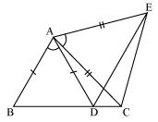
  - In the given figure, AC = AE, AB = AD and BAD = EAC. Show that BC = DE.

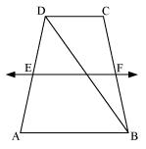
  - ABCD is a trapezium in which AB || DC, BD is a diagonal and E is the mid - point of AD. A line is drawn through E parallel to AB intersecting BC at F (see the given figure). Show that F is the mid-point of BC.

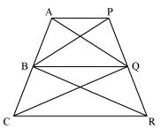
  - In the given figure, AP || BQ || CR. Prove that ar (AQC) = ar (PBR).

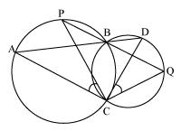
  - Two circles intersect at two points B and C. Through B, two line segments ABD and PBQ are drawn to intersect the circles at A, D and P, Q respectively (see the given figure). Prove that ACP = QCD.

  - Numbers $\text{50},\text{42},\text{41},\text{35},2x+\text{10},2x−8,\text{12},\text{11},8,6$ are written in descending order and if their median is 25,find x.
OR
Find the value of p if the mean of the following data is 40.4
x | 10 | 20 | 30 | 40 | 50 | 60 | 70
f | 3 | 8 | 12 | 5 | p | 7 | 5

  - D and E are points on sides AB and AC respectively of triangle ABC such that ar(DBC)=ar(EBC).Prove that DE||BC
  - Find the volume of a sphere whose surface area is 154cm²
SECTION – D
(Questions 30 to 34 carry 4 marks each)
  - Prove ASA congruence theorem.

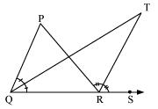
  - In the given figure, the side QR of ΔPQR is produced to a point S. If the bisectors of PQR and PRS meet at point T, then prove that QTR= $\frac{1}{2}$ QPR.

  - If x³ + mx² + nx + 6 has (x-2) as a factor and leaves a remainder 3, when divided by x – 3, find the values of m and n.
  - The following are the scores of two groups of class 9 students in a mathematics test.

Scores | 32-34 | 35-37 | 38-40 | 41-43 | 44-46 | 47-49 | 50-52 | Total
Group A | 13 | 12 | 20 | 18 | 15 | 10 | 4 | 92
Group B | 22 | 17 | 12 | 8 | 4 | 3 | 2 | 68
Represent the scores of the students of both the groups on the same graph by two frequency polygons .From the two polygons compare the performance of the two groups.
  - A hemispherical dome of a building needs to be painted. If the circumference of the base of the dome is 17.6 m, find the cost of painting it, given the cost of painting is Rs. 5 per 100 cm².
OR
A tent is in the form of a right circular cylinder surmounted by a cone. The diameter of cylinder is 24 m. The height of the cylindrical portion is 11 m while the vertex of the cone is 16 m above the ground. Find the area of the canvas required for the tent.
Paper Submitted By :
Name : PRASHANT KUMAR
Email prash11677@gmail.com
Phone No. 0096892806084

