Guess Paper – 2010
Class – XII
Subject – Mathematics(Matrix and Determinant)

1.


2.

3.

4.

5.

6.
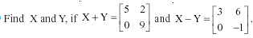
7.
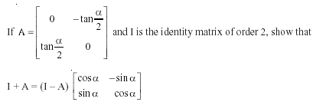

8.

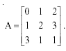
OR
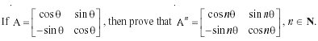

10.
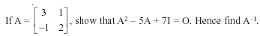

11. By using properties of determinant prove that:
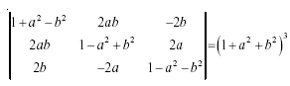

12.
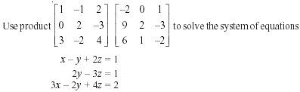

13.

Education Point
B-184 Karam Pura New Delhi-15,ph.9971750366

