Guess Paper – 2010
Class – XII
Subject – Mathematics

1.
2.
3.
4.
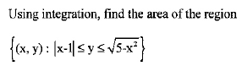
5.
Find the area of the region
6.
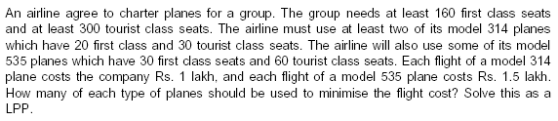
7.
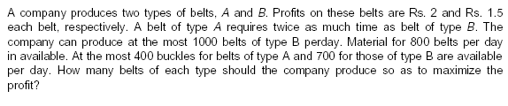
8.
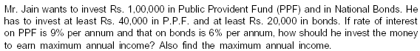
Education Point
B-184 Karam Pura New Delhi-15,ph.9971750366

