Sample Paper – 2010
Class – IX
Subject – Mathematics

(ONE MARKS)
1.
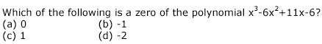
2.
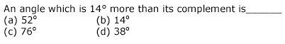
3.
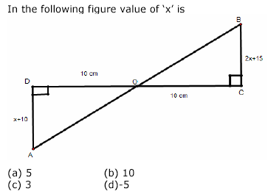
4.
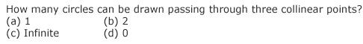
5.
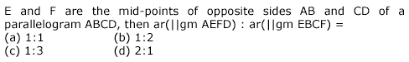
6.
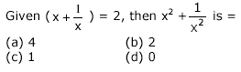
7.
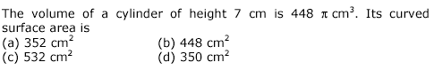
8.
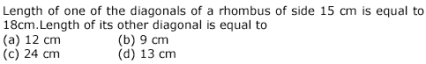
(2/3/4 Marks Questions)
9.
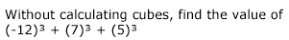
10.
11.
12.
13.
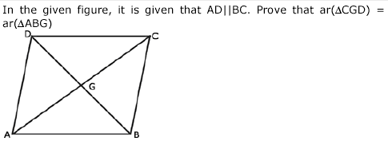
14.
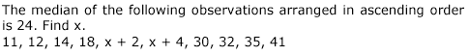
15.
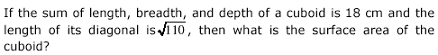
16.
17.
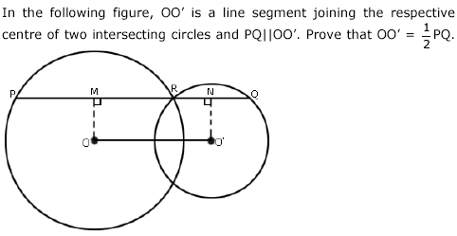
18.
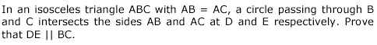
19.
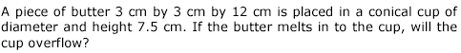
20.
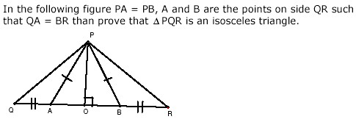
21.

Education Point
B-184 Karam Pura New Delhi-15,ph.9971750366

