Guess Paper – 2010
Class – XII
Subject – Mathematics

Vector And Three D

- For what values of ‘λ’, the vectors (2î - 3 ĵ ) and (λî - 6ĵ) are parallel ?

- Find the projection of the vector î +3 ĵ +7k on the vector 7î – ĵ + 8k.

3. If a vector makes angles α, β, γ with x-axis, y-axis, z-axis respectively, then what is the value of sin²α + sin²β + sin²γ .
4.
5.
Show that the normals to the planes r . (î – ĵ + k) = 4 and r .( 3î + 2ĵ - k) -11 = 0 are perpendicular to each other.

6.
If 4x + 4y – λz =0 is the equation of the plane through the origin that contains the line
x – 1 = y + 1 = z ,
2 3 4

find the value of ‘λ’.
7.

8.

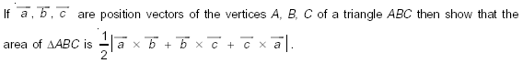

9.

10. 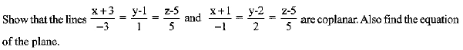

Differentiability

1.

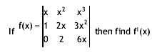

2.
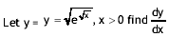

3.
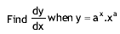

4.
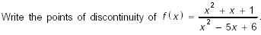

5.

6.
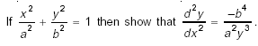

7.
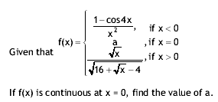

8.
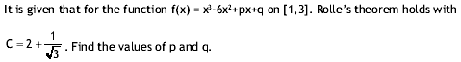
9.
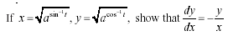
10.
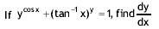

Education Point
B-184 Karam Pura New Delhi-15,ph.99717503

