Informatics Practices
Set – I

Max. Marks : 70 Duration : 70

General Instructions
- The question paper is divided into three sections.
- Section – A consists 30 marks.
- Section – B and Section – C are of 20 marks each.
- Answer the questions after carefully reading the text.

---------------------------------------------------------------------------------------------------------------------

Section – A

- Answer the following questions :
- Differentiate between ER modeling & Object Modeling Techniques 2

- Give any four application areas of Databases? 2

- What are the difference between software, Hardware & Firmware ? 2

- Explain what is meant by Generalization and Specialization ? 4

- Answer the following questions in the references of Oracle :
(a) How is the primary key Constraint different from the Unique Constraint? 2

(b) Differentiate between Decision Control and Looping Control Structure in context
with PL/SQL? 4

(c) What are Cursor attributes? What do these attributes evaluate to when associated with IMPLICIT and EXPLICIT cursors? Write a PL/SQL block to find the factors of a number entered by user.
4
- Answer the following questions in the references of Visual Basic:
(a) What do you understand by option explicit statement? How and where we can set it? 2

(b) Explain the use of Access Keys and Shortcut Keys for menus? How can you add a menu separator
to you menu. 2

(c) Define Recordset and all its types. How we can apply the recordset in a project? 4

(d) What is Common Dialog Box control? How it is applied in your program? 2

Section – B

(VISUAL BASIC)

- Read the following case study and answer the questions that follow:
Home Decor Furnishing is a company that manufactures and sells various furnishing items in three qualities (Economy, Business and Elite) and three sizes (Kids, Adults and Giants). The cost of each furnishing item is calculated on basis of a Base Cost, which is the cost of the item in Business quality and Adults size. The cost is changed by – 10% and +20% in case of Economy and Elite quality respectively. Similarly the cost is changed by –5% and +15% in case of Kids and Giants sizes respectively. The interface for gathering users choice is as given below :

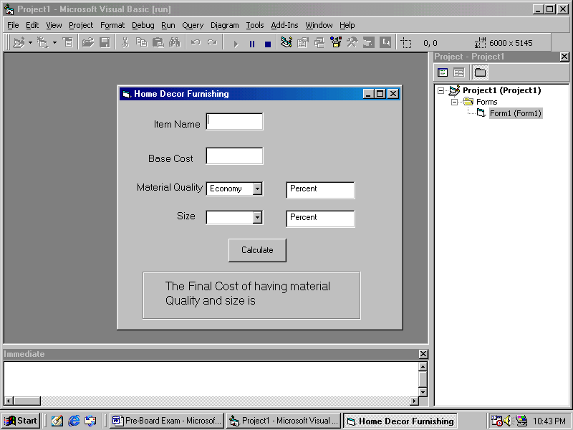

Add the following functionality to the interface:
- The combo box cmbquality must contain economic, Business and Luxury when the form loads in the memory. 2
- The combo boxes cmbquality and cmbsize should respectively be set to default values of Economy and Adults initially. 1
- What is the caption of cmdcalculate button and lblsize. 1
- When a user chooses a choice other than the default choices, the labels lblchangeforquality and lblchangeforsize should display the message.
‘Percent Increase / Decreases in cost ....% according to the logic explained above. 3
- When user clicks the Calculate button the final message should be displayed in the label lblyourchoice as indicated in the form image. 3

- Read the following text and answer the questions that follow:
- A student of ABCD School, Davis Mathews wanted an application to find Even or Odd out of a given number. He had written the following code snippet and he is unable to correct some of the errors in the code. You are requested to help him in correcting the code segment. Find the errors and erwrite the corrected code underlining the correction made.

Dim n as integer
N = val(txtnumber)
If n mod 2 = 0
Msgbox “It is an Even”
Else
Msgbox “it is an odd”
Endif 2

- What is the output of the following programs:
Dim i as integer, num as integer
For i = -10 to 5 step 3
If i mod 2 = 0 then
Num = num + i
End if
Print num
Next 2

- Discuss various types of errors that may encountered in VB? Specify with examples? 3

- What is ADO? How is it useful as a database access technology? Specify the steps to connect ADODC to the oracle and specify recordsource? 3

Section – C

(ORACLE SECTION)

- Read the questions given below and answer accordingly :
- Write the output produced by the following part of code in PL/SQL :
DECLARE
Y NUMBER;
X NUMBER;
BEGIN
Y:=2;
FOR X IN 1..5
LOOP
Y:=X+(Y*2);
DBMS_OUTPUT.PUT_LINE(Y);
END LOOP;
END; 2

- Find the error(s), if any, in the following code :
DECLARE
v_empno NUMBER[4];
v_empname VARCHAR2(20);
begin BOOLEAN :=’True’
START
SELECT empno,ename,salary
into v_empno,v_ename
FROM emp
FOR empno = 1234 and 2345 2
END

- What happens when you close and then re-open a cursor? Create a view VU_EMP2 which should include columns Empno, Ename and Deptno from the table Emp and change the column headings as Empnumber, Employee, Department. 3

- Write a PL/SQL Function ISODDEVEN to return value True if the number passed to it is odd else will return False. 3

- (a) Answer the following questions based on the following Employee Table :

Column Name | Data Type
ID | Number(4)
First_Name | Varchar2(30)
Last_Name | Varchar2(30)
Email_ID | Varcharr2(10)
Salary | Number(9,2)

- Write the difference between a Cursor and a Trigger. 2
- Write a PL/SQL procedure EDSAL to find out the salary of an Employee with ID=1234 is less than 5000 or not. If it is less then 5000, modify the salary of employee by increasing it by 15%. 4
- Write a PL/SQL block to create a trigger to display a Hello message before each insert operation on the table. 4

2004 - 2005
Pre-Board
Informatics Practices
Set – II

Max. Marks : 70 Duration : 70

---------------------------------------------------------------------------------------------------------------------

General Instructions
- The question paper is divided into three sections.
- Section – A consists 30 marks.
- Section – B and Section – C are of 20 marks each.
- Answer the questions after carefully reading the text.

---------------------------------------------------------------------------------------------------------------------

Section – A

1. Answer the following questions :
- Differentiate between ER Modeling and Object Modeling Techniques. 2

- What are the four building blocks of information system? 2

- Explain Data Mining and Data Warehouse with examples. 2

- Discuss the roll and significance of client/server computing. Discuss various client/server architectures. 4

2. Answer the following questions in the references of Oracle :
(a) How is the Primary key Constraint different from the Unique Constraint? 2

(b) What do you understand by functions and triggers in PL/SQL? Explain instead of triggers and create a function TOTAL(), to find sum of 1st n terms. N must be passed as argument and should return result. 4

(c) What are Cursor attributes? What do these attributes evaluate to when associated with IMPLICIT and EXPLICIT cursors? Write a PL/SQL block to find the factorial of a number entered by user. 4
3. Answer the following questions in the references of Visual Basic:
(a) What do you understand by option explicit statement? How and where we can set it? 2

(b) Explain the use of Access Keys and Shortcut Keys for menus?
Write code statements to make a menu namely mnuX invisible when the form is loaded. Also give statements to activate the menu option namely mnuX_opt1 whenever the checkbox chkstatus is checked and deactivate it when the checkbox is unchecked. 4

(c) Define Recordset and all its types. How we can apply the recordset in a project? 4

Section – B

(VISUAL BASIC)

4. Read the following case study and answer the questions that follow:
Home Decor Furnishing is a company that manufactures and sells various furnishing items in three qualities (Economy, Business and Elite) and three sizes (Kids, Adults and Giants). The cost of each furnishing item is calculated on basis of a Base Cost, which is the cost of the item in Business quality and Adults size. The cost is changed by – 10% and +20% in case of Economy and Elite quality respectively. Similarly the cost is changed by –5% and +15% in case of Kids and Giants sizes respectively. The interface for gathering users choice is as given below :

Add the following functionality to the interface:

- The combo box cmbquality must contain economic, Business and Luxery when the form loads in the memory. 2
- The combo boxes cmbquality and cmbsize should respectively be set to default values of Business and Adults initially. 1
- What is the caption of cmdcalculate button and lblsize. 1
- When a user chooses a choice other than the default choices, the labels lblchangeforquality and lblchangeforsize should display the message.
‘Percent Increase / Decreases in cost ....%
according to the logic explained above. 3
- When user clicks the Calculate button the final message should be displayed in the label lblyourchoice as indicated in the form image. 3

5. Read the following text and answer the questions that follow:
- A student of ABCD School, Davis Mathews wanted an application to find Even or Odd out of a given number. He had written the following code snippet and he is unable to correct some of the errors in the code. You are requested to help him in correcting the code segment. Find the errors and erwrite the corrected code underlining the correction made.

Dim n as integer
N = val(txtnumber)
If n mod 2 = 0
Msgbox “It is an Even”
Else
Msgbox “it is an odd”
Endif 2

- What is the output of the following programs:
Dim i as integer, num as integer
For i = -10 to 10 step 2
If i mod 2 = 0 then
Num = num + i
End if
Print num
Next 2

- Discuss various types of errors that may encountered in VB? Specify with examples? 3

- What is ADO? How is it useful as a database access technology? Specify the steps to connect ADODC to the oracle and specify recordsource? 3

Section – C

(ORACLE SECTION)

6 Read the questions given below and answer accordingly :
(a) Write the output produced by the following part of code in PL/SQL :
DECLARE
Y NUMBER;
X NUMBER;
BEGIN
Y:=3;
FOR X IN 1..5
LOOP
Y:=X+Y;
DBMS_OUTPUT.PUT_LINE(Y);
END LOOP;
END; 2

- Find the error(s), if any, in the following code :
DECLARE
v_empno NUMBER[4];
v_empname VARCHAR2(20);
begin BOOLEAN :=True
START
SELECT empno,ename,salary
into v_empno,v_ename
FROM emp
FOR empno = 1234 and 2345 2
END;

- What happens when you close and then re-open a cursor? Create a view VU_EMP2 which should include columns Empno, Ename and Deptno from the table Emp and change the column headings as Empnumber, Employee, Department. 3

- Write a PL/SQL Function ISPRIME to return value True if the number passed to it is prime else will return False. 3

- (a) Give the SQL statement required to create the following table :

Table : Transactions
Column Name | Data Type | Size | Constraint
Invoicenumber | Number | 10 | Primary Key
Itemcode | Number | 10 | Referenced from item Table
Transactiondate | Date | -- | System date
Transactionmode | Varchar2 | 10 | Allowed Values : SALE, PURCHASE
Transactionunits | Number | 5 | >0
2
- Write a PL/SQL trigger that give a message :
<n> units of <itemcode> sold/purchased
after each sale or purchase is recorded in the above given table Transaction. 2

- Write a PL/SQL procedure that calculates and displays the volume of a cuboid. The procedure takes three parameters for length, width and height of the cuboid respectively. The last two parameters are optional having a default value of –1. If the last two parameters are not passed then the volume of a cube having sides equal to the first parameter is to be calculated. 3

- Write a PL/SQL block that accepts the desired invoice number through a substitution variable and
Display the detail of all the matching items from the Transaction table. 3

