Sample Paper – 2010
Class – X
Subject – Mathematics

Time: 3 Hrs MM : 80

General Instructions:

- All questions are compulsory.
- The question paper consists of thirty questions divided into four sections A, B, C & D. Section A comprises of ten questions of 01 marks each, Section B comprises of five questions of 02 marks each, Section C comprises of ten questions of 03 marks each and section D comprises of five questions of 06 marks each.
- All questions in section A are to be answered in one word, one sentence or as per the exact requirement of the question.
- There is no overall choice. However internal choice has been provided in one question of 02 marks each, three questions of 03 marks each and two questions of 06 mark each. You have to attempt only one of the alternatives in all such questions.
- In question on construction, drawings should be neat and exactly as per the given measurements.
6. Use of calculators is not permitted.

Section - A

- If the H C F of 309 and 657 is 9, find their L C M.
- If α and β are the zeros of the polynomial 3x ² – 5x + 7, find the value of .
- The system of equations 3x – 4y + 7= 0, kx + 3y – 5 = 0 is inconsistent. Find the value of k.

- Find the coordinate of the point at which the line 3x + 2y = 12 intersects the x -axis.
- Find the 10th term of the A.P. , ........
- If 3 sin² θ = 2, find the value of θ.
- Find the distance between the points (a cos 35⁰, 0) and ( 0, a cos 65⁰)

- In Δ ABC, DE||BC, so that AD = 2.4 cm, DB = 3.2 cm, and AC = 9.6 cm, then find EC ?

- Find the perimeter of a sector of a circle of radius 14 cm and central angle 60⁰.

- In a throw of a pair of dice, what is the probability of getting a sum more than 7.

Section – B

- Find the 12th term from the end of the A.P. 3, 8, 13, .............., 253.

- If 3 cos θ – 4 sin θ = 2 cos θ + sin θ, find tan θ.
Or
If tan 2x = cos 60⁰ + sin 45⁰ cos 45⁰, find the value of x.

- The diagonal BD of a parallelogram ABCD intersects the segment AE at the point F, where E is any point on the side BC. Prove that DF × EF = FB × FA.

- Find the value of k, if the point P (0, 2) is equidistant from (3, k) and (k, 5).

- From a pack of 52 playing cards jacks, queens, kings and aces of red colour are removed. The remaining cards are shuffled and one card is taken at random. Find the probability that the card drawn is (i) a face card (ii) neither queen nor king.

Section – C

- In a morning walk three persons step off together, their steps measure 80 cm, 85 cm and 90 cm respectively. What is the minimum distance each should walk so that they can cover the distance in complete steps ?
- Solve:
Or
If – 5 is a root of the quadratic equation 2x² + px – 15 = 0 and the quadratic equation p(x² + x) + k = 0 has equal roots, find the value of k.

- If α and β are the zeros of the polynomial f(x) = 3x² – 6x + 4, find a quadratic polynomial whose zeros are (α + β) and (α – β).

- Prove that: (sin θ + sec θ)² + ( cos θ + cosec θ)² = (1 + sec θ cosec θ)²
Or
If x = r Sin A cos C, y = r sin A sin C and z = r cos A, prove that r² = x² + y² + z².

- The sum of the third and the seventh terms of an A.P. is 6 and their product is 8. Find the sum of first 16 terms of the A.P.

- The vertices of a Δ ABC are (1, 2), (3, 1) and (2, 5). Point D divides AB in the ratio 2 : 1 and P is the mid-point of CD. Find the coordinates of the point P.
Or
The line joining the points (2, 1) and (5, – 8) is trisected at the points P and Q. If the point P lies on the line 2x – y + k = 0, find the value of k.

- The area of a triangle is 5. Two of its vertices are (2, 1) and (3, – 2). The third vertex lies on y = x + 3. Find the third vertex.

- Let ABC be a right triangle in which AB = 7 cm and B = 90⁰ and BC = 5 cm. BD is the perpendicular from B on AC. The circle through B, C, D is drawn. Construct tangents from A to this circle.

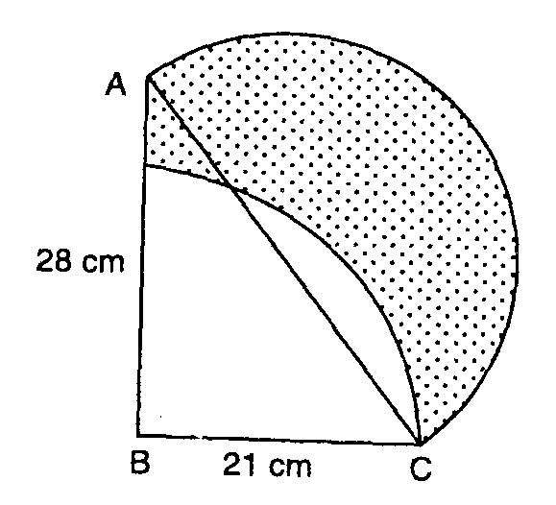
- In the adjoining figure ABC is a right angled triangle,
B = 90⁰, AB = 28 cm and BC = 21 cm. With AC as
diameter a semicircle is drawn and as BC as radius
a quadrant is drawn.Find the area of the shaded region.

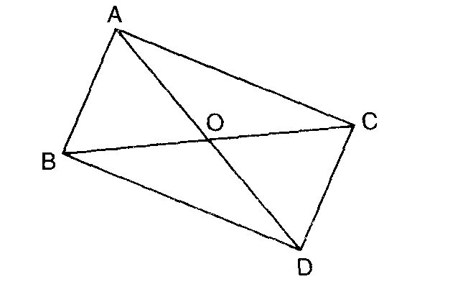
- In figure, ABC and DBC are two triangles on the same base
BC.If AD intersect BC at 0.
Prove that:

Section – D

- Determine graphically the vertices of the triangle,the equations of whose sides are given below:2x – y + 1 = 0 ; x – 5y + 14 = 0 ; x – 2y + 8 = 0

- State and prove the Pythagoras theorem.Using the above theorem prove the following :In an isosceles triangle ABC with AB = AC, BD is perpendicular from B to the AC.Prove that : BD² – CD² = 2 CD . AD

- A boy is standing on the ground and flying a kite with a string of 150 m, at an angle of elevation of 30⁰. Another boy is standing on the top of a 25 m tall building and is flying his kite at an elevation of 45⁰. Both the boys are opposite sides of both the kites. Find the length of the string in metres, correct to two decimal places that the second boy must have so that the two kites meet.

Or
Two pillars of equal height stand on either side of a roadway which is 150 m wide.from a point on the roadway between the pillars the elevations of the top of the pillars are 60 ⁰ and 30⁰. Find the height of the pillars and the position of the point.

- A right triangle, whose sides are 15 cm and 20 cm, is made to revolve about its hypotenuse. Find the volume and surface area of the double cone so formed. (Use π = 3.14)
Or
A conical vessel of radius 6 cm and height 8 cm is completely filled with water. A sphere is lowered into the water and its size is such that when it touches the sides, it is just immersed as shown in the figure.What fraction of water overflows ?

- Compute the missing frequencies $f_{1}$ and $f_{2}$ in the following data if the mean is $\text{166}\frac{9}{\text{26}}$ and the sum of the observations is 52.
Classes | Frequency
140 – 150 | 5
150 – 160 | $$f_{1}$$
160 – 170 | 20
170 – 180 | $$f_{2}$$
180 – 190 | 6
190 – 200 | 2
Total | 52

OR

Using the data given below construct the cumulative frequency table and draw the ogive.From the determine the median.

Marks | 0-10 | 10-20 | 20-30 | 30-40 | 40-50 | 50-60 | 60-70 | 70-80
No.of St. | 3 | 8 | 12 | 14 | 10 | 6 | 5 | 2

Paper Submitted By :
Name : Mr Yash
Email: yash.236@rediffmail.com
Phone No.: 9868842695

