Guess Paper – 2010
Class – X
Subject: Mathematics

Time : 3 Hours

Max. Marks : 80

GENERAL INSRTUCTIONS:-

- The question paper consists of 30 questions divided into four sections– A, B, C and D. Section A comprises of ten questions of 1 mark each, Section B comprises of five questions of 2 marks each, Section C comprises of ten questions of 3 marks each, and Section D comprises of five questions of 6 marks each
- All questions in section A are to be answered in one word, one sentence or as per the exact requirement of the question
- In question on construction, the drawings should be neat and exactly as per the given measurements
SECTION – A
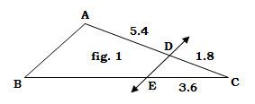
- Find the length of a rectangular garden whose length is 6 m more than its width and whose half perimeter is 30 m.
- In fig. 1, DE║AB and all dimensions are given in cm. Find BE.
- State Euclid’s Division Lemma.
- What will be the value of m so that the lines given by the following equations are parallel :
$3x−2y=5$
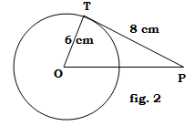
$4y=\text{mx}−8\text{.}$
- Find the nature of roots of the quadratic equation $2x^{2}−6x+3=0\text{.}$
- In fig. 2, PT is a tangent to circle whose centre is O. How far is P from O?
- Express the following in terms of trigonometric ratios of angles between $0°$and $\text{45}°$: $\text{tan}\text{76}\text{°+}\text{sec}\text{67}°\text{.}$
- Find the radius of the circle whose perimeter and area are numerically equal.
- A grouped data (arranged in ascending order) has 29 observations. Which observation will represent the median?
- What will be the mode of the following frequency distribution?
Marks obtained | 29 | 32 | 35 | 43 | 46 | 49 | 50
No. of students | 3 | 5 | 10 | 18 | 26 | 19 | 12
SECTION – B

- Solve by using quadratic formula: $4x^{2}−8\text{ax}+4a^{2}−b^{2}=0\text{.}$
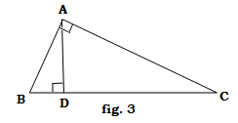
OR
Two numbers are in the ration 5 : 6. If 8 is subtracted from each of the numbers, they become in the ratio 4 : 5. Find the numbers.
- Evaluate : $\frac{5{\text{cos}}^{2}\text{60}\text{°+}4{\text{sec}}^{2}\text{30}°−{\text{tan}}^{2}\text{45}°}{{\text{sin}}^{2}\text{30}\text{°+}{\text{cos}}^{2}\text{30}°}$
- In fig. 3, ΔABC is right angled at A, AD ⊥ BC; show that ΔABC∼ΔCAD.
- Find the area of ΔABC whose vertices are : A(4, 6), B(1, 5) and C(7, 2).
- Cards marked will all 2-digit numbers are placed in a box thoroughly mixed up. One card is drawn at random. Find the probability of getting
  - A number divisible by 10.
  - A number which is a perfect cube.

SECTION – C

- Prove that $\sqrt{7}$ is not a rational number.
- Find the zeros of the polynomial $3x^{2}−x−4$and verify the relationship between the zeros and the coefficients.
OR
The difference of the squares of two natural numbers is 48. The square of the larger number is 4 times the square of the smaller number. Find the numbers.
- Find the sum of the natural numbers between 300 and 900 which are multiple of 11.
- Evaluate : $\frac{\text{cos}\text{41}°}{\text{sin}\text{49}°}+2\text{tan}\text{11}°\text{tan}\text{29}°\text{tan}\text{45}°\text{tan}\text{79}°\text{tan}\text{61}°−2({\text{sin}}^{2}\text{11}\text{°+}{\text{sin}}^{2}\text{79}°)$
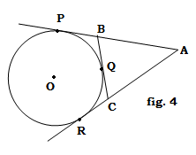
OR
Prove that : $\frac{\text{tan}θ+\text{sec}θ−1}{\text{tan}θ−\text{sec}θ+1}=\frac{1+\text{sin}θ}{\text{cos}θ}$
- In fig. 4, circle with centre O touches the side BC of
ΔABC at Q and sides AB and AC are produced at P
and R respectively. Show that AP = $\frac{1}{2}$perimeter of ΔABC.
- A solid composed of a cylinder with one of its ends as a hemisphere of the same radius as the cylinder. The length of the whole solid is 13.5 cm and radius of the base is 3.5 cm. Find the total surface area of the solid.
- Find the values of p and q for which the point A(p, q) divides the line segment joining the points (4, −3) and (1, 9) in the ratio 1 : 2 (internally).
- Prove that (−18, 10), (6, 3) and (2, −5) are the vertices of an isosceles triangle.
OR
Find the length of the median through A of ΔABC whose vertices are A(5, −3), B(6, 7) and C(−4, −7).
- Construct a triangle PQ’R’ similar to ΔPQR in which PQ = PR = QR = 5.6 cm such that each side of ΔPQ’R’ is $\frac{6}{7}$ of the corresponding sides of ΔPQR.
- A man travels 600 km partly by train an partly by car. If he covers 400 km by train and rest by car, it takes him 6 hours 30 minutes. But if he travels 200 km by train and the rest by car, he takes half an hour longer. Find the speed of the train and that of the car.
SECTION – D
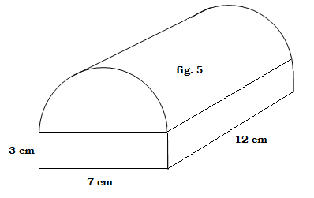
- A train travels 360 km at a uniform speed. If the speed had been 5 km/h more, it would have taken him 1 hour less to complete the same journey. Find the speed of the train.
- A godown building is in the form as shown in fig. 5. The vertical cross section parallel to the width side of the building is a rectangle of size 7 m × 3 m mounted by a semicircle of diameter 7 m. If the length of the godown is 12 m, find the volume of the godown and the cost of painting the inner side of the building at Rs 6 per square metre.
OR
A container, open from the top is made up of a metal sheet, is in the form of a frustum of a cone of height 16 cm with radii of its lower and upper ends as 8 cm and 20 cm respectively. Find the cost of milk which can completely fill the container at the rate of Rs 20 per litre. Also find the cost of the metal sheet used to make the container, if it costs Rs 8 per dm². [ Take π = 3.14 ]
- As seen from the top of a light house 150 m high, the angles of depression of two ships approaching it are 45° and 30°. Find the distance between the two ships if they are coming directly from the opposite directions.
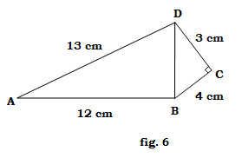
- Prove that in a triangle, it the square on one side is equal to the sum of the squares on the remaining two, the angle opposite to the first side is a right angle.
By using the above theorem, prove the following :
In fig. 6, ABCD is a quadrilateral in which $∠$C=90°, DC = 3 cm and BC = 4 cm. If AB = 12 cm and AD=13 cm, prove that $∠$ABD = 90°.

- The measures of the diameters of the heads of 150 screws are given in the following table. If the mean diameter of the heads of the screws is 51.2 mm, find the values of f₁ and f₂.
Diameter (in mm) | 32 - 36 | 37 - 41 | 42 - 46 | 47 - 51 | 52 - 56 | 57 - 61 | 62 – 66
No. of screws | 15 | 17 | f₁ | 25 | f₂ | 20 | 30
OR
The following data gives the information on the observed life times (in hours) of 225 electric components :
Life times (in hours) | 0 - 20 | 20 - 40 | 40 - 60 | 60 - 80 | 80 - 100 | 100 - 120
No. of components | 10 | 35 | 52 | 61 | 38 | 29
Determine the mean, median and modal life time of the components.

Paper Submitted By :
Name : Mr Dilip Biswas
Email : dilipbiswas2006@gmail.com
Phone No. : 09214927974

