Guess Paper – 2010
Class – IX
Subject –Maths

Time 1h , Max Marks :17

Note : Q1 toQ5 . 1marks , Q6 to Q8 . 2marks , Q9toQ10 . 3 marks

1.
2.
3.
4.
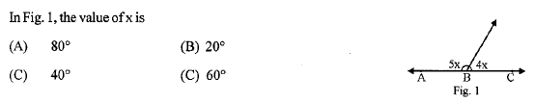
5.
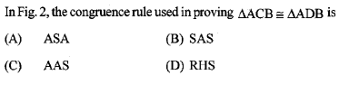
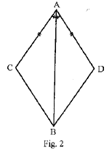
6.
7.
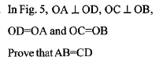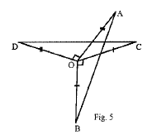

8.
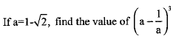
9.
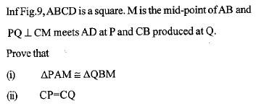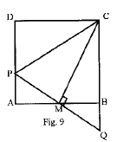
10.
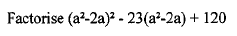

Paper Submitted By:
Name: Mr. Arun
Email: arunshukla09@yahoo.in
Phone No : 9971750366

