Guess Paper – 2010
Class – X
Subject – Mathematics

Maximum Time: 3hours Maximum Marks:80
1. Write 98 as a product of its prime factors.
2. In fig., graph of some polynomial p(x) is given. Find the zeroes of the polynomials.
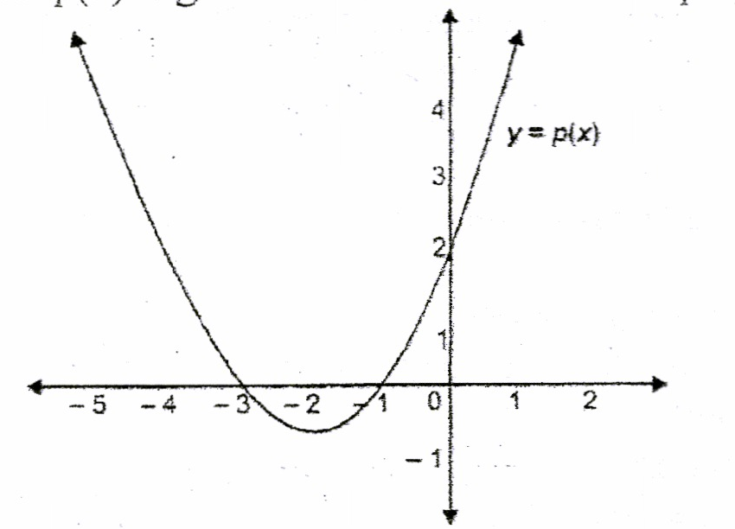
3. For what value of k, the following pair of linear equations has infinite many solutions? 10x+5y-(k-5) = 0 and 20x + l0y-k = 0
4. What is the maximum value of l/secA
5. If tan A = ¾ and A + B = 90° then what is the value of cot B?
6. What is the ratio of the areas of a circle and an equilateral triangle whose diameter and a side are respectively equal?
7. Two tangents TP and TQ are drawn from an external point T to a circle with centre 0, as shown in figure. If they are inclined to each other at an angle of 100° then what is the value of angle POQ?
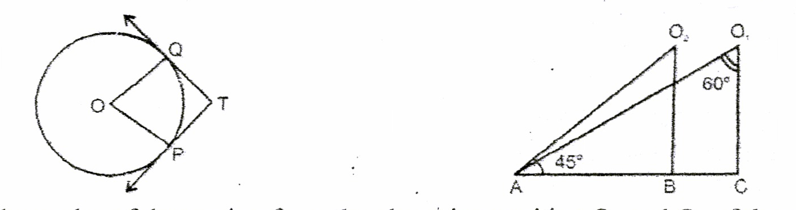
8. In fig., what are the angles of depression from the observing position O₁ and O₂ of the object at A?
9. A die is thrown once. What is the probability of getting a prime number?
10. What is the value of the median of the data using the graph in fig., of less than ogive and more than ogive?
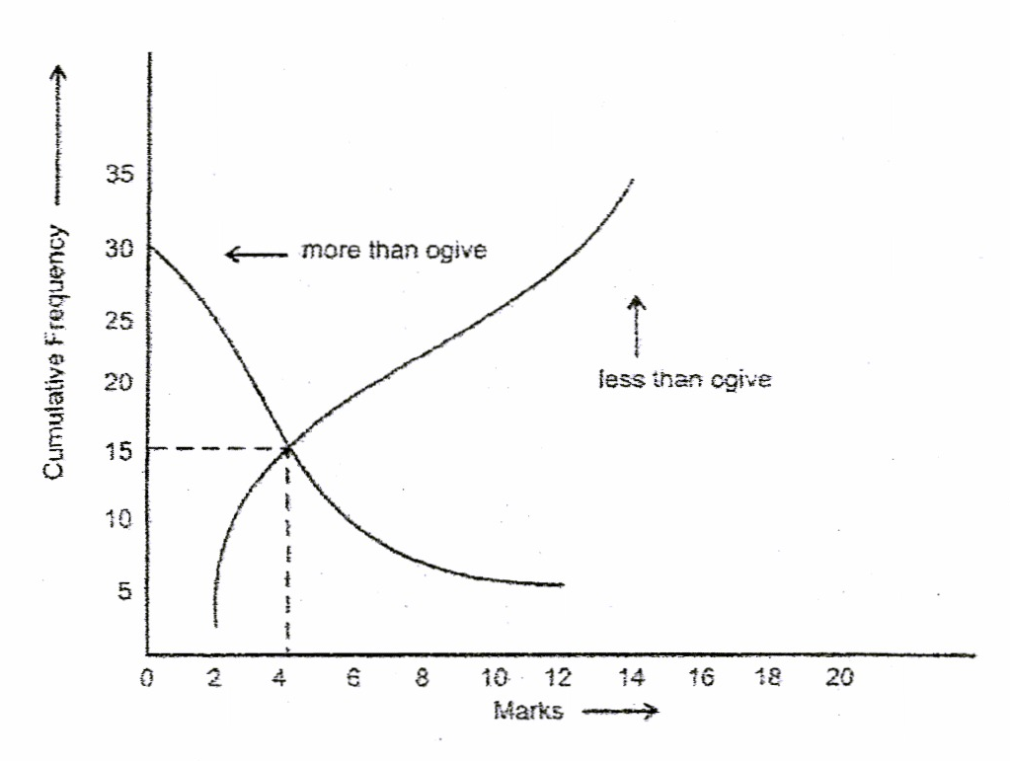
SECTION-B
11. If the 10th term of an A.P. is 47 and its first tennis 2. find the sum of its first 15 terms.
12. Justify the statement: “Tossing a coin is a fair way of deciding which team should get the batting first at the beginning of a cricket game.”
13. Find the solution of the pair of the equations: 3/x + 8/y = -1, 1/x - 2/y =2.
14. The coordinates of the vertices of ∆ABC are A (4. 1), B (-3, 2) and C (0, k). Given that the area of ∆ABC is 12 unit², find the value of k.
15. Write a quadratic polynomial, sum of whose zeroes is 2√3 and their product is 2. Or
What are the quotient and the remainder, when 3x⁴ + 5x³ -- 7x² - 2x + 2 is divided by x² + 3x +- 1?
SECTION-C
16. If a student had walked 1 km/hr faster, he would have taken 15 minutes less to walk 3km. Find the rate at which he was walking.
17. Show that 3 + 5√2 is an irrational number.
18. Find the value of k so that the following quadratic equation has equal roots: 2x² -- (k-2)x +1 =0.
19. Construct a circle whose radius is equal to 4 cm. Let P be a point whose distance from its centre is 6cm. Construct two tangents to it from P.
20. Prove that: sin φ/(cot φ + cosec φ) = 2 + sin φ/(cot φ -- cosec φ) Or
Evaluate: (sec29°/ cosec 61°) + 2 cot 8° cot 17° cot 45° cot 73° cot 82° - 3 (sin² 38° + sin² 52°)
21. In fig., XP × QZ = PY × XQ = 3, if the area of ∆XYZ is 32 cm², then find the area of the quadrilateral PYZQ. Or
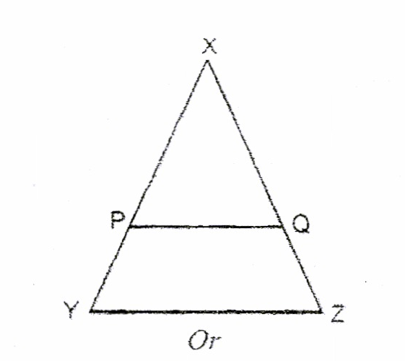
A circle touches the side BC of a ∆ABC at a point P and touches AB and AC when produced at Q and R respectively. Show that: AQ = ½ (Perimeter of ∆ABC).
22. Find the ratio in which the line segment joining the points A (3. -6) and B (5 3) is divided by x-axis. Also find the coordinates of the point of intersection.
23. Find relation between x&y such that the point P(x. y) is equidistant from the point A(2, 5)&B(-3,7).
24. If in the fig., ∆ABC and ∆AMP are right angled at B and M respectively, prove that CA×MP=PA×BC
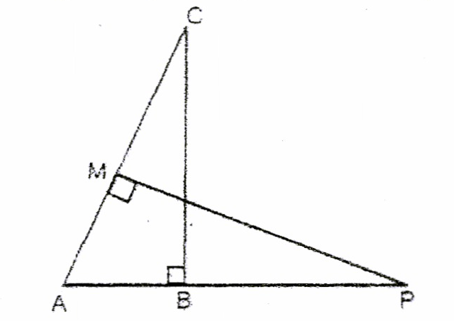
25. In the following fig., OAPB is a sector of a circle of radius 3.5 cm with the center at O and angle AOB = 120°. Find the length of OAPBO.
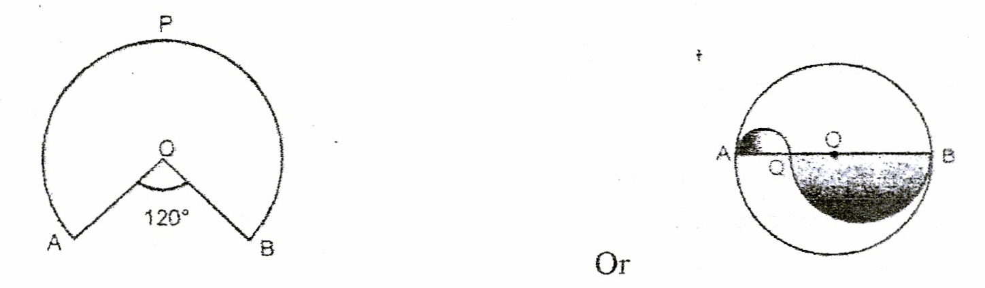
Find the area of shaded region of fig., if the diameter of the circle with centre O is 28 cm and AQ= ¼AB
SECTION-D
26. Prove that in a right triangle, the square of the one side is equal to the sum of the squares of the other two sides the angle opposite to the first side is a right angle.
Using the converse of above, determine the length of an altitude of an equilateral triangle of side 2 cm.
27. Form a pair of linear equations in two variables using the following information and solve it graphically. Five years ago, Sagar was twice as old as Tiru. Ten years later Sagar’s age will be ten years more than Tiru’s age. Find their present ages. What was the age of Sagar when Tim was born?
28. From the top and foot of a tower 40 m high, the angle of elevation of the top of a lighthouse is found to be 30° and 60° respectively. Find the height of the lighthouse. Also find the distance of the top of the lighthouse from the foot of the tower.
29. A solid is composed of a cylinder with hemispherical ends. If the whole length of the solid is 100 cm and the diameter of the hemispherical ends is 28 cm. find the cost of polishing the surface of the solid at the rate of 5 paise per sq cm. Or
An open container made up of a metal sheet is in the form of a frustum of a cone of height 8 cm with radii of its lower and upper ends as 4 cm and 10 cm respectively. Find the cost of oil which can completely fill the container at the rate of Rs. 50 per litre. Also, find the cost of metal used, if it costs Rs. 5 per 100 cm2. 30. The mean of the following frequency table is 53. But the frequencies f1 and f2 in the classes 20-40 and 60-80 are missing. Find the missing frequencies.
Age in years | 0-20 | 20-40 | 40-60 | 60-80 | 80-100 | Total
Number of People | 15 | F1 | 21 | F2 | 17 | 100

Paper Submitted By :
Name: Mr Sunil Rai
Email : sunilplayer@gmail.com
Phone No. : 9818957447

