INFORMATICS PRACTICES
CLASS XII

Time allowed : 3 hrs Maximum Marks : 70

~~~~~~~~~~~~~~~~~~~~~~~~~~~~~~~~~~~~~~~~~~~~~~~~~~~~~~~~~~~~~~~~~~~~~~~~~~~~~~
General Instructions :

- Please check that this question paper contains 5 printed pages
- Please check that this question paper contains 7 questions.
- This question paper is divided into three Sections.
- Section – A consists of 30 marks.
- Section – B ( Visual Basic ) consists of 20 marks.
- Section – C ( Oracle ) consists of 20 marks.

~~~~~~~~~~~~~~~~~~~~~~~~~~~~~~~~~~~~~~~~~~~~~~~~~~~~~~~~~~~~~~~~~~~~~~~~~~~~~~~~~~~~~

Section – A
- Answer the following Questions :

  - Explain any two application areas of database. 2
  - What is meant by Relationship. Explain any two relation with diagram. 2
  - Explain the term Data Dictionary and Data mining . 2
  - Elaborate the term SDLC explaining four essential components using a sample case study. 4

- Answer the following Questions :

  - Explain the terms ODBC and OLE - DB. 2
  - Define the term Errors .Give an two general types of errors with respect to Visual Basic error object. 2
  - What do you understand by scope and lifetime of variable ? State the use and significance of Static,
Local and Global variables. Explain with example. 2
  - Differentiate between a ADO DB project reference and ADO DC in a form using suitable example. 4

- Answer the following questions :

  - Explain the terms DDL and DML .Give one example of each categories. 2
  - Differentiate between Function and Procedure. 2
  - What is a cursor? What types of cursors are supported in PL/SQL ? 2
  - What are the different types of triggers. Explain with an example. 2
  - Briefly explain the numeric For and Cursor For loops with example. 2

Section – B

- Read the following case study and answer the questions that follows :

An institute offers two courses MBA and MCA of duration 2 years and 3 years respectively . The interface given to capture the marks secured by student in the semester exam.

Object Type Object Name  MCA optmca  MBA optmba  GPA cmdgpa  Report cmdreport  Total txttotal  Average txtavg  Report lblreport | 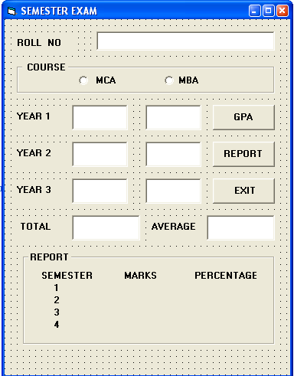

  - When the user clicks cmdgpa ,the total marks and the average marks secured by the student should be displayed in text boxes txttotal , txtavg respectively depending upon the option MCA or MBA . An overall GPA in the range 0-10 should be displayed in the message box when the user click it .GPA = Average /10. ( Assume that the marks in each semester are out 600) 4

  - When the user clicks cmdreport , the final report should be displayed in the label lblreport. 2

Object Type Object Name  Stalls optstall  Circle optcircle  Upper optupper  Box optbox  Cash optcash  City bank optcbank  Master card optmcard  Visa optvisa  Price per seat lblseat  Payment lblpay  Number of seats txtseat  Rate :  Stalls 50  Circle 100  Upper 250  Box 500 | 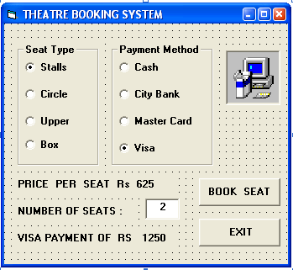

  - On the click event of Book seat , display the total amount to pay, price per seat, payment method in the label boxes, depending upon the seat type and payment method , when the total no of seats are more than 0 . 4

- Answer the following questions :

  - Find the errors and rewrite the corrected code underlining the correction made: 2
Private function icsk ( I as integer) as currency
Do While I <=15
If mod (I , 5) = 0 then
Msgbox “Divisible by 5 “
Else
Msgbox “ I “
End if
I = I + 2
End loop
End sub

  - Find the output of the following code segment : 2
S = ”School”
I = 0
Do while I <= len(s)
I = I + 1
Print Ucase ( mid (s , I) ) + Lcase ( mid ( s, -I, 1) )
If I mod 2 = 0 then
Print Left ( S, I-1 )
Else
Print Right( S, I-1 )
End if
I = I + 2
Next I

  - Rewrite the following code segment using Select Case: 2

c = 20
If c = 20 or c = 40 or c = 80 then
Print “ Santhi ”
Else if c = 100 then
Print “ Seva ”
Else if c >100 then
Print “ Shayog ”
Else
Print “ Santhosh ”
End if

  - Write a Visual Basic Function to check the given date (dd / mm / yy) is valid or not, and return the value true if it is valid, else return false. 4

Section – C

- Read the questions given below and answer accordingly :

  - Write the output produced by the following part of code in PL/SQL. 2

Begin
For I in 2 .. 3 loop
For J in reverse - 6 .. - 4 loop
Dbms_output.put ( ‘ ‘);
End loop;
Dbms_output.put_line ( I + J *2 ) ;
End loop;
Dbms_output.put_line ( I – J / 2 ) ;
End;

  - Look at the Emp table given below and give the output produced by the following PL/SQL code on execution: 2
TABLE : EMP
EMPNO | ENAME | JOB | MGR | HIREDATE | SAL | COMM | DEPTNO
7369 | SMITH | CLERK | 7902 | 17-Dec-80 | 900 | 200 | 20
7499 | ALLEN | SALESMAN | 7698 | 20-Feb-81 | 1700 | 300 | 30
7566 | JONES | MANAGER | 7839 | 2-Apr-81 | 3075 | 100 | 20
7698 | BLAKE | MANAGER | 7839 | 1-May-81 | 2950 |  | 30
7782 | CLARK | MANAGER | 7839 | 9-Jun-81 | 2550 | 400 | 10
7788 | SCOTT | ANALYST | 7566 | 19-Apr-87 | 3100 |  | 20
7876 | ADAMS | CLERK | 7788 | 23-May-87 | 1200 | 250 | 20
7900 | JAMES | CLERK | 7698 | 3-Dec-81 | 1050 |  | 30
7902 | FORD | ANALYST | 7566 | 3-Dec-81 | 3100 | 350 | 20
7934 | MILLER | CLERK | 7782 | 23-Jan-82 | 1400 | 170 | 10

Declare
Name emp.ename%type;
Salary emp.sal %type;
Begin
Select max(sal) - min(sal) /2 into salary from emp where deptno = 20 and sal > 500;
Select ename into name from emp where empno = 7934;
Dbms_output .put_line ( trunc (salary, 2) || initcap(substr(name,3)));
End;

  - Write a PL/SQL Procedure that takes a parameter , and return the reversed digits of the number: 2

  - Consider the table Emp & Dept .Write a Explicit cursor called maxhalf to increase the salary of particular department , where department number will be passed as parameter. Your Procedure will increase the salary of the employee to 2 times of the minimum salary , if the salary < 3000. Display employee number, name, department name and updated salary of the employee. 4

- Answer the questions based on the table emp :
TABLE : EMP  Name Type  -----------------------------------------------------------------  EMPNO NOT NULL NUMBER(4)  ENAME VARCHAR2(10)  JOB VARCHAR2(9)  MGR NUMBER(4)  HIREDATE DATE  SAL NUMBER(7,2)  COMM NUMBER(7,2)  DEPTNO NUMBER(2) | TABLE : DEPT  Name Type  -----------------------------------------------------------------  DEPTNO NOT NULL NUMBER(2)  DNAME VARCHAR2(14)  LOC VARCHAR2(13)

  - Write a SQL Command to display the no of months between the hiredate and 31-jan-2004. 1

  - Write a SQL Command to insert a new column called pincode and store the default value “560000” 1

  - Write a SQL Command to Create a virtual table called employee to store emp name, department name , salary, location and 2% increase in commission for all the employee who are from Scott’s department 2
  - Write a SQL Command to modify the record of the employee 8100. The new values should be as follows:
    - Deptno of Research department 2
    - Salary is the maximum salary already given.

  - Write a Database Trigger that allows Changes to employee table only during the business hours ( ie from
8:00 am to 5:00 pm ) from Monday to Friday . 4

