Sample Paper
Class – XII
Subject –Informatics practices

Note :
(i) All questions are compulsory.
(ii) Section A consists of 40 marks.
(iii) Section B consists 30 marks .
(iv) Answer the questions after carefully reading the text.

Section – A

Q 1. Answer the following questions.
a) Define – (i) Freeware ii) Shareware iii) OpenSource iv) Tomcat 2
b) What is the purpose of Data Mining? 2
c) Define the following terms. 2
i) Data Dictionary ii) Data Warehousing
d) What is E-R model? Explain the concept of E-R model using the case study of a school that has three entities: Student, Teacher and Subject. Assume that each student can study more than one subject while each teacher can teach only one subject. 2
e) Name the essential components of SDLC. 2
Q 2. Answer the following questions.
a) What is Bound Control? Name any two data aware properties of bound controls. 2
b) Explain the following terms:
i) Startup Form ii) Load Statement iii) Show Method iv) Event 2
c) How is a standard module different from a form module? Explain with example. 2
d) Which loop executes when the given condition is False? Explain with an example. 2
e) Differentiate between public and private variables and discuss their scope of visibility. 2
Q3. Answer the following questions.
a) Differentiate between DML and TCL giving suitable example of each case. 2
b) What is the need of normalization? Define second normal form. 2
c) State the difference between –
i) Constraints and Triggers. ii) Before and After trigger 2
d) Define database Transaction. What is the role of SavePoint in database transaction? 2
e) What is Cursor in PL/SQL? Explain the commands associated with cursor. 2

Section B
Q 4. Read the following case study and answer the questions that follow.
Hyderrabad Bazaar has decided to computerize some of its operations. In this regard they have approached a Software firm which has designed the following interface. HB provides discount @3% during Regular sales and an additional 5% during festival season. Payments made by cash are entitled for an additional discount of 2% of the amount while those made by card are entitled for an additional discount of 1.5% of amount. However for payments on credit an additional surcharge @2.5% of amount is levied. Write the code based on the questions given below in appropriate event procedures.

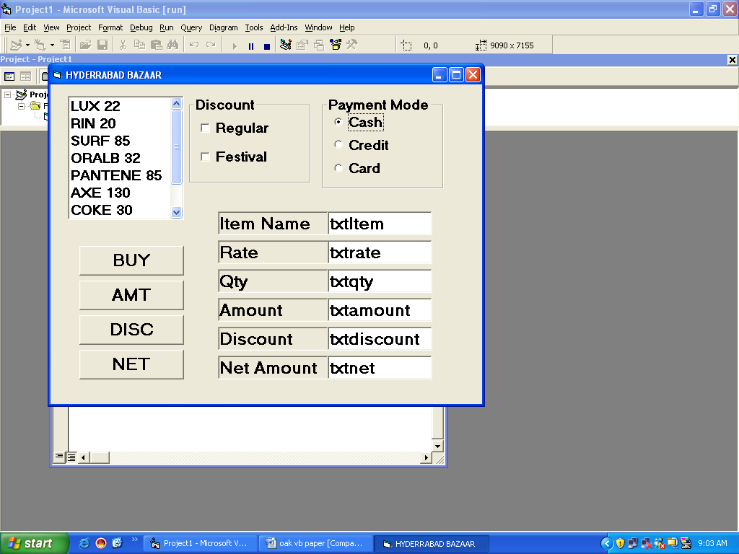

- Write the code to disable the text boxes for storing the Item Name, Rate, Amount, Discount and Net Amount initially. 1
- The user can purchase a item by selecting it from the List box (LstItem). After selecting an item when the user clicks on BUY then the Item Name should appear in txtItem and the rate should appear in txtrate. (Note: The Item Name and its rate are separated by a single space. For example if the user selects COKE and clicks on BUY then COKE should appear in txtItem and 30 should be displayed in txtrate) 3
- When the user clicks on Amount the Amount should be calculated and displayed in txtamount. 1
- When the user clicks on Discount then the discount is calculated based on the data given above and displayed in txtdiscount. 3
- Write the code to calculate the Net amount and display it in txtnet. 2
Q 5. Answer the following questions.
a) Find the error from the following code segment and rewrite the corrected code underlining and write the correction made (VB): 2
x=50 ; y=10
for i= 1 to 100 then
if x mod 6 = 0
print x+y
end
x=x**x+y*2
y+1= y
loop
b) Find the output of the following code segment: 2
dim st as string, I as integer
st = "Happy New Year"
For i = 1 To Len(st)
If i Mod 4 = 1 Then
ss = Mid(st, i, 1)
ss = ss + "SS"
Print ss;
End If
Next
c) Rewrite the following code segment using If ... ElseIf ... EndIf instead or Select ... Case. 2 Select Case marks
Case Is >= 85
comment.Caption = "Excellent"
Case Is >= 60
comment.Caption = "Above Average"
Case Is >= 50
comment.Caption = "Average"
Case Else
comment.Caption = "Need to work harder"
End Select
d) Write a function that takes two string and return 0 if both the arguments are equal. The function returns -1 if the first argument is smaller than the second and 1 if the second argument is smaller than the first. 2
e) Write a function that take a two numbers as argument and return the sum. 2

Section C
Q 6. Answer the following question.
- Write the output produced by the following part of code in PL/SQL. 2
DECLARE
Num NUMBER;
Counter NUMBER;
BEGIN
Counter :=8;
Num:=4;
While counter>4 Loop
Num:=num-2;
Counter:=counter-1
If counter>4 then
Dbms_Output.Put_Line(counter);
End if;
End loop;
DBMS_OUTPUT.PUT_LINE(num);
END;
b) Find Error in the following code, underline errors and rewrite the correct code. 2
DECLARE
NUMBER Total ;
BEGIN;
Total:=30;
LOOP
Total:=total***3;
DBMS_OUTPUT.PUT_LINE(total);
EXIT WHEN total>2000;
ENDLOOP;
END;
c) Write a PL/SQL procedure printsum to print the sum of all even and odd numbers between M and N. M and N is passed as argument. 4
d) Write a PL/SQL function CHCK_YEAR that accepts a date from the user and return 1 if the year is a leap year and returns 0 otherwise 2
Q 7. Answer the following question based on the FLIGHT table.
Table : FLIGHT
Column Name | Data Type | Size | Constraint | Description
Flight_No | NUMBER | 4 | Primary Key | Flight Number
Origin | VARCHAR2 | 30 | NOT NULL | Place of Origin of Flight
Destination | VARCHAR2 | 30 | NOT NULL | Destination of Flight
Seats | NUMBER | 3 | Less than 50 | No. of seats Available
Flt_Date | DATE |  |  | Sate of Flight
Rate | NUMBER | 7,2 |  | Rate of Ticket

a) Write the SQL command to create the table Flight including the constraints. 2
b) Write the SQL command to display the details of all the flights whose destination is the same as the destination of Flight_No 3002. 2
c) Write a PL/SQL procedure IncreaseRate to increase rate by 15% of the flight whose Flight_No is passed in the procedure. 2
d) Write PL/SQL code to create two statement level triggers BD_FLIGHT and AD_FLIGHT before and after DELETE statement respectively on the table FLIGHT which displays a message ‘Ready for Deletion’ and ‘Record Deleted’ respectively.

Paper Submitted By :
Name Ranga
Email : krangachry2005@gmail.com
Phone No. 9391371992

