Guess Paper – 2010
Class – XII
Subject – History

Time: 3 Hours
Marks: 100

PART – A
1 Explain any two functions that may have performed by rulers in Harappan Society. 2
2 Briefly explain the evidences provided by Ibn-Battuta about slavery in India. 2
3 What were the two processes involved in integration of cult according to historians? 2
4 Write any two problems of using official sources in writing about the history of peasants? 2
5 What do the terms “White” and “Black” Town signify? 2

PART – B (Section – I)
Answer any three of the following questions:
6 What were the social implications to access resources and status in early society from 600
BCE to 600 CE? Explain any five implications. 5
7 What were considered right occupations for the four varnas according to Dharmasutras?
What were the three strategies followed by Brahmanas to enforce them? 2+3=5
8 Discuss the development in sculpture and architecture associated with rise of vaishnavism
and Shaivism in five points. 5
9 Explain the major and important teachings of Buddhism (any five teachings). 5

PART – B (Section – II)
Answer any two of the following questions:
10 Discuss whether the term royal centre is an appropriate description for the part of the city Vijayanagara. Explain any five points. 5
11 To what extent is it possible to charactesise agriculture production in the 16th & 17th
centuries as subsistence agriculture? Explain any five reasons. 5
12 What were the concerns that shaped Mughal policies and attitude towards regions outside the subcontinent? 5
OR
What were the distinctive features of the Mughal nobility? How was their relationship with the emperor shaped?
PART – B (Section – III)
Answer any three of the following questions :
13 Explain two strategies devised by the zamindars of Bengal to survive the pressure of high
revenue demand and auction of their lands. 5
14 Why was the revolt particularly widespread in Awadh? What prompted the taluqdars and zamindars to join the revolt? 5
15 How did the nature of the colonial cities change after the 1857 revolt? 5
16 Why did the Congress reject the offer of the Muslim League to form a joint Government?
Explain. 5
PART – C
17 Explain the roles played by women and tribes in agrarian society during the Mughal rule. 4+4=8
OR
Explain the physical environment of the capital city Vijaynagara ? Why do you think agricultural tracts were incorporated with in the fortified area? 5+3=8

18 How did Mahatma Gandhi seek to identify with the common people? In what way did he transform the nature of the national movement? 8
OR
Why was the state monopoly in the manufacture and sale of salt unpopular among the masses? Also explain how the Salt March of Mahatma Gandhi was notable.

PART – D
19 Read the following passage and answer the questions given below.

The most ancient system yet discovered
About the drains, Mackay noted: “It is certainly the most complete ancient system as yet discovered.” Every rouse was connected to the street drains. The main channels were made of bricks set in mortar and were covered with loose bricks that could be removed for cleaning. In some cases, limestone was used for the covers. House drains first emptied into a sump or cesspit into which solid matter settled while water flowed out into the street drains. Very long drainage channels were provided at intervals with sumps for cleaning. It is a wonder of archaeology that “little heaps of material, mostly sand, have frequently been found lying alongside drainage channels, which shows… that the debris was not always carted away when the drain was cleared.”
FROM ERNEST MACKAY, Early Indus Civilisation, 1948.

Drainage systems were not unique to the larger cities, but were found in smaller settlements as well. At Lothal for example, while houses were built of mud bricks, drains were made of burnt bricks.

- How were street drains used in Harappa?
- What was considered as wonder of archaeology in drainage system?
- Name the materials used for drainage system.
- How were construction of houses interconnected with drains? 2×4=8
OR
Life in a small village
The Harshacharita is a biography of Harshavardhana, the ruler of Kanauj (see Map 3), composed in Sanskrit by his court poet, Banabhatta (c seventh century CE). This is an excerpt from the test, an extremely rare representation of life in a settlement on the outskirts of a forest in the Vindhyas:

The outskirts being for the most part forest, many parcels of rice-land, threshing ground and arable land were being apportioned by small farmers … it was mainly spade culture … owing to the difficulty of ploughing the sparsely scattered fields covered with grass, with their few clear spaces, their black soil stiff as black iron …

There were people moving along with bundles of bark … countless sacks of plucked flowers, … loads of flax and hemp bundles, quantities of honey, peacocks’ tail feathers, wreaths of wax, logs, and grass. Village wives hastened en route for neighbouring villages, all intent on thoughts of sale and bearing on their heads baskets filled with various gathered forest fruits.

How would you classify the people described in the text in terms of their occupations?
- Why did peasants use spade culture?
- What was the location of village described in the text?
- How could you classify the people described in the text in terms of their occupation?
- How was the rural society divided in India at that period? 2×4=8

20 Read the passage and answer the questions:

Nuts like a man’s head
The following is how Ibn Buttuta described the coconut:
These trees are among the most peculiar trees in kind and most astonishing in habit. They look exactly like date-palms, without any difference between them except that the one produces nuts as its fruits and the other produces dates. The nut of a coconut tree resembles a man’s head, for in it are what look like two eyes and a mouth, and the inside of it when it is green looks like the brain, and attached to it is a fibre which looks like hair. They make from this cords with which they sew up ships instead of (using) iron nails, and they (also) make from it cables for vessels.
a) What are the comparisons that Ibn-Battuta makes about look of coconut ?
b) Do you think his comparisons are appropriate ? Why ?
c) How does he convey a sense that this fruit is unusual ?
d) What was the other commodity which he saw unusual in India ? Why ? (2+2+2+2=8)
OR
The pilgrimage of the Mughal princess Jahanara, 1643
The following is an excerpt from Jahanara’s biography of Shaikh Muinuddin Chishti, titled Munis al Arwah (The Confident of Spirits):

After praising the one God … this lowly faqira (humble soul) Jahanara … went from the capital Agra in the company of my great fathers (Emperor Shah Jahan) towards the pure region of incomparable Ajmer … I was committed to this idea, that everyday in every station I would perform two cycles of optional prayer …

For several days … I did not sleep on a leopard skin at night, I did not extend my feet in the direction of the blessed sanctuary of the revered saving master, and I did not turn my back towards him. I passed the days beneath the trees.

On Thursday, the fourth of the blessed month of Ramzan, I attained the happiness of pilgrimage to the illuminated and the perfumed tomb… With an hour of daylight remaining, I went to the holy sanctuary and rubbed my pale face with the dust of that threshold. From the doorway to the blessed tomb I went barefoot, kissing the ground. Having entered the dome, I went around the light-filled tomb of my master seven times… Finally, with my own hand I put the finest quality of itar on the perfumed tomb of the revert one, I placed it on the top of the blessed tomb…

- Who was Shaikh Muinuddin Chisti?
- Who was Jahanara? Why did she visit the dargah?
- What were the gestures that Jahanara records to indicate her devotion to the Shaikh?
- How did she suggest that the dargah was a special? 1+1+3+3=8

21 Read the following extracts and answer the questions that follow.

“A voice in the wilderness”
Mahatma Gandhi knew that his was “a voice in the wilderness: but he nevertheless continued to oppose the idea of partition:

But what a target change we see today. I wish the day may come again when Hindus and Muslims will do nothing without mutual consultation. I am day and night tormented by the question what I can do to hasten the coming of that day. I appeal to the League not to regard any Indian as its enemy. Hindus and Muslims are born of the same soil. They have the same blood, eat the same food, drink the same water and speak the same language.

But I am firmly convinced that the Pakistan demand as put forward by the Muslim League is un-Islamic and I have not hesitated to call it sinful. Islam stands for the unity and brotherhood of mankind not for disrupting the oneness of the human family. Therefore, those who want to divide India into possible warning groups are enemies alike of Islam and India. They may cut me to pieces but they cannot make me subscribe to something which I consider to be wrong.

(a) Why did Mahatma Gandhi think that his was a voice in the wilderness? 2
(b) What are the arguments that Mahatma Gandhi offers in opposing the idea of
Pakistan? 3
(c) Why according to Gandhiji Pakistan demand as put forward by the Muslim League
was un-Islamic? 3
OR
“There cannot be any divided loyalty”
Govind Ballabh Pant argued that in order to become loyal citizens people had to stop focusing only on the community and the self:

For the success of democracy one must train himself in the art of self-discipline. In democracies one should care less for himself and more for others. There cannot be any divide loyalty. All loyalties must exclusively be centred round the state. If in a democracy, you create rival loyalties, or you create a system in which any individual or group, instead of suppressing his extravagance, cares nought for larger or other interests, then democracy is doomed.

(a) Give three attributes of a loyal citizen in a democracy according to G.B. Pant. 3
(b) Why was the demand for separate Electorate made during the drafting of the
constitution. 3
(c) Why was G.B. Pant against this demand? Give two reasons. 2
PART – E
22 On the outline map of India mark the following places
(a) Magadha
(b) Panchala
(c) Rajgir
(d) Taxila
(e) Gandhara 5

OR
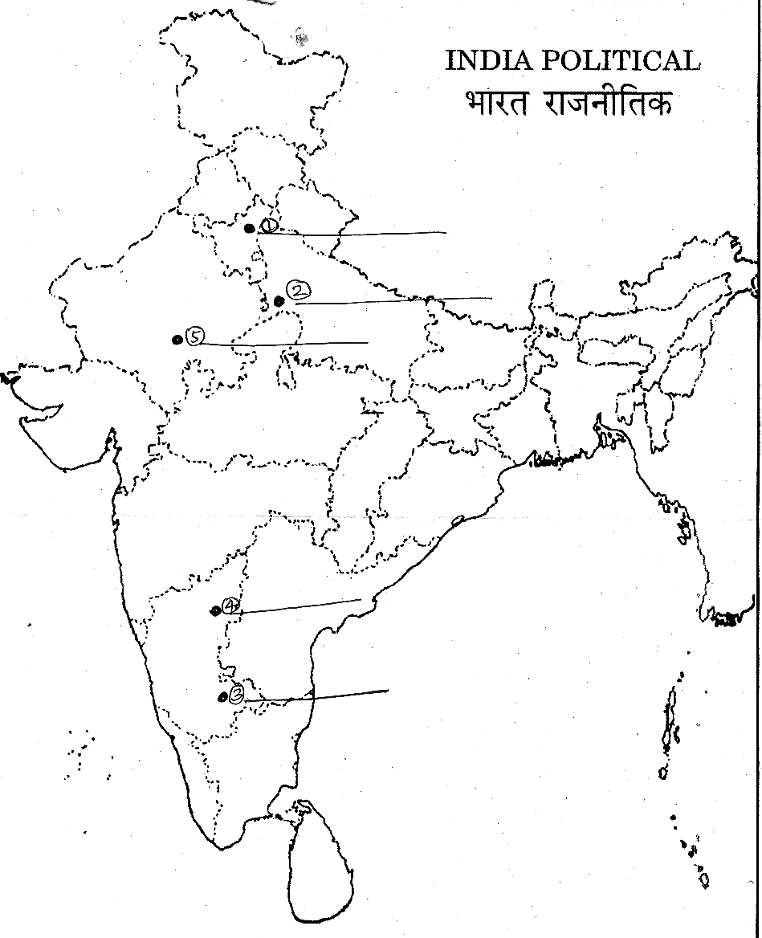
On the given outline map of India 5 places are marked as 1 to 5. Identify the places and write their names on the lines provided. 5

23 On the given political outline map of India mark
the following centres of the national movement
and label them:
Amritsar, Dandi, Chauri-Chaura, Bardoli, Bombay. 5
OR
On the outline map of India, mark and name five important centres of revolt of 1857.

Paper Submitted By :
Name : Mr P.suresh
Email : suresh.ponniah72@yahoo.com
Phone No : 9435735727

