Sample Paper – 2010
Class – X
Subject -Maths

Q1. What is the nature of roots of the quadratic equation 2x² – 3x + 5 = 0?
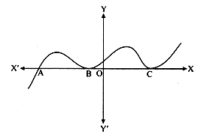
Q2. State Euclid's division lemma.

Q3. The graph of y =f(x) is shown Find the number of zeroes of f(x).

Q4. Find the perimeter of the sector whose central angle is 45º and radius is 14cm

Q5. The length of tangent from a point A at a distance of 26 cm from the centre of the circle is 10cm. What will be the radius of the circle?

Q6. Cards marked with the numbers 2 to 51 are placed in a box and mixed thoroughly. One card is drawn from this box. Find the probability that the number on the card is an odd number.

Q7. Two concentric circles are of radii 5 cm and 3 cm. Find the length of the chord of the larger circle which touches the smaller circle.

Q8. Find the value of k so that following system of linear equations may have unique solution:
2x + ky = 6 and 4x – 11y – 7 = 0
Q9. Given that tan θ = $\frac{1}{\sqrt{5}}$, what is the value of $\frac{{\text{sin}}^{2}θ−{\text{cos}}^{2}θ}{{\text{sin}}^{2}θ+{\text{cos}}^{2}θ}$

Q10. In ABC, DE ll BC if AD = 4 cm, DB = 4.5 cm and AE = 8 cm, find AC.

SECTION – B

Q11. If A, Band C are interior angles of a triangle ABC, then show that $\text{sin}\left(\frac{B+C}{2}\right)=\text{cos}\frac{A}{2}$
OR

Consider ΔABC right angled at C in which AB = 29cm, BC = 21 cm and $∠$ABC= θ. Determine cos² θ + sin² θ.

Q12. If the mid- point of the line joining (3, 4) and (k, 7) is (x, y) and 2x + 2y + 1= 0. Find the value of k.

Q13. A box contains 5 red marbles, 8 white marbles and 4 green marbles. One marble is taken out of the box at random. What is the probability that the marble taken out will be
(i) red (ii) white (iii) not green (iv) red or green

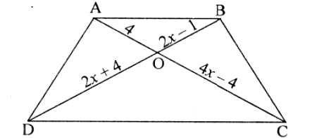
Q14. If Q (0,1) is equidistant from P(5, – 3 ) and R(x, 6), find the values of x.

Q15. In the figure, AB II CD. Find the value of x.

SECTION – C

Q16. If the sum of first n terms of an AP is 3n² – 2n , find the AP and its 19th term.

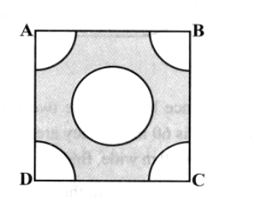
Q17. Show that any positive odd integer is of the form 6q + 1, or 6q + 3, or 6q + 5, where q is some integer.

Q18. From each comer of a square of side 4 cm a quadrant of a circle of
radius 1cm is cut and also a circle of diameter 2 cm is cut as shown .
Find the area of the remaining portion of the square.
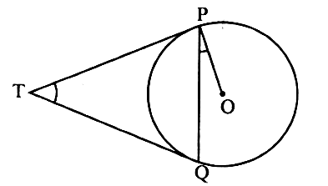
Q19. Two tangents TP and TQ are drawn to a circle with centre O from
an external point T. Prove that $∠$PTQ = 2$∠$OPQ.

Q20. Construct a triangle of sides 4 cm, 5 cm and 6 cm and then a triangle similar to it whose sides are two – third of the corresponding sides of the first triangle.

Q21. Solve for x: $\frac{5x+1}{2x+3}+\frac{2x+3}{5x+1}=\frac{5}{2} , x≠ \frac{−3}{2} , \frac{−1}{5}$

OR

Solve for x and y: $\frac{5}{x−1}+\frac{1}{y−2}=2; \frac{6}{x−1}−\frac{3}{y−2}=1$ $x≠ 1 , 2$

Q22. The line joining the points (2, 1) and (5, – 8) is trisected at the points P and Q. If P lies on the line 2x – y + k =0, find the value of k.

Q23. Prove that: $\frac{\text{tan}θ}{\frac{{\text{sin}}^{3}θ}{\text{cos}θ}+\text{sin}θ\text{cos}θ}=1$
OR

Find the value of ${\left[\text{sin}(\text{90}°−θ)+\text{cos}(\text{90}°−θ)\right]}^{2}−{\left[\text{cos}θ−\text{cos}(\text{90}°−θ)\right]}^{2}$
Q24. If two zeroes of the polynomial x⁴ – 6x³ – 26x² + 138x – 35 are 2$±\sqrt{3}$ , find other zeroes.

Q25. Draw the graphs of the equations2x – y = 2 and 4x – y = 8. Determine the coordinates of the points where these lines intersect the x-axis

SECTION – D

Q26. Prove that the ratio of the areas of two similar triangles is equal to the ratio of the square of their corresponding sides.
using above result, prove that the area of an equilateral triangle described on one side of a square is equal to half the area of the equilateral triangle described on one of its diagonals.

Q27. At a point on level ground, the angle of elevation of the top of a vertical tower is found to be such that its tangent is 5/12. On walking 240 metres towards the tower the tangent of angle of elevation of the top of the tower is 3/4. Find the height of the tower.

Q28. A solid is composed of a cylinder with hemispherical ends. If the whole length of the solid is 104cm and the radius of each of the hemi-spherical ends is 7 cm, find the cost of polishing its surface at the rate of 1 Re per cm².
OR
A circus tent is made of canvas, and is in the form of a right circular cylinder and a right circular cone above it. The diameter and height of the cylindrical part of the tent are 126 m and 5 m respectively. The total height of the tent is 21m; find the total cost of the tent, if the canvas used costs Rs 12 per m²

Q29. A plane left 40 minutes late due to bad weather and in order to reach its destination, 1600km away in time, it had to increase its speed by 400 km/hr from its usual speed. Find the usual speed of the plane.
OR
Some students planned a picnic. The budget for food was Rs. 480. But eight of these failed to go and thus the cost of food for each member increased by Rs. 10.How many students attended the picnic

Q30. For the following grouped frequency distribution find the mean and mode:
Class: Frequency:
3 – 6 2
6 – 9 5
9 – 12 10
12 – 15 23
15 – 18 21
18 – 21 1
21 – 24 7
Paper Submitted By :
Name : Mr Navtej
Email : navtejmahajan@gmail.com
Phone No. 9872041836

