Sample Paper – 2010
Class – IX
Subject – Mathematics
Time: 3hrs. M.M. 80

- Question paper consist 34 questions.
- All the question are compulsory.
- Attempt the question in serial order.
- Question paper has four section A,B, C&D
- Sec. A Consist 2 parts MCQ-1 and MCQ-2
Sec A MCQ-1 (Each1 Mark)
Choose the correct Answer & Write in your Answer sheet.
Q.1 Evaluate (3+) (3-)
(a) 7 (b) 2 (c) (3-) (d) 6
Q.2 Which of the among is polynomial
(a) (b) (c) (d) None of all
Q.3 In ABC
Name the largest side
(a) AB (b) BC (c) CA (d) None of all
Q.4 "The Line drawn through mid point of side of triangle parallel to another side bisect the third side"
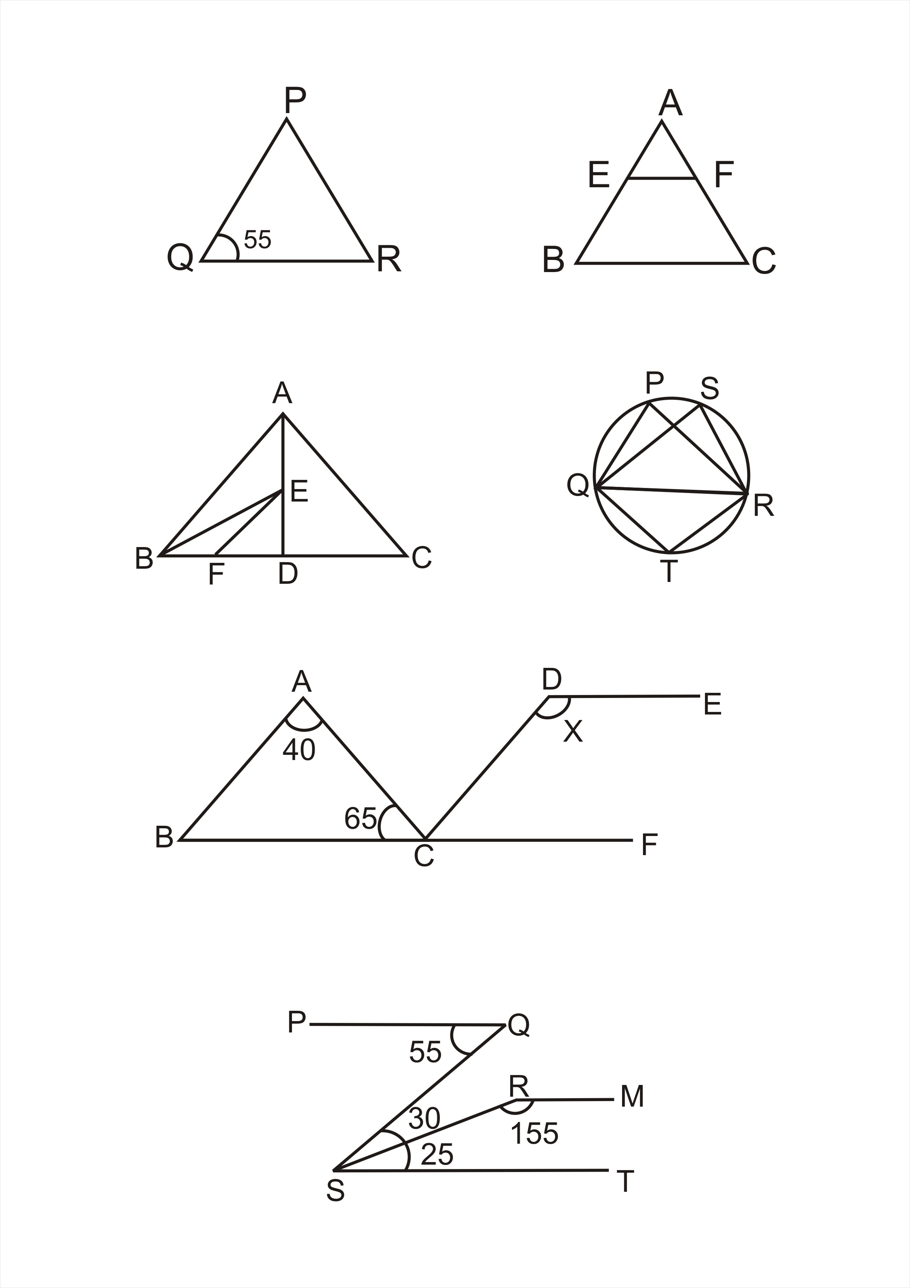
Choose the name of the fact
- Angle sum prop (b) Linear Pair (c) Mid Point Theorem (d) None
Q.5 In fig. write the correct value of & if PQ = PR
(a) 85, 40 (b) 70,55 (c) 100, 25 (d); None

Q.6 The Length of complete circle is
(a) Area (b) Chord (c) Diameter (d) Circumference
Q.7 How many circle can passes through 3 non collinear points:
(a) 2 (b) 5 (c) 3 (d) 1
Q.8 Surface area of sphere is :
(a) 2 times Circumfrence (b) (c) 4 times area of circle (d)
MCQ-II (each 2 mark)
Q.9 Which of the following is irrational:
(a) (b) 0.39765 (c) 0.3 (d) 1.7205.........
Q.10 Value of 185 x185-15x15 is :
(a) 170 (b) 1700 (c) 34000 (d) 200
Q.11 In fig. find the value of BC if AE =BE=x, and AF=CF=y, EF=29 cm
(a) 29x + 29y (b)
(c) 58 cm (d) 14.5 cm
Q.12 Find the value of K if x-2 is factor of :
(a) 2 (b) -2 (c) 6 (d) 5
Sec. "B" (Each 2 marks)
Q.13 Evaluate
Q.14 If = 2.236......... then calculate , will it be rational or irrational.
Q.15 Non zero constant polynomial has ........ and every ...... is zero of zero polynomial.
Q.16 If P(x), be any polynomial and P(x) is divided by (x-a) then what would be remainder and write the name of this important fact.
Q.17 A chord of length 16 cm is 6 cm from centre find the radius of circle.
Q.18 Find the value of P if mode of following data is 7. Explain the answer.
3, 5, 7, 4, 7, 8, 3, 6, 7, 4, P, 3
Q.19 Factoriese 12x²-7x+1
Sec."C" (Each 3 marks)
Q.20 Express 0.418 in the form of p/q
Q.21 Rationalise and and add the results.
Q.22 Median of 144,145,147,148, p+1,150,152,155,160 is 149 find p
Q.23 Examine if (x+2 is factor of 2x³-3x²-17x+30
Q.24 in a fig. PQ=PR = 35 find and

Q.25 Prove that the bisectors of two adjacent supplementary angle form right angle.
Q.26 In isosceles PQR, PQ= PR, M and N are point on QR such that QM= NR prove that PM= PN
Q.27 M and N are points on sides PQ and PR of such that MQR NRQ prove MN QR
Q.28 A chord of circle is equal to the radius of circle. Find angle subtended by chord at point minor arc and major arc.
Q.29 find the quantity of liquid in litrs. which is just sufficient to fill 1000hemispherical bowls of diam. 7 cm.
Sec. "D" (Each 5 marks)
Q.30 If P (x) is a polynomial for any real no. a, (x-a) is factor of P (x) then P (a) = 0" Name this important fact. using this fact factories 2x³-x² -13x-6
Q.31 Prove that median of triangle divide the triangle in two triangles
of equal area. Using this fact in a give fig. prove that
ar. (BEF) = ar. (ABC). If EF is median of BED
and E is a mid point of median AD.
Q.32 The height of cone is 24cm. and circumfrence of base of cone is 44cm. Find CSA, TSA & Volume of cone.
Q.33 (a) In a given fig. find the value of x if AB DC & DE BF

(b) In a given fig. check is PQ RM or not explain.

Q.34 If mean of following distribution is 6 find the value of P.
x | 2 | 4 | 6 | 10 | P+5
y | 3 | 2 | 3 | 1 | 2

Paper Submitted By :
Name : Mr Pradeep Sahajwani
Email : pradeepsahajwani@yahoo.co.in
Phone No. : 0755 2751377, 0

