CBSE SAMPLE PAPER: 2010
CLASS: XII
SUBJECT: BIOLOGY (Theory)

Code No.CB/XII/BIO-1
Candidates must write the Code on the title page of the answer-book.
Roll No.

- Please check this question paper contains 6 printed pages.
- Please check this question paper contains 30 questions.
- Please write down the Serial Number of the question before attempting it.
- 15 minutes time has been allotted to read this question paper. The student will read the question paper only and will not write any answer during this period.

Time: 3 hours Maximum Marks: 70
General Instructions:
- All questions are compulsory.
- This question paper consists of four Sections A, B, C and D. Section A contains 8 questions of one mark each, Section B is of 10 questions of two marks each, Section C is of 9 questions of three marks each and Section D is of 3 questions of five marks each.
- There is no overall choice. However, an internal choice has been provided in one question of 2 marks, one question of 3 marks and all the three questions of 5 marks weightage. A student has to attempt only one of the alternatives in such questions.
- Wherever necessary, the diagrams drawn should be neat and properly labelled.

Section – A
1. Why do you think that the offspring’s of bony fish are extremely vulnerable to predators? (1)
2. Mention the external opening of the Urethera. (1)
3. How does incomplete dominance differ from co-dominance? (1)
4. Mention the information found/gathered during HGP, which promises to revolutionize the process of tracing human history etc. (1)
5. ‘In the case of tetanus, the patient is injected readymade (preformed) anti bodies’. Identify the types of immunization here! (1)
6. What is the advantage of use of biotechnology in molecular biology over traditional pathological tests? (1)
7. Which attribute of human population do the following figures represent? (1)
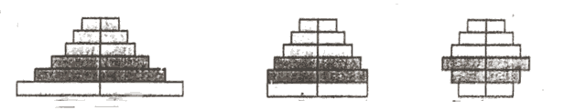

8. Is it possible to have following type of ecological pyramid in the nature? Give reason. (1)

TC
PC
SC
PP
OR

X J of Sunlight

SECTION B
9. Is self (fertilisation) pollination possible in date palm? Give reasons. (2)
10. a) Expand IUT.
(b) In which part of the female reproductive system the 8 called embryo will be transferred during test tube baby programme. (2)
11. a) What is common(evolutionary point of view) between the two plants’ parts as shown below?
b) How does sweet potato and potato differ from following? (2)
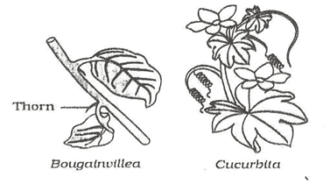
Tendril
12. Which cell or histological part of the AIDS victim does act a HIV factory? Why does the
HIV/AIDS patient become too immuno-deficient to fight against mild infections? (2)
13. What do you mean by inbreeding depression? How this problem should be solved during animal breeding? (2)
14. What is SCP? Write its advantage. (2)
15. Write with examples, how use of microbes helps us to make different types of cheese with specific texture & flavors? (2)
16. How can the ‘BOD’ be used as the Indicator of the pollution? (2)
17. a) Differentiate litter from detritus.
b) Mention the steps in the process of decomposition leading to degradation of detritus in to simpler inorganic substances. ½ +1½ =2
18. Explain, how integrated organic farming can help to reduce/check eutrophication. 2
OR
What may be the reasons for low productivity of ocean? 2
19. Draw a labeled diagram of a human sperm. 3
20. The following figure represents karyotype (edited) of a person suffering from a genetic disorder. Study the karyotype and answer the following questions:

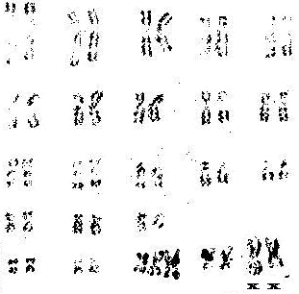
a) what may be the reason if the disease is wrongly identified a student as Klinefelter’s syndrome?
b) Identify the disorder correctly.
c) Mention the cause and symptoms of the disease. 1+ ½ +½ +1=3

21. a) identify the process as shown in the following diagram.
b) Why is it continuous on one strand while discontinuos on other?
c) Mention the enzyme joining the discontinuously synthesized fragments. ½ +2+½ =3
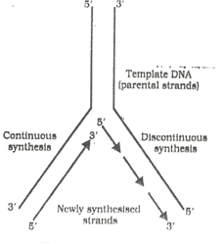

22. Explain Miller’s experiment to prove the ‘theory of chemical origin of life’ as proposed by Oparin and Haldane. (3)
23. What do you mean by withdrawal syndrome? Write the side effects of the use of anabolic steroids in males. (3)
24. Study the following figure and answer the questions:
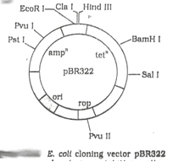
a) What does Eco RI & rop in the figure represent?
b) What will happen if transformants with foreign DNA insert at Bam HI (in the above fig) grown on tetracycline containing medium?
c) What is the advantage to use genes coding for a-galactosidase as selectable marker? 3
25. Why & how the bacteria (hosts) are made competent to take up recombinant plasmid? 3
26. How is a transgenic cotton plant protected against army worm? 3
27. Explain with examples, how do the plant animal interactions involve co-evolution. 3
28. (a) Identify the types of gynoecium (pistil) as shown in the following diagrams A & B.
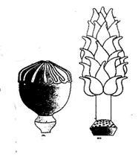
A. B
(b) Write briefly the process of different types of endosperm formation in coconut.
(c) Why does the endosperm development precede embryo development? 2+2+1=5
OR
Go through the following figure & answer the questions.
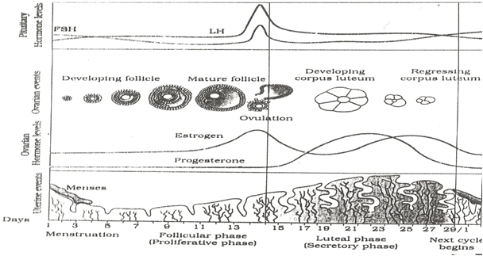
1

2

- Name the pituitary hormones which control the level of Progesterone & estrogen.
- Identify & label 1 & 2 as given in the following figure.
- By which day of cycle LH & FSH attain a peak level?
- Why does the level of progesterone level go below estrogen level by the 25th day of the cycle?
- Mention any of the key changes that you are suppose to do in following figure to indicate that successful fertilization has taken place. 1x5=5
29. Morgan while carrying 2 separate dihybrid crosses in drosophila to study the genes that were present on the same chromosome(say X), found that genes did not segregate independently of each other and therefore, F₂ ratio deviated significantly from expected 9:3:3:1 ratio. He found 98.7% of gametes in F₁ were of parental types & rest 1.3 % were non parental types in cross I while in cross II the % of gametes of parental combinations & non parental combinations were 62.8% and 37.2% respectively. Based on the above information answer the following questions:
a) Due to which genetic phenomenon as suggested by Morgan, the F₂ ratio (as stated above) deviated from expected Mendelian ratio, 9:3:3:1.
b) What term used by Morgan to explain the creation of non parental combinations.
c) Differentiate between the genetic phenomenons as identified in a) & b) above.
d) How did the ‘phenomenon, leading to non parental combination & its frequency’ use by A. Sturtvent?
e) Why did the % of non parental combinations vary greatly in the above crosses?
½ +½ +1½ +1+1½=5
OR
Study the following diagram and answer the questions:
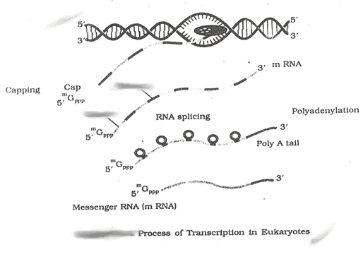
2
1
a) Based on the only information available in the above diagram, write, how does the same process differ in bacteria ?
b) Identify & Label (1) & (2).
c) Write the chemical composition of cap and tail added to hnRNA during processing.
d) “the presence of non functional sequences in hnRNA is reminiscent of antiquity”, how? 1+1+1+2=5
30. a) What may be the probable reasons for the greater biodiversity of tropics?
b) Explain the importance of species diversity in reference to the “rivet popper hypothesis”. 3 + 2=5
OR
- Why do CO₂, CH₄, N₂O etc known as green house gases?
- See the following flow chart & fill in the blanks at (i), (ii), (iii), (iv)

(i)…………………………………..
Refrigerators/ Propellants
(ii)…………………………………..

+
UV rays act upon

(iii)…………………………………..

(iv)…………………………………..

Emits

(a chemical)

In the stratosphere

& releases

(an ion/element)

Continuous degradation with release of O₂

(Result of above degradation)

Deleterious effects
(an environmental problem)

- Why is CNG better than Diesel? 2+2+1=5

Paper Submitted By :
Name : Mr Ajay Agarwal Navadeep
Email : kyalajay_tsk@yahoo.co.in
Phone No. 09435134589

