Guess Paper – 2010
Class – X
Subject – Maths

General Instructions:
All questions are compulsory.
The question paper consists of 30 questions
Question No’s. from 1 to 10 , 1 mark each,
Question No’s. from 11 to 15 , 2 mark each,
Question No’s. from 16 to 25 , 3 mark each,
Question No’s. from 26 to 30 , 6 mark each.
In question on construction, the drawing should be neat and exactly as per the given measurements.

- The 8 times of the 8th term of an A.P is equal to the 6 times the sixth term. Find the 14th term.
- If the following system of equation has no solution then find the value of K : (K-1)²x + (2k-1)y=7 and (3k+2)x+6ky=5
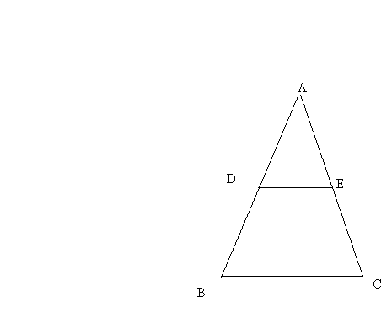
- The sum of circumference of two circles is 154 cm. If the radius of one circle is 16cm then find the radius of the other.
- In the following fig DE||BC
AD=3cm,DB=6cm and
DE=2cm find BC.
- The top of a ladder touches the 12m high wall and if the foot of the ladder is at 5m away from the foot of the wall. Find the length of the ladder.
- Write 3.424242…… in P/q form.

- Find the value of 8tan²x – 8sec²x

- The areas of two similar triangles are 25cm² and 81cm² find the ratio of their corresponding sides.

- If the roots of the quadratic equation 6x² - 5x +2a are the reciprocals of each other. Find a.

- Show that a-3b, a+b and a+5b are in A.P.

- Find third vertex of triangle whose two vertex are (5,2) and (6,4) and the centroid is (4,6) are the vertices of an isosceles Triangle.

- Triangle ABC is right angled at B if AB=8cm and AC-BC=2cm then find the value of SinC and CosC.

- If tan θ=3/4, then find the value of
$\frac{(\text{Co}\text{sec}θ−1)(\text{Co}\text{sec}θ+1)}{(\text{Sec}θ−1)(\text{Sec}θ+1)}$
- Find roots by completing square method : 3x²-3x -5

- Two coins are tossed ones find the probability of getting (i)only one head,(ii) at least one head.

- If a_{n}= 3-5n then find the AP also find the sum of 15 terms

- Solve graphically: 3x-y =13,2x-3y =4

- Prove that (CosecA-SinA)(SecA- CosA)(tanA+CotA)=1
- Find the co-ordinates of the point of trisection of line joining A(-1,4) and B(3,7).

- If x⁴ – 6x³+16x²-25x+10 is divided by x²-2x+k then remainder is x + a. Find the value of x and a.

- Construct a circle of radius 3 cm and draw pair of tangents from both ends diameter which is at 5 cm away from centre

- Solve the quadratic equation :
4x² - 8ax + 4a² - b² = 0

- How many terms of A.P: -12,-5,2…….give the sum of 253

- If A (1, 5), B (-1, 4),C(4,-2) and D(3,-3) then find area of ABCD.

- ΔABC is a right angled triangle at C and D is the mid point of BC
prove that AB ² = 4 AD ² - 3 AC ²
- In a triangle, if the square of one side is equal to the sum of the squares of the other two sides, prove that the angle opposite to the first side is a right angle.
Using it prove that: If ABC is an isosceles triangle with AC=BC. If AB² = 2 AC², prove that ABC is a right triangle.

- The inner diameter of the circular pipe is 4 cm. Through this pipe water is pouring into a cylindrical tank with base radius 40cm. Find in 40 minutes what is the height of water in the tank.

- Find the mean, median and mode of the following distribution.

Marks | No. of students
0 - 10 | 7
10 -20 | 14
20 -30 | 13
30-40 | 12
40-50 | 20
50-60 | 11
60-70 | 15
70-80 | 8

- The angle of elevation of the top of the tree from the opposite bank of the river is 60˚If he goes 60m away from the river he find the angle is 45˚. Find the height of the tree and the width of the river.

- The speed of steamer in still water is 12 km/h. It takes a total of 8 hours in going and returning from a point 45 km away. Find the speed of stream.

Paper Submitted By :
Name : Mr Deepak Sharma
Email : deep.iec@gmail.com
Phone No. : 9958802876

