Guess Paper – 2010
Class – X
Subject – Mathematics

Time: 2 hrs.
30 min M.M.: 80

Section – A( 1 Mark each )
- Find the condition that the equation $x^{2}−\text{mx}+1=0$ has two distinct real roots.
- If $α$, $β$and $γ$ are the zeroes of the polynomial ${\text{ax}}^{3}+{\text{bx}}^{2}+\text{cx}+d$, then write the value of $α$+$β$+$γ$ and $\text{αβγ}$
- Find the condition that the pair of linear equations $\text{ax}+\text{by}=c, \text{lx}+\text{my}=n$ has unique solution.
- ABCD is a trapezium in which BC || AD. If AB = 4cm and diagonals AC and BD intersect at O such that $\frac{\text{AO}}{\text{OC}}=\frac{\text{DO}}{\text{OB}}=\frac{1}{2}$, find BC.
- Show that ${\text{cos}}^{4}A−{\text{sin}}^{4}A=2{\text{cos}}^{2}A−1$
- In, $Δ\text{ABC},$ DE || BC meeting AB at D and AC at E. If $\frac{\text{AB}}{\text{BD}}$= 4 and CE = 2cm, find the length of AE.
- The H.C.F. and L.C.M. of two numbers are 23 and 1449 respectively. If one number is 207, find the other.
- The length of an arc of a circle of radius 12 cm is $\text{10}π$ cm. Find the angle measure of this arc.
- A die is thrown once. Find the probability of getting a number equal or greater than 1.
- If median of the data, arranged in ascending order, 3, 5, 7, x+1, x+3, 10, 12, 13 is 9, find the value of x.

Section – B ( 2 Marks each )
- Find the discriminant of the equation $3x^{2}−2x+\frac{1}{3}$= 0 and hence find the nature of its roots. Find them if they are real.
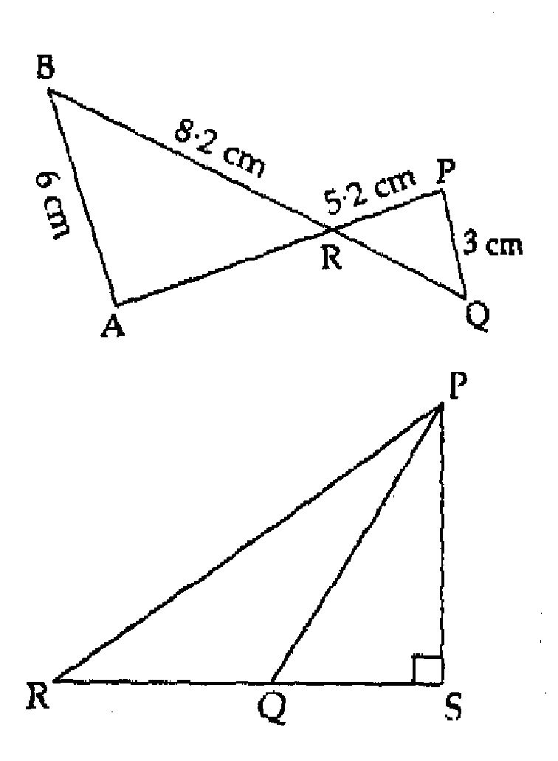
- In $Δ\text{ABC},$ right angled at B if tan A=$\frac{1}{\sqrt{3}}$, find the value of sin A cos C + cos A sin C.
- Find the coordinates of the centre P of a circle passing through the points (2, 1), (5, –8) and (2, –9).
- In the adjoining figure, $Δ\text{ABR}\text{\sim }Δ\text{PQR}\text{.}$If PQ = 3 cm, AB = 6cm, BR = 8.2 cm and PR =5.2 cm, find QR and AR.

Or

In the adjoining figure, $Δ\text{PSR}$ is a right triangle, right angled at S. if PQ =10 cm, QS =6cm and RQ =9 cm, find the length of side PR.

- A bag contains 5 white, 3 red, 4 blue and 7 black balls. A ball is drawn at random from the bag. Find the probability that it is: (i) either white or black ball (ii) neither white nor red ball.
Section–C ( 3 marks each)
- Find the missing numbers in the following factorization:
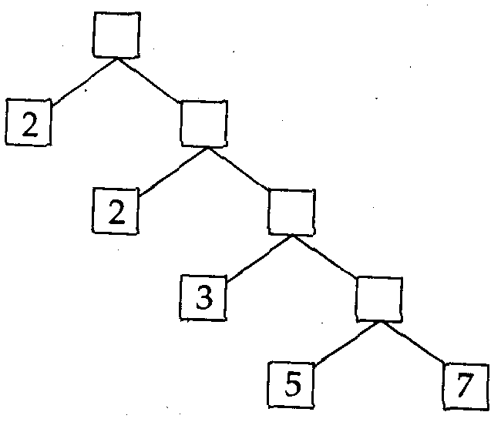
- Solve the following pair of linear equations for equations for x and y: $\frac{3}{x+y}+\frac{2}{x−y}=2, \frac{9}{x+y}−\frac{4}{x−y}=1, x+y≠0, x≠y$
- Draw the graph of the pair of linear equations:$2x+y−6=0, 2x−y+2=0$. Shade the region bounded by these lines and the x-axis.
- Find the sum of all three digit numbers which are multiples of 7.
Or
The sum of first 8 terms of an A.P. is 100 and the sum of its first 19 terms is 551. Find the A.P.
- Prove that : $2{\text{sec}}^{2}θ−{\text{sec}}^{4}θ−2\text{cos}{\text{ec}}^{2}θ+\text{cos}{\text{ec}}^{4}θ={\text{cot}}^{4}θ−{\text{tan}}^{4}θ$
Or
If $\text{sin}(A−B)=\frac{1}{2}=\text{cos}(A+B), 0\text{°<}A+B≤\text{90}°, A>B$, find A and B.
- The midpoint of a line segment joining the points A(2a, 4) and B(–2, 3b) is C(1, 2a+1). Find the values of a and b.
Or
Using the formula for area of a triangle, show that the points (–1, 1), (5, 7) and (8, 10) are collinear.
- Find the ratio in which the line segment joining the points A(–4, 10) and B(7, –1) is divided by y-axis. Also find the coordinates of their point of intersection.
- Draw a circle of 4 cm radius. Take a point P in the exterior of the circle 7 cm away from the centre. From P draw two tangents to the circle. Measure their length and verify by calculations.
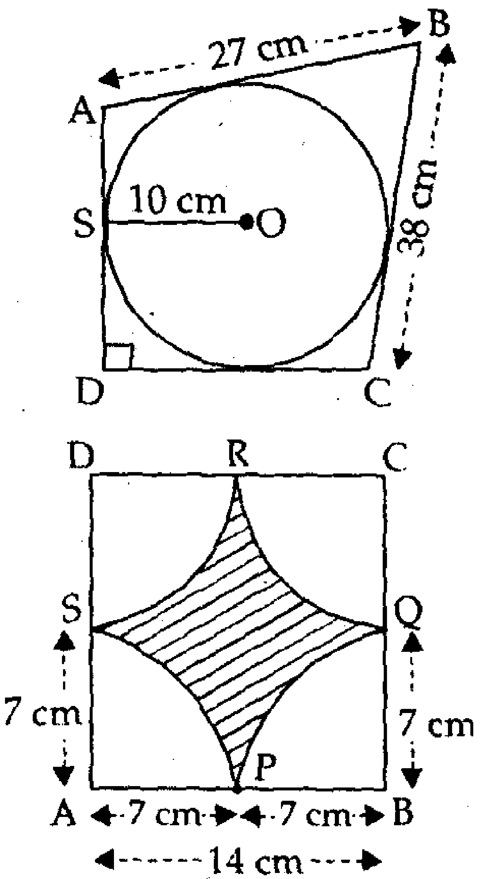
- In the adjoining figure, quadrilateral ABCD is circumscribed about a circle with centre O and ADDC. If the radius of the incircle is 10 cm, find the length of side DC.

- In the adjoining figure, ABCD is a square of side 14 cm. From each vertex of the square, arcs of radius 7 cm are drawn. Find the area of the shaded region.

Section – D ( 6 Marks each)
- The following table gives the score of 200 candidates in an entrance examination:
Score | No.of candidates
200 – 250  250 – 300  300 – 350  350 – 400  400 – 450  450 – 500  500 – 550  550 – 600 | 30  15  45  20  25  40  10  15
Draw the ‘less than’ and ‘more than’ ogives and hence find median score.
- State and prove Pythagoras theorem. Use the above to prove the following: In $Δ\text{ABC}, \text{AD}$ is a median. Show that ${\text{AB}}^{2}+{\text{AC}}^{2}=2({\text{AD}}^{2}+{\text{BD}}^{2})$.
- The rain water from the roof 22m20m drains into a cylinder vessel having diameter of base 2 m and height 3.5 m. If the vessel is just full, find the rainfall in centimeters.
Or
A circus tent is cylindrical to a height of 3 m and conical above it. If its diameter is 105 m and the slant height of the conical portion is 53 m, calculate the length of the canvas, 5m wide, required to make the tent.
- The angle of elevation of the top of a tower from a point on the ground is 30°. After walking 30 m towards the tower, the angle of elevation becomes 60°. What is the height of the tower?
- Two water taps together can fill a tank in $9\frac{3}{8}$ hours. The tap of larger diameter takes 10 hours less than the smaller one to fill the tank separately. Find the time in which each tap can separately fill the tank.
Or
A cottage industry produces certain number of pottery articles in a day. It was observed on a particular day that the cost of production of each article (in rupees) was 3 more than twice the number of articles produced on that day. If the total cost of production on that day was Rs. 90, find the number of articles produced and the cost of each article.

Paper Submitted By:
Name: Mr Neeta Das
Email: neetanvi@rediffmail.com
Phone No: 919826038066

