Sample Paper – 2010
Class –X
Subject – Maths
Time: M.M:
Section – ‘A’ (carry one mark each)
- Find the greater integer on dividing leaves remainder respectively.
- Find a quadratic polynomial whose one zero is & product of zeroes is
- If find , where is an acute angle.
- Are the roots of the quadratic equation rational or irrational? Justify your answer.
- Find first term of an A.P. if term of A.P. is ^{n-1}.
- If 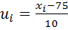 where are class marks of a grouped data & are corresponding frequencies, , & mean is , then find .
- How many tangents can be drawn to a circle at a given point on its circumference?
- The circumference of a circle exceeds its diameter by . Find the radius of the circle.
- Find the distance between the points & .
- What is the sum of probabilities of all the elementary events of an experiment?
Section – ‘B’ (carry two marks each)
- A vertical pole of length costs a shadow long on the ground & at the same time a tower casts a shadow long. Find the height of the tower.
- A solid cylinder has a total surface area of . Its curved surface area is of the total surface area. Find the volume of the cylinder.
- For what value of the system of linear equations: will have no solution?
- A box contains half the bolts & half the nuts are rusted. If one item is chosen from the box at random, what is the probability that it is rusted or is a bolt?
- If be a point on the line joining the points prove that
Section – ‘C’ (carry three marks each)
- Ten percent of the red balls were added to twenty percent of thee blue balls & the total was . If three times the number of the red balls exceed the number of blue balls by find the number of red balls & blue balls.
- The angles of a triangle are in A.P. The least being half the greatest. Find the angles.
- Find the length of the medians of the triangle whose vertices are .
- Prove that:
- Construct a in which using a scale factor .

- The area of an equilateral triangle is . Taking each angular point as centre, a circle is describes with radius equal to half the length of the triangle. Find the area of the region, not included in any circle. Also find the perimeter of this region.
- The diameters of the internal & external surfaces of a hollow spherical shell are & respectively. It is melted & recast in to a solid cylinder of height 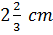, find the diameter of the cylinder.
- Prove that 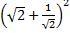is rational.
- If are the two zeroes of the polynomial a, find value of a.
- Two circles with centre’s
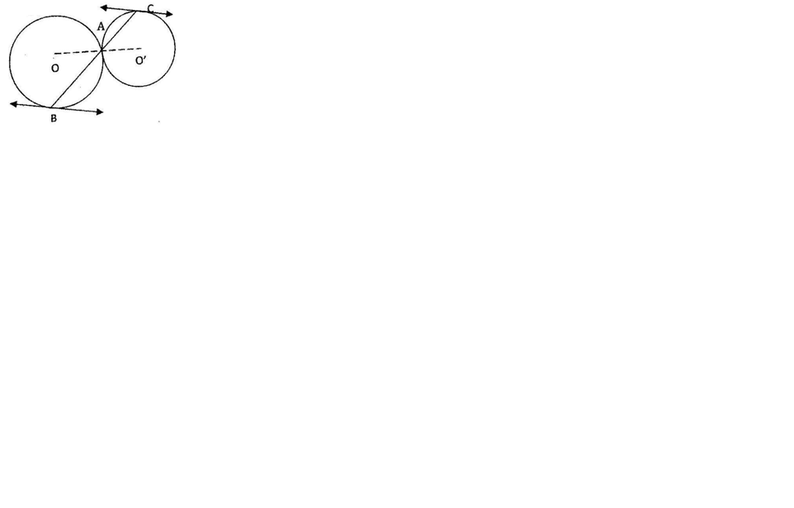
touch
externally at a
point .
A line through
is drawn to
intersect these circles in . Prove that the tangents at & are parallel.
Section – ‘D’ (carry six marks each)
- The numerator of a fraction is one more than its denominator. If its reciprocal is subtracted from it, the difference is , find the fraction.
- A cylinder whose height is two-thirds of its diameter, has the same volume as a sphere of radius . Calculate the radius of the base of the cylinder.
- Prove that the ratio of two similar triangles is equal to the square of the ratio of their corresponding sides.
Using above theorm:
If the areas of two similar triangles are equal, prove that they are congruent.
- The angle of elevation of the top of a light house at a point on the ground is such that 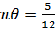 . When the point is moved towards the light house, the angle of elevation becomes such that 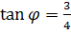 . Find the height of the light house.
- The annual profits earned by shops of a shopping complex in a locality give rise to the following distribution:
Draw both the types of ogives for the above data and hence find the value of the median profit.

Answers:

- 14.
- 17.
- 18. 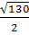 ,,
By: Ashwani Gupta
Mb: 09810817270, 09811091238
Email: gupta.ankit54@yahoo.in
- 21.
- 22.
- 24.
- 26.
- 27.
- 29.
- 30.

Paper Submitted By :
Name : Mr Ashwani Gupta
Email : gupta.ankit54@yahoo.in
Phone No : 9810817270

