Sample Paper – 2010
Class – IX
Subject – Mathematics
Time: - 3hrs.
Max Marks– 80

General Instructions:-
- All questions are compulsory.
- The question paper consists of 34 questions divided into four sections – A, B, C and D.
- In Section A questions 1 to 8 are of 1marks each, 9 to 12 are of 2marks each. Section B contains 7 questions of 2marks each, Section C contains 10 questions of 3 marks each and Section D contains 5 questions of 4 marks each.

======================= SECTION–A =========================

- Between two rational numbers, there are
(a) Only one rational no. (b) No rational no.
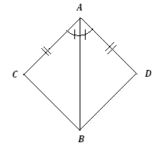
(c) Infinite rational no. (d) No irrational no.

- An irrational number between 3/2and 2 is
(a) 1.73 (b) (c) (d) $π$

- In the given fig. ▲ACB ▲ADB by using the rule
(a) ASA (b) SAS (c) AAS (d) RHS

- AD is a diameter of a circle and AB is a chord. If AD=34cm, AB=30cm, the distance of AB from the centre of the circle is:
(a) 17 (b) 15 (c) 4 (d) 8

- The area of an equilateral triangle of side 10cm is
(a) 25 (b) 50 (c) 75 (d) 100

- The degree of the polynomial P(x)=0
(a) 1 (b) 0 (c) not defined (d) none of above
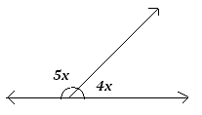
- The value of x in given fig. is
(a) 80⁰ (b) 20⁰ (c) 40⁰ (d) 60⁰

- If AOB is a diameter of the circle and C is any point on the circumference such that AC=BC, then ∠CAB is equal to:
(a) 30⁰ (b) 45⁰ (c) 60⁰ (d) 90⁰

- The value of p for p(z) = is
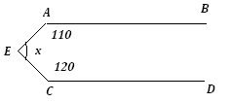
(a) (b) (c) (d)

- In the figure if AB ⏐⏐CD, then value of x will be:
(a) 60° (b) 70° (c) 10° (d) 130°

- The following observations are arranged in ascending order:
26, 29, 42, 53, x, x+2, 70, 75, 82, 93, if the median is 65, then the value of x will be:
(a) 61 (b) 62 (c) 63 (d) 64

- The volume of a right circular cone is 100π cm³ and its height is 12cm.Then its curved surface area is
(a)62π cm² (b)64π cm² (c)65π cm² (d)67π cm²

======================= SECTION–B=========================

- In the given fig. AB|| CF and CD|| FE .Find the value of x.

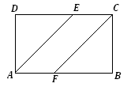
- In figure ABCD is a parallelogram and E, F is the midpoints of sides AB and CD respectively. Show that quadrilateral AECF is a parallelogram.

- A solid cube of side 24 cm is cut into 27 cubes of equal volume. What will be the side of the new cube?

- ABCD is a cyclic quadrilateral, whose diagonals intersect at E. If ∠DBC = 70°, ∠BAC = 30°, find ∠BCD. If AB = BC find ∠ECD.

- If the mean of five observations, x, x+2, x+4, x+6 and x+8 is 11. Find the mean of the first three observations.

- Find the median of 19, 25, 60, 49, 36, 31, 30, 32, and56, if 25 is replaced by 52, what will be the new median?
OR
The mean of 16 numbers is 8. If 2 is added to every number, what will be the new mean.

- Evaluate : (x-a) ³+(x-b) ³+ (x-c) ³-3(x-a) (x-b) (x-c); where 3x = a+b+c
OR
Factorize: x²-51x+378
======================= SECTION–C=========================

- If x = then find the values x+ .

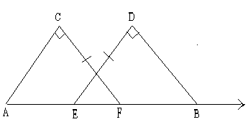
- In fig. AC⊥ CF and BD⊥ DE. If CF=DE and AE=BF, prove that AC=BD. If AC=BD, which congruence rule can be applied?

- Factories: (y² – 5y)²–2(y² – 5y) – 24
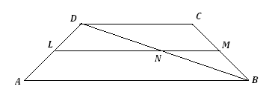
- ABCD is a trapezium with AB║ CD. LM is a line joining mid-points of AD and BC respectively. Prove that LM=1/2(AB+CD).

- If the radius and height of the cylinder, a cone and a hemisphere are same, find the ratio of their volumes.

- The lengths of two parallel chords of a circle are 6 cm and 8 cm. If the smaller chord is at distance 4 cm from the center, what is he distance of the other chord from the centre?

- A hemispherical bowl of internal radius 9 cm contains a liquid. This liquid is to be filled into cylindrical shaped small bottles of diameter 3 cm and height 4 cm. How many bottles are required to empty the bowl?

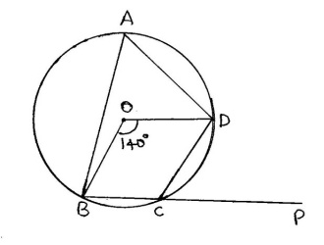
- If O is the centre of the circle, the angle subtended by the arc BCD at the centre is 140º. BC is produced to P. Determine ∠BCD and ∠DCP.

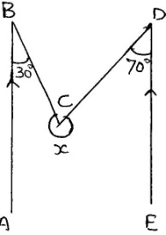
- In figure ABااED and <ABC=30º, <EDC=70º. Find x

- Find the missing frequency p for the following distribution whose mean is 7.68.
X | 3 | 5 | 7 | 9 | 11 | 13
F | 6 | 8 | 15 | p | 8 | 4

OR
The mean of 11 numbers is 35.If the mean of first 6 numbers is 32 and that of last 6 numbers is 37, find the sixth number.

======================= SECTION–D=========================

- Find the values of a & b if x⁴ – 5x + 4x²+ax+b is divisible by x²-3x+2 .

- State and Prove Mid point theorem.
OR
Prove that the angle subtended by an arc at the centre is double the angle subtended by it any point on the remaining part of the circle

- Represent the following data by means of a frequency polygon.

Marks | 0-10 | 10-30 | 30-45 | 45-50 | 50-60
No. of students. | 8 | 32 | 18 | 10 | 6

- The radius and height of a cone are in the ratio 4 : 3. The area of the base is 154 cm². Find the area of the curved surface.
OR
A storage tank consists of a circular cylinder with a hemisphere adjoined on either end. If the external diameter of the cylinder is 1.4 m. and its length is 5m. What will be the cost of painting it on the outside at the rate of Rs.10 per square metre.

- Prove that diagonals of a parallelogram bisect each other.

=======X========== X==========X=======

Paper Submitted By :
Name : Anil Kumar
Email :- anil_mpa06@yahoo.com
Mob : 01125915242

