GUESS PAPER - 2008
Class - X
SUBJECT - MATHEMATICS
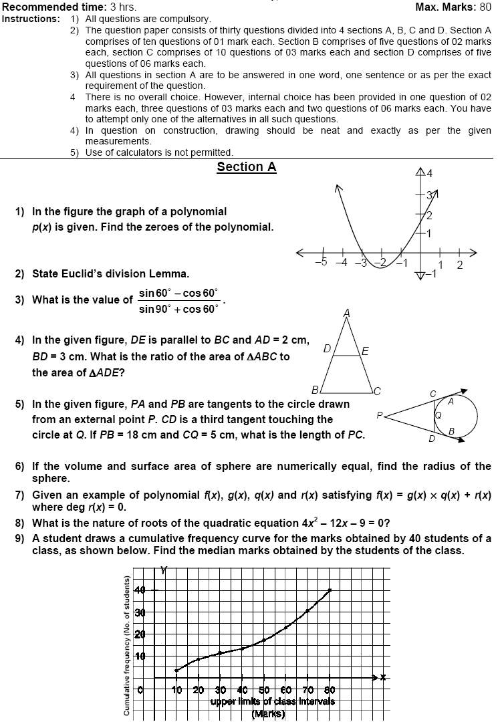

Paper Submitted By :
Name : Mr aatish
Email : smartboy_aatish@yahoo.co.in
Phone No : 9533533538

