Sample Paper – 2010
Class – IX
Subject – Science
Time allowed: 3-3 1/2 hrs. Maximum Marks: 80
General Instructions:
- Questions 1 to 5 are one mark questions. They are to be answered in one word or one sentence.
- Questions 6 to 14 are two marks questions. They are to be answered in about 30 words.
- Questions 15 to 23 are three marks questions. They are to be answered in about 50 words.
- Questions 24 to 26 are five marks questions. They are to be answered in about 70 words.
- Questions 27 to 41 are multiple choice questions based on practical skills. Each question is a one mark question.
You are to choose one most appropriate response out of the four a, b, c and d provided to you.
================================================================================================
- What is meant by Buoyant force? [1
- Mention one function each of Golgi apparatus and Smooth Endoplasmic Reticulum (SER). [1

- Write dispersed phase and dispersed medium of emulsion. [1

- What is echocardiography (ECG)? [1

- The atom of an element has 9 protons, 10 neutrons and 9 electrons. Mention its atomic number and mass number. [1

- Where are chromosomes located? What are they composed of? What is chromatin material and how does it change just before the cell divides? [2

- Give a diagrammatic representation showing the location of meristematic tissue in a plant body. Mention any two characteristic features of meristematic tissues. [2

- Mention two initiatives taken for increasing the water availability for agriculture. How are these practices helpful? [2
- (A) Write the names of the compounds represented by the formulae : [2
(i) CaCO₃ (ii) (NH₄)₂SO₄
(B) Calculate the formula unit mass of Na₂O (Given atomic mass of Na = 23u, O = 16u)

- The number of electrons in an outermost shell of sulphur is 6. What is its valency and why? [2

- (A) Name the technique used to separate : 1
(i) Mixture of sand and water (ii) Coloured pigment from blue/black ink
(B) Differentiate between homogenous and heterogeneous mixture. 1

- A man lifts two suitcases weighing 15kg and 5kg from the ground to a height of 1.5 m. Calculate the work [2
done by him on the suitcases.

- (A) What is meant by 'Compression' and 'Rarefaction' of a longitudinal wave? 1
(B) Give well labelled graphical representation of a longitudinal wave. 1

- Aditi clapped her hands near a cliff and heard the echo after 4 seconds. What is the distance of the cliff from her if the speed of sound is taken as 346 ms -1 [2

- (A) What are weeds? Why are they harmful to the growth of the crops? 2
(B) What is meant by vermicompost’? 1

- Draw a neat diagram of a plant cell and label any four organelles common in plant and animal cell. [3

- (A) Why is blood a connective tissue? [1
(B) Compare the function of smooth muscle and cardiac muscle. [1
(C) Where are the skeletal muscles located? [1
- With the help of schematic representation of atomic structure of magnesium and sulphur, explain how are electrons distributed in different orbits? [3

- Differentiate between compound and mixture. (Mention any three important points.)
- A solution contains ll0g of sugar in 500g of water. Calculate the concentration in terms of mass by mass percentage of the solution. [3

- (A) What are infrasonic and ultrasonic sounds? [2
(B) Why are ceilings of concert halls curved? [1

- (A) State Archimedes principle. [1
(B)The relative density of silver is 10.8. Tine density of water is 10³ kg m - ³. What is the density of silver in SI units? [2

- (A) Which is greater, the attraction of the earth for 1 kg of iron or the attraction of 1 kg irons for the earth? Why? [1
(B) A boy throws a ball vertically upwards and catches it back in 10 s. Calculate: (i) the velocity with which it was thrown up and (ii) maximum height attained by the ball. (Take g = 10 ms⁻²) [2

- (A) Name any two air-borne diseases. How does the disease causing microbe spread through air? [1
(B) How does HIV virus spread from a patient to a healthy person? Give any two methods of transmission of this disease. [2
(C) How does the immune system of our body function? [2

- (A) State the 'Law of conservation of mass' 1
(B) Mention the postulate of Dalton's Atomic Theory that explains the Law of Constant Proportions. [1
(C) Mention any two rules to write a chemical formula. [1+1
(D) Write chemical formulae for the following compounds: [1
(i) Calcium hydroxide (ii) Ammonium Sulphate

- (A) Give reason for the following :
(i) The kinetic energy of a freely falling object increases yet it holds law of conservation of energy. [1
(ii) A girl fills up 10 pages of a note book in order to practice sums yet she has not done 'work' in terms of Science/Scientific concept. [1
(iii) Work done by gravitational force on an object moved along a horizontal path is zero. [1
(B) Find the energy in kWh consumed in 24 hours by two electric devices, one of 100 W and other of 500 W. [2
Choose the most appropriate option out of the four choices (A), (B), (C), (D) provided to you: [1x15=15
- You are viewing a prepared slide of striated muscle fibres of a cockroach. When you focus it in the microscope, the striations appear pale and indistinct. To observe the striations clearly you would:
- slowly close the diaphragm to reduce the light
- remove the mirror to cut out light
- change the eye piece to increase magnification
- replace the objective to decrease magnification

- Which of the following can be subjected to sublimation?
(A) NH₄CZ (B) Camphor
(C) Naphthalene (D) All of the above

- Sohan found green coloured slimy scum in the lake water. What could it be?
(A) Agaricus (B) Moss (C) Spirogyra (D) Dryopteris
- In the experiment of verification of laws of reflection of sound, sound is directed along :
(A) Axis of the tube (B) Normal to the axis of tube
(C) Both (A) and (B) (D) Neither (A) nor (B)
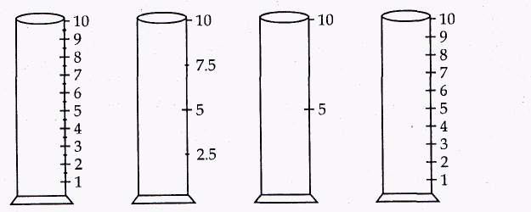

Four measuring cylinders with different least counts are shown in figures A,B/C and
D. The most suitable cylinder for determining the volume of a cube of side 1 cm is:
(A) A (B) B (C) C (D) D

- In the experiment to establish the relation between loss in weight of an immersed solid with the weight of water displaced by it, the up thrust experienced by the object in tap water and in salty water are U_{w} and U_{s} respectively, then :
(A) U_{W} = U_{S} (B) U_{W}>U_{S} (C) U_{S} = 2U_{W} (D) U_{w} < U_{s}

- To prepare Iron sulphide, by heating a mixture of iron filings and sulphur, we should use :
(A) Copper dish (B) China dish
(C) Watch glass (D) Petri dish

- Parth prepared a temporary mount of human cheek cell and stained it with methylene blue. He observed a darkly stained spherical structure near the centre of each cell. Which of the following did he observe:
(A) Nucleoid (B) Mitochondria (C) Nucleus (D) Golgi apparatus

- In the formation of a mixture :
(A) Energy is absorbed (B) energy is evolved
(C) Energy is neither evolved nor absorbed (D) none of the above

- A pulse was created in a slinky/string of length 4 m by a group of students. They observed that it returned, after reflection, at the point of creation 6 times in 10 seconds and calculated the speed as follows:
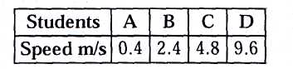

- Four watch glasses with labels A,B,C and D were placed on the laboratory table. Watch glass A had chalk powder, B had sago powder, C had common salt and D had powdered sugar. On adding two drops of iodine to the content of each watch glass, which one will turn blue black?
(A) A (B) B (C) C (D) D

- The temperature - time (T -1) graph for showing cooling of hot water is best represented by:
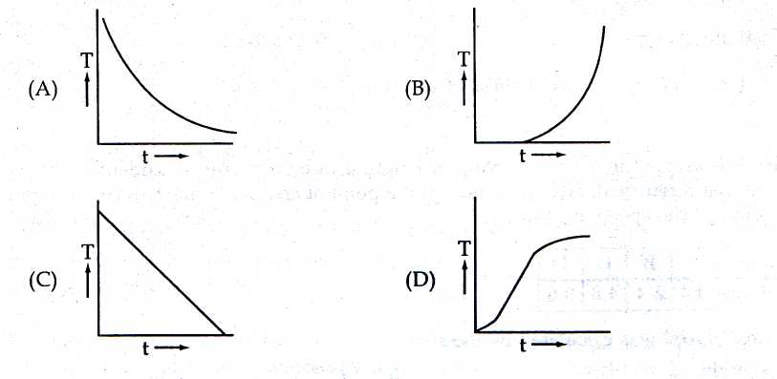

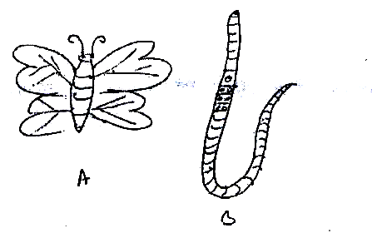
- Two pictures of animals A and B are shown above. Which characteristic features of their bodies are specific features of their respective phyla?
- Antennae of A and segments of B
- Three pairs of legs of A and scales of B
- Jointed appendages of A and metamerically segmented body of B
- Wings of A and slender body of B

- Which of the following is heterogeneous mixture?
(A) sugar + water (B) salt + water
(C) CuSO₄ + water (D) oil + water

- The size of the cone of the filter paper should be :
(A) smaller than the funnel (B) larger than the funnel
(C) equal to the funnel (D) very large

Paper Submitted By : Basant Tripathy
Email Id : basant.physics@gmail.com
Phone No : 9777702608

