Sample Paper – 2010
Class – X
Subject –Information Technology (165)
TIME: 2 ½ hr MARKS: 40

1. (a) What is field size property in context to MS-Access? What is the default value for the field
size property of a Number type field ? 2
(b) Define Data Redundancy and Data inconsistency. What are the features that Ms Access
provide to let you manage your Data? 2
(c) What validation check can be applied to the ADMISSION_NUMBER field of STUDENT
table so that admission number always starts with either ‘E’ or ‘V’? 2
(d) Define Input Mask. Name the data types of field where input Mask is applicable. 1
(e) Write the interpretation of the following characters in the first part of the Input Mask. 2
&, L, ?, >,
(f) What you mean by Validation Rules and Validation Text? 1

2. (a) What do you understand by a website’s home page and a user’s home page. 1
(b) Distinguish between downloading and uploading files. 1
(c) What do you understand by streaming multimedia software and plug-in multimedia
software. 2

(d) Give four good searching tips for internet users. 2
(e) What do you mean by Emoticons. 1
(f) When we send Emails we find two options are provided CC and BCC. What is the
difference between these CC and BCC. 2
(g) Give the extension of the following:. 1
(i) GIF (II) ASCII

3. (a) Define Tag and Attribute in HTML documents. 1
(b) Write the HTML command to display the following in your web page. 2
X₂ + Y₂
(c) What will be displayed on the web page for the following HTML command? 1
<I Atomic weight of > </I> O<sub>2</sub><br>
(d) The following code is written to align the image in center in the browser’s window.
however, the desired result is not achieved. Mention the reason.
<IMG SRC=”house.gif” ALIGN=Center> 2
(e) Which tag do we use to change the size and style (face) of the text of a HTML file
viewed on a web Browser ? Also explain any two attributes used with this tag. 2
(f) Explain the specific meaning of the following validation rule. 2
(i) >1000 or IS Null (ii) Like “P[A-F] ###”
(g) Consider the HTML code <A HREF= #intro> Introduction </A>. 2
in the above code,
(i) What is the purpose of # ?
(ii) What will happen when the user clicks “Introduction”?

4. Write down the HTML code to generate a page in the format and style shown below: 8

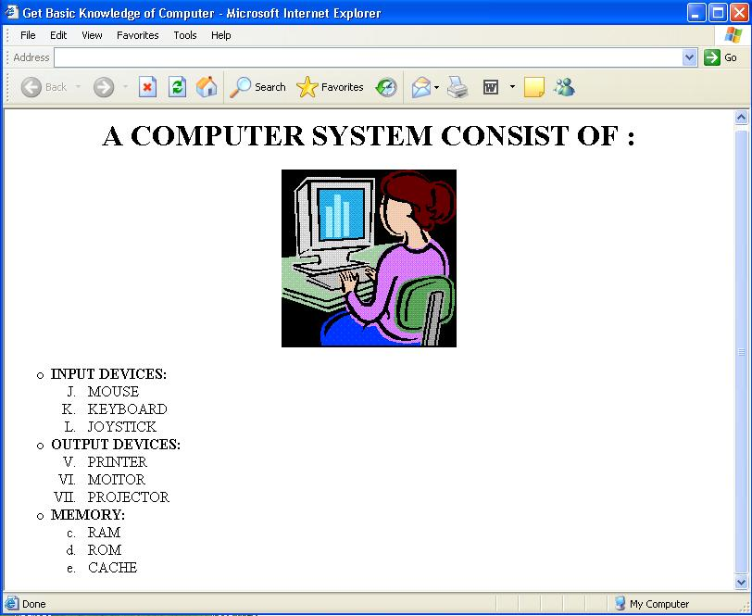

Special Notes:

(a) Title of the page is ‘Get Basic Knowledge of Computer’.
(b) Background of the page should be ‘Yellow’.
(c) Font Face of the page should be “Arial’.
(d) Logo used in the page is the file ‘logo.gif’ stored in the same directory.
(e) Text colour of the main heading should be ‘Black’.

SUBMITTED BY: ABUL QUASIM
(PGT COMP.SC.)
JNV WEST TRIPURA
Mob: 09856017528

