 | Sample Paper – 2010
 | Class – X |  | Prepared by:
 | Subject – Science |  | 

General Instructions:
- The question paper comprises of two sections A and B. You are to attempt both the sections.
- All questions are compulsory.
- There is no overall choice. However internal choice has been provided in all the three questions of five marks category. Only one option in such questions is to be attempted.
- Questions 1 to 6 in section A and 19 to 21 in section B are short questions. These carry one mark each.
- Questions 7 to 12 in section A and 22 to 24 in section B are short answer type questions and carry two marks each.
- Questions 13 to 16 in section A and 25 & 26 in section B are also short answer type questions and carry three marks each.
- Questions 17 and 18 in section A and question 27 in section B are long answer type questions and carry five marks each.
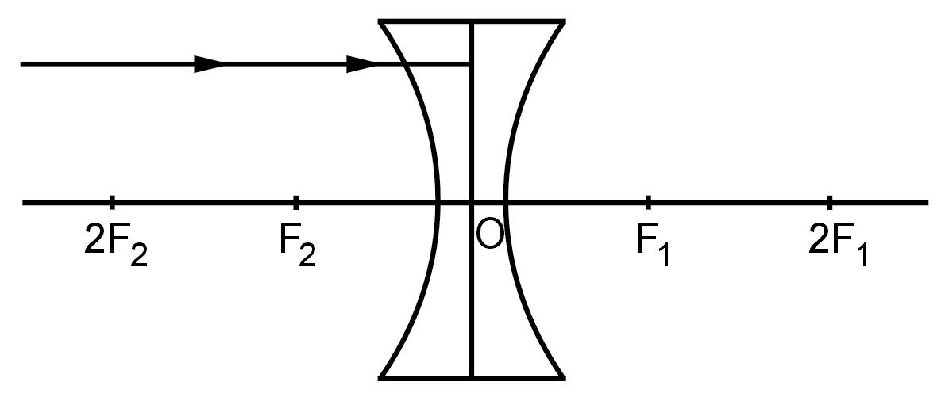

SECTION ‘A’
Q.1 Complete the path of ray of light after refraction from the lens in the given diag.
Q.2 What do you mean by galvanization?
Q.3 The pH of a solution of NaOH is 11. What would happen to the pH of the solution when a few drops of HCl are added the solution?
Q.4 The following table gives the values of refractive indices of a few liquid media:
S.No. | 1 | 2 | 3 | 4 | 5
Medium | Kerosene | Water | Alcohol | Benzene | Turpentine
Refractive index | 1.44 | 1.33 | 1.36 | 1.50 | 1.47
Light passes through these media one by one. Arrange the given media in the decreasing order of the speed of light.
Q.5 Why do ionic compounds not conduct electricity in their solid state?
Q.6 Why do two magnetic field lines not cross each other?
Q.7 Equal lengths of magnesium ribbons are taken in test tubes A and B. Hydrochloric acid (HCl) is added to test tube A, while acetic acid (CH₃COOH) is added to test tube B. In which of test tube will the fizzing occur more vigorously and why?
Q.8 In the electrolytic refining of a metal M, what would you take as the anode, the cathode, and the electrolyte?
Q.9 An electric heater has a resistance of 40 and draws a current of 4A.
Calculate (i) The power consumed by the heater (ii) p.d. applied across at the ends of the heater.
Q.10 State Right Hand Thumb rule to find the direction of the magnetic field around a current carrying straight conductor. How will this magnetic field be affected on:
- Increasing the electric current through the conductor.
- Changing the direction of flow of current in the conductor.
Q.11 If you could use any source of energy for heating your food, which one would you use and why?
Q.12 Why are we looking at alternate sources of energy?
Q.13 Why does the sun appear reddish early in the morning?
Q.14 In the periodic table given below lithium, carbon, oxygen and neon have been placed in their correct positions. The positions of nine other elements have been represented by letters X, Y, Z, E, G, L, Q, R, and T. These letters are not the symbols for the elements concerned. By reference to the table answer the following questions:
Groups→ | 1 | 2 | 3 to 12 | 13 | 14 | 15 | 16 | 17 | 18
Period 2 | Lithium |  |  |  | Carbon |  | Oxygen | L | Neon
Period 3 | X |  |  |  | E |  | G | Q
Period 4 | Y |  |  |  |  |  |  | R
Period 5 | Z |  |  |  |  |  |  | T
(a) Write the electronic configuration of E. Also mention its valency.
(b) Arrange the elements G, E and Q in the increasing order of non-metallic character.
(c) Name the family of elements represented by X, Y, and Z.
(d) Will L⁻ and X⁺ have the same number of electrons? Justify your answer.
(e) Write the formula of the compounds formed when (i) Y reacts with L and (ii) Z reacts with G.
Q.15 How far should an object be held from a concave mirror of focal length 40 cm so as to form an image magnified three times?
Q.16 How are Na, Ca and Al different from one another in terms of their reaction with water? Explain with the help of chemical reactions.
Q.17 In a household electric circuit different appliances are connected in parallel to one another. Give two reasons.
Two electric lamps rated 100W; 220V and 25W; 220V are connected in parallel to a 220V supply. Calculate the total electric current flowing through the circuit.

Or

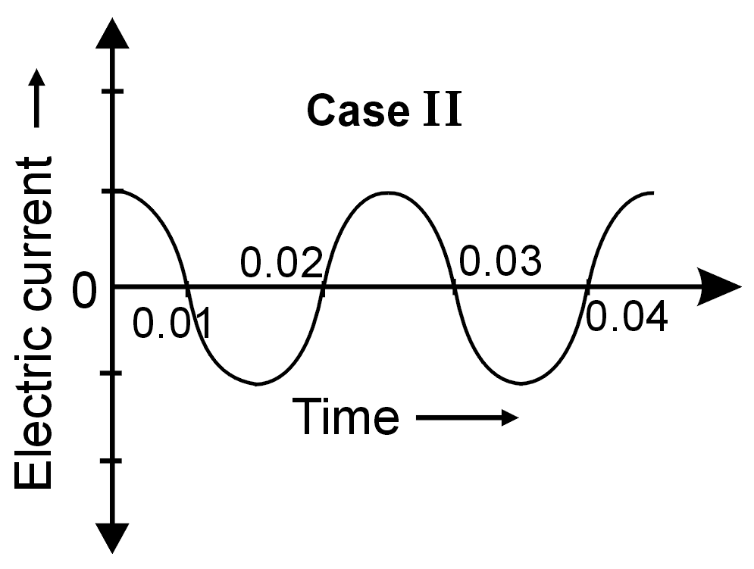
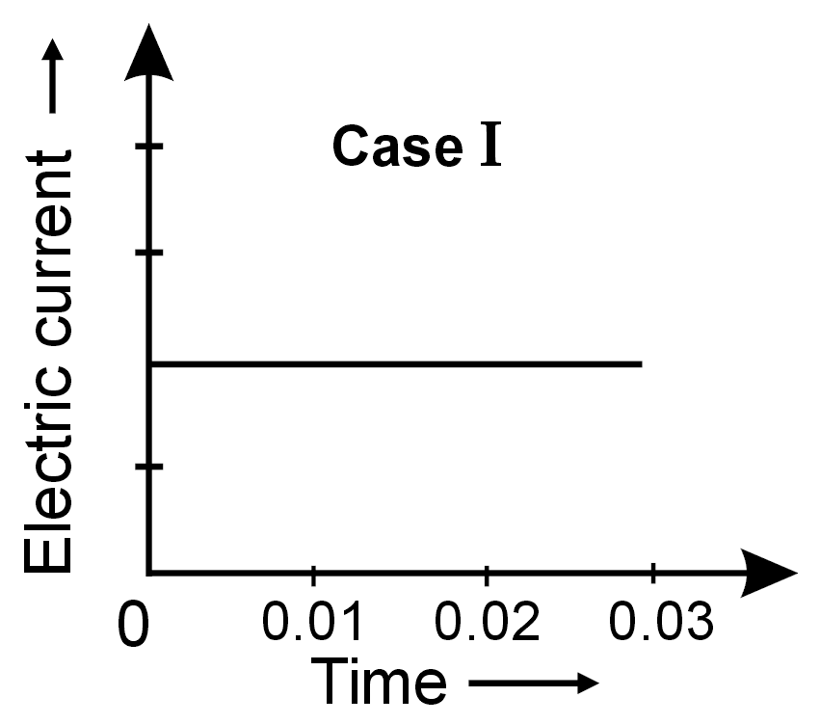
You are given the following current-time graphs:

(i) Name the type of current in two cases.
(ii) Identify any one source for each type of these currents.
(iii) Using the diagram, calculate the frequency of current in case II.
- What is the frequency of current in case I.
- Which of the two currents can be used for electrolysis of acidified H₂O and NaCl?

Q.18 An organic compound ‘A’ is a constituent of wine and cough syrup. This compound on heating with alkaline potassium permanganate forms another organic compound ‘B’. Compounds ‘A’ and ‘B’ react with each other to form a sweet smelling substance ‘C’.
(i) Identify the compounds ‘A’, ‘B’ and ‘C’.
(ii) Write the chemical equation for the conversion of A into B.
(iii) Name and write the chemical reaction taking place between A and B.
(iv) Name the process to get compound ‘B’ back from ‘C’ and write corresponding chemical equation.
(v) What happens when A burns in the presence of oxygen? Write the chemical equation.

Or
(a) Why does micelle formation take place when soap is added to water? (2)
- Explain the formation of scum when hard water is treated with soap? (1)
- What change will you observe if you test soap with litmus paper (red and blue)? (1)
- Would you be able to check if water is hard by using a detergent? (1)

SECTION ‘B’
Q.19 Why does trachea not collapse when there is not much air present in it?
Q.20 Which gland secretes a hormone that regulates growth and development of the body? Where is this gland located?
Q.21 How does spirogyra reproduce?
Q.22 What is meant by the term 'sustainable development'? Suggest any two ways to achieve it.
Q.23 If a woman is using a copper-T, will it help in protecting her from sexually transmitted diseases? Justify.
Q.24 Consider the food chain given below:
Plants → Deer → Tiger
What would happen if we kill all the deer?
Q.25 DDT, an insecticide used in agriculture, has been banned in many countries. Give reason, why?
Q.26 Write four methods by which problem of waste disposal can be reduced.
Q.27 Study the given data and answer the questions following the data.
Parental plants cross fertilised & seeds collected | F₁ (first generation off spring) | F₂ (offspring of self pollination of F₁)
Male parent always bore red flowers. Female parent always had white flowers. | 330 seeds sown and observed. All 330 gave red flowers | Out of 44 seeds 33 seeds gave plants with red flowers and 11 seeds gave plants with white flowers.
(i) What is the term for this type of cross?
(ii) What does the data of the column marked F₁ indicate?
- Express the genotype of the (a) parents (b) F₁ Progeny and (c) F₂ Progeny

Or
(i) Give two points of differences between respiration in plants and respiration in animals.
(ii) What are the various ways in which glucose us oxidized to provide energy in various organisms?

Paper Submitted by: Vikrant Arora
Email : vicks_virgo@rediffmail.com
Ph No. : 01165796404

