Guess Paper – 2010
Class – XI
Subject - INFORMATICS PRACTICES

General Instructions : MM : 70
1. All questions are compulsory.
2. Answer in sequence.
3. Put the questions no. properly.
4. Programming Language Java & Database MySQL

Q1.
a. Answer the following questions : (4)
i. What is an operating system ? Give two examples of an operating system ?
ii. Give the relationship between Byte and gigabyte.
iii. What is a computer virus ? How can it affect your computer ?
iv. How is backup utility useful ? Is it necessary to take backup of data ?
b. Give example for each of the following: (2)
i. A language processor. ii. A utility software.
iii. A package software. iv. A non-impact printer.
c. Differentiate between : (4)
i. A volalite and non volalite memory. ii. Compiler and Interpreter.
iii. Machine language and High level language. iv. System s/w and Application s/w.
Q2.
a. Answer the following questions :
i. What is e-Business ? (1)
ii. If you are e-Learner,how e-Learning will benefit you ? (2)
iii. How does the e-Business impact daily life of a common man ? (2)
Q3. Answer the following questions :
- Differentiate between : (2)
  - Char and Varchar b. Primary Key and Unique Key
- What is the significance of DELETE command ? How does the WHERE clause
restrict the query in MySQL ? (2)
iii. What are views ? How are they useful ? (2)
iv. Define SQL. Explain SQL subcategories giving at least one example in each category. (4)
Q4. Answer the following questions :
a. i) Find the output of the following program segment : (3)
int i,j,k,x=0;
for(i=0;i<5;++i)
{
for(j=0;j<i;j++)
{
switch(i+j-1)
{
case -1 :
case 0 :
x+=1;
break;
case 1 :
case 2 :
case 3 :
x+=3;
default :
x+=3;
}
System.out.println(x +"\t");
}
}
System.out.println("\n");
System.out.println(x);
ii) What will be the final value of digit ? (2)
int digit ;
for(digit = 0; digit <= 9; digit++)
System.out.print(digit);
digit = 2 * digit ;
- - digit;
(a) 19 (b) -1 (c) 17 (d) 16
b. Find the syntax error(s) , if any in the following program ;
Rewrite the code after making the correction. (2)
int a = 5;
int b=6;sum=0;
System.out.print(“a = “ a);
sum = + a;
if (sum>0);
System.out.print(“b = “ +b);
else
System.out.print(“a = “ +a);
c. Rewrite the following code using for loop : (2)
int i,sum =0;
while(i<=10)
{
sum =sum +i ;
i++;
}
System.out.print(sum);

d. Write the equivalent switch statement for the following : (2)
if (code == ‘R’ || code== ‘W’)
System.out.println(“Rainy Season “);
System.out.println(“Winter Season “);
else if (code == ‘S’)
System.out.println(“Summer Season “);
else
System.out.println(“Spring Season “);

e. Create a Java Desktop Application to find the Discount of an item on the basis of Category
of item[Electrical Appliance/Electronic Gadget / Stationary ].The Categories will be implemented in JRadioButton controls. The Discount will be calculated as follows : (4)

Cost | Discount(%)
<=1000 | 5
Otherwise | 10

The extra Discount will be calculated as follows :
Category | Discount(%)
Electrical Appliance | 3
Electrical Gadget | 2
Stationary | 1

- Calculate the total discount as : Discount on cost +Discount on Category
- Calculate the discount amount as : cost * discount
- On clicking of Exit Button ,it will exit the application

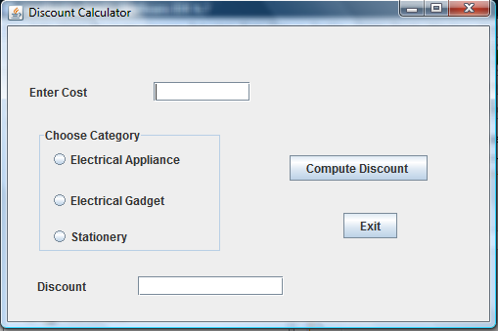

Control | Property Name | Property Value
JFrame | Title | Discount Calculator
Jlabel1 | Text | Enter Cost
Jlabel2 | Text | Discount
JTextField1 | Variable Name | txtCost
JTextField2 | Variable Name | txtDiscount
JRadioButton1 | Text | Electrical Appliance
JRadioButton1 | Variable Name | rdbtn1
JRadioButton2 | Text | Electrical Gadget
JRadioButton2 | Variable Name | rdbtn2
JRadioButton3 | Text | Stationery
JRadioButton3 | Variable Name | rdbtn3
JButton1 | Variable Name | btnComp
JButton2 | Variable Name | btnExit
Q5.
a. Create a Java Desktop Application to perform the following calculations: (4)
i) Calculation of Total and Average Marks
Total = English + Maths + Physics + Chemistry + IP
Average = Total / 5
ii) Displaying the Distinction /Average Marks based on the Total Marks scored.
iii) Displaying the grade (A,B,C,D,F) based on the average marks scored.
iv) On clicking of Exit Button ,it will exit the application.
Average | Result | Grade
>=75 | Distinction | A
>=60 | First Class | B
>=50 | Second Class | C
>=40 | Average | D
Otherwise | Fail | F
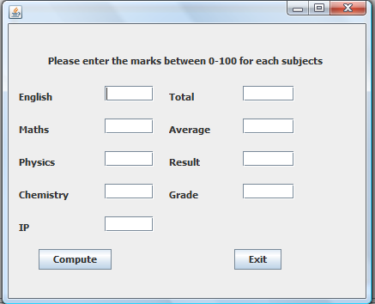

Enter five Subject marks.Also the entered marks should be between 0 and 100 for each subject.
Control | Property Name | Property Value
JFrame | Title | Calculation of Result
Jlabel1 | Text | Please enter marks between 0-100 for each subjects
Jlabel2 | Text | English
Jlabel3 | Text | Maths
Jlabel4 | Text | Physics
Jlabel5 | Text | Chemistry
Jlabel6 | Text | IP
Jlabel7 | Text | Total
Jlabel8 | Text | Average
Jlabel9 | Text | Result
Jlabel10 | Text | Grade
JTextField1 | Variable Name | txtEng
JTextField2 | Variable Name | txtMaths
JTextField3 | Variable Name | txtPhy
JTextField4 | Variable Name | txtChem
JTextField5 | Variable Name | txtIP
JTextField6 | Variable Name | txtTot
JTextField7 | Variable Name | txtAvg
JTextField8 | Variable Name | txtRes
JTextField9 | Variable Name | txtGrd
JButton1 | Variable Name | btnComp
JButton2 | Variable Name | btnExit

b. Write a method Min_Three that returns the smallest of three floating – point numbers. (2)
c. Write a method CheckVowel for a Java class that accepts a character and check whether it is
a vowel or a consonant.It returns 1 if character is a vowel else it returns 0. (2)
d. An integer is said to be prime if it is divisible only by 1 and itself.For example 2,3,5 and 7 are prime but 4,6 and 9 are not prime.Write a method PrimeCheck that determines if a number is prime or not. (2)
Q6. Answer the following questions :
a. Which command is used to change column size from VARCHAR(10) to VARCHAR(50). (1) b. What is a NULLvalue? (1)
c. What do % and _ mean inside SELECT with LIKE statement? Explain with the help of examples of each. (2)
d. After creating the "employee" database, you want to use it. Write the command that you should give. (2)
e. What will be the putput of the following : (2)
i. SELECT ROUND(124.44) + POW(4,3) ;
ii. SELECT LOWER(SUBSTR(TRIM(‘THE JAIN INTERNATIONAL SCHOOL’),4,10));
iii. SELECT LEFT(TRIM(‘IPL2010-12MAR’),5);
iv. SELECT MONTHNAME(19-03-2010);
f. Write the purpose of the following clause using suitable example : (2)
i. DISTINCT ii. ORDER BY

Q7. Write SQL commands for the queries given from a to f and write the output of the SQL
commands given in part g based on a table LIBRARY shown below: (10)
Table: LIBRARY
No. | Title | Author | Subject | Publisher | Quantity | Price
1 | Data Structure | Lipschute | DS | McGraw | 4 | 217.00
2 | DOS Guide | NORTRON | OS | PHI | 3 | 175.00
3 | Turbo C++ | Robort Lafore | Prog | Galgotia | 5 | 270.00
4 | Dbase Dummies | Palmer | DBMS | PustakM | 7 | 130.00
5 | Mastering Windows | Cowart | OS | BPB | 1 | 225.00
6 | Computer Studies | French | FND | Galgotia | 2 | 75.00
7 | COBOL | Stern | Prog | John W | 4 | 1000.00
8 | Guide Network | Freed | NET | Zpress | 3 | 200.00
9 | Basic for Beginners | Norton | Prog | BPB | 3 | 40.00
10 | Advanced Pascal | Schildt | Prog | McGraw | 4 | 350.00

- To display the title of all books with Price between 100 and 300.
- To display Title and Author of all the books having type Prog and published by BPB.
- To display the list of all the books with price more than 130 in ascending order of Qty.
- To display the list of all books whose quantity is less than 4.
- To display the publishers and the number of books of each book in the table.
- To insert a new book in the table LIBRARY.
- To increase the price of the book title ‘TURBO C++’ by Rs.30.
- To display the Title and Total Price of all Computer books.The Total Price is calculated as Price * Qty.
- Write the output of the following:
- Select MIN(Price) from Library;
- Select Sum(Price * Qty) from Library where Qty > 3;
- Select Avg(Price) from Library where Qty < 4;
- Select Count(Distinct Publisher) from Library;

Paper Submitted By : Minni Saxena
Email : good.minni@gmail.com
Phone No. : 9993695257

