Sample Paper – 2011
Class – XII
Subject – Informatics Practices

Time 1hr 30min M.M 35
Answer the following.
- What is Default constructor? 1
- How an inheritance does support software reuse? 1
- What is function overloading? 1
- What are the various visibility mode in java 1
- What is method overriding? 1

- Difference between Abstract class and Interface 2
- What are the different types of constructor in java explain with example? 2
- What is super class and sub class 2
- How can you make the connection? 2
- Write the steps of retrieving data from the Result set 2
- Write a code to remove first and last row of a table namely atbl 2

- Write the output of the following code 2
String st="Sharda";
for(int i=0;i<st.length();i++)
{
System.out.println((st.substring(st.length()-i)).toUpperCase());
}
- Write a java code to display the system date and the date before 763 days from system date today’s date. 2

- Write a code in java which take 10 numbers through input box and store it in a combo box and display the greater one. 2

- Write a code in java to generate single calculator using classes and accepting the two integers and operator with all methods to input, display, add, subtract, product and division. 2

- Write a java code to get the output as shown below if the user input the String ‘D’. 2
A
B A
C B A
D C B A
- Write a java code to find area of a rectangle and triangle by using class hierarchy. 2

- Write a java method which take a float argument and return integer without using type casting and round method. 2
- Write the output of the following java code. 2
String st="Comp9UtEr Scie7 nce";
char ch;
int i;
for(i=0;i<st.length();i++)
{
ch=st.charAt(i);
if(Character.isUpperCase(ch))
System.out.print(Character.toLowerCase(ch));
else
if(Character.isWhitespace(ch))
System.out.print("#");
else
if(Character.isDigit(ch))
System.out.print(" ");
else
System.out.print(Character.toUpperCase(ch));

}
- Write a java code to design the below application and perform the following task: 2
- When the user click left mouse button on the frame the message box should appear with icon message and title.
- When the user click right mouse button on the frame the message box should appear with icon message and title.
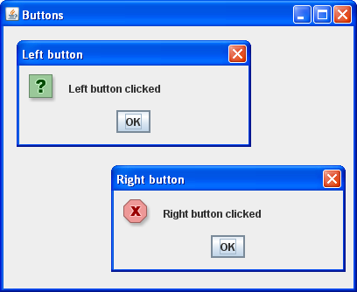

Paper Submiited By:
Name : Sanjay Nair
Email : sanjay_eishan@yahoo.com

