Sample Paper – 2011
Class – XII
Subject – INFORMATICS PRACTICES
MAX.MARKS: 30 TIME : 1:00 Hrs.
Note :
1. All questions are compulsory.
4. Answer the questions after carefully reading the text.
Q1. | Answer the following questions.
 | (a) What do you mean by lifetime of variable? How is a local variable different from other variable | 2
 | (b) What is syntax error in the context of a program? Give an example. | 2
 | (c) What are containers or container controls? | 2
 | (d) What is a list ? How is it different from combox? | 2
 | (e) Differentiate between Call by Value and Call by Reference. | 2
Q.2 | Read the following case study and answers the question that follows:
 | ABC Company has developed the following interface to enter and display data related to Income Tax of employees.  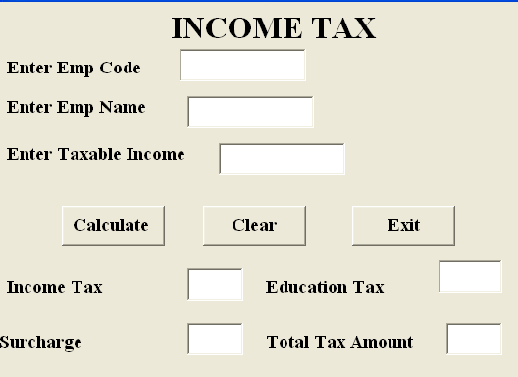  The Frame details of the above Frame are given in the following table:  Write the code to implement the following:  (a) When the Frame loads Text Fieldes for Income Tax, Education Tax, Surcharge and Total Tax Amount should be disabled. They should also be enabled when Calculate command button is clicked.  (b) Taxable income entered should be numeric data only.  (c) When the user clicks the clear command button, the Text Fieldes EmpCode and EmpName should be set to blank and other TextFields should be set to zero.  (d) When calculate command button is clicked, Income Tax, Education Tax, Surcharge and Total Tax (sum of Income Tax, Education Tax and Surcharge) is displayed in their respective Text Fieldes based on the following criterion: | 2  2  2  4
  Object Type | Object Name | Description
  Frame | FrmSalary | The main Frame object
  Text Field | TxtEmpCode | To enter code of the employee
   | TxtName | To enter name of the Employee
   | TxtIncome | To enter Taxable Income of the Employee
   | TxtTax | To display Income Tax
   | TxtEDTax | To display Education Tax
   | TxtSurcharge | To display Surcharge
   | TxtIncomeTax | To display total tax to be paid by the employee
  Command Buttons | CmdCalculate | To calculate Income Tax, Education Tax, Surcharge and Total Tax
   | CmdClaer | To clear all the values in the Text Fieldes
   | CmdExit | To close the application.
  Taxable Income | Income Tax | Education Tax | Surcharge
  Upto Rs. 1,00,000 | Nil | Nil | Nil
  Rs. 1,00,001 -Rs. 1,50,000 | 10% of the amount exceeding Rs. 1,00,000 | 2% of Taxable Income | Nil
  Rs. 1,50,001 – Rs.2,50,000 | Rs. 5000 + 20 % of the amount exceeding Rs. 150,000 | 2% of Taxable Income | Nil
  Rs. 2,50,001 and above | Rs. 2,50,000 + 30% of the amount exceeding Rs. 2,50,000 | 2% of Taxable Income | 1% of the Taxable Income
Q3. | Write the output that the following code segment will generate :  int i, j, k;  for(i=1; i<=4; ++i){  for(k=1,j=i;k<=i; k++, j+=2)  System.out.printl(“ “,+j);  System.out.println(“ “);  } | 2
Q.4 | (a) Rewrite the following code using switch  if(ch==’E’)  Eastern++;  if(ch==’W’)  Western++;  if(ch==’N’)  Northern++;  if(ch==’S’)  Southern++;  else  Unknown++; | 2
 | (b) Write a methode in Java that takes two integer arguments and returns power of it. Suppose x and y passing as an argument then it returns x to power y after calculation. | 2
 | (c) Write a program to check given no is prime number or not. The number is prime if number is divisible by 1 and itself. | 2
 | (d) Write a Method in Java to take a number as argument and print the product of its digit, as if a number entered is 234 then the program gives o/p as 24. | 2

Paper Submiited By:

Name: Dinesh Kumar Ram
Email: dinesh.rawani2005@gmail.com

