Sample Question Paper – 2011
Class – IX
Subject – Mathematics

Choose the correct answer and write in your answer sheet 8x1=8
Q.1 The degree of zero polynomial is
a. 0 b. 4 c. 1 d. not defined
Q.2 Which of the following is not polynomial
a. b.
c. d. all are polynomial
Q.3 Zero of polynomial 5x-125 is
a. -125 b. -25 c. 20 d. none
Q.4 is
a. positive integer b. irrational no
c. negative integer d. whole no
Q.5 Abscissa at y axis is
a. 1 b. any negative no c. o d. all are correct
Q.6 Two distinct lines :
a. always intersect b. either intersect n parallel
c. two common points d. always parallel
Q.7 AB CD is a rhombus with angle ABC = 60 the measure of angle ACD is
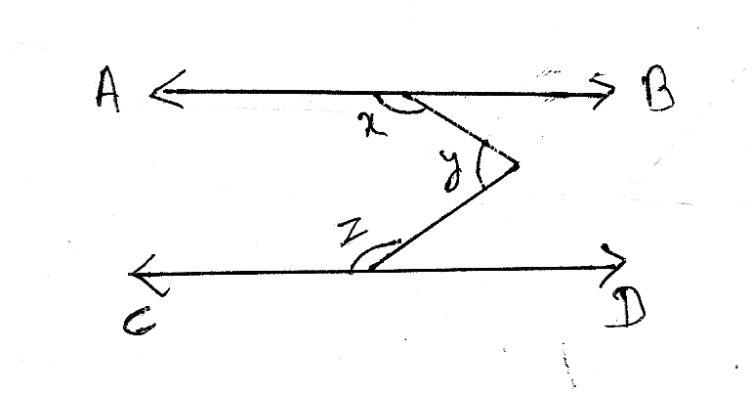
a. 30 b. 60 c. 120 d. 50
Q.8 The value of in fig is AB parallel CD
a. 180 b. 220
c. 360 d. can’t say
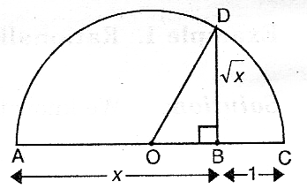
Q.9 The value of BD in a given fig is: 4x2=8
a. 2x b. x+1
c. d. x-1
Q.10 The value of is
a. b. c. 144 d. none

Q.11 Every real no. is zero of _____________ polynomial
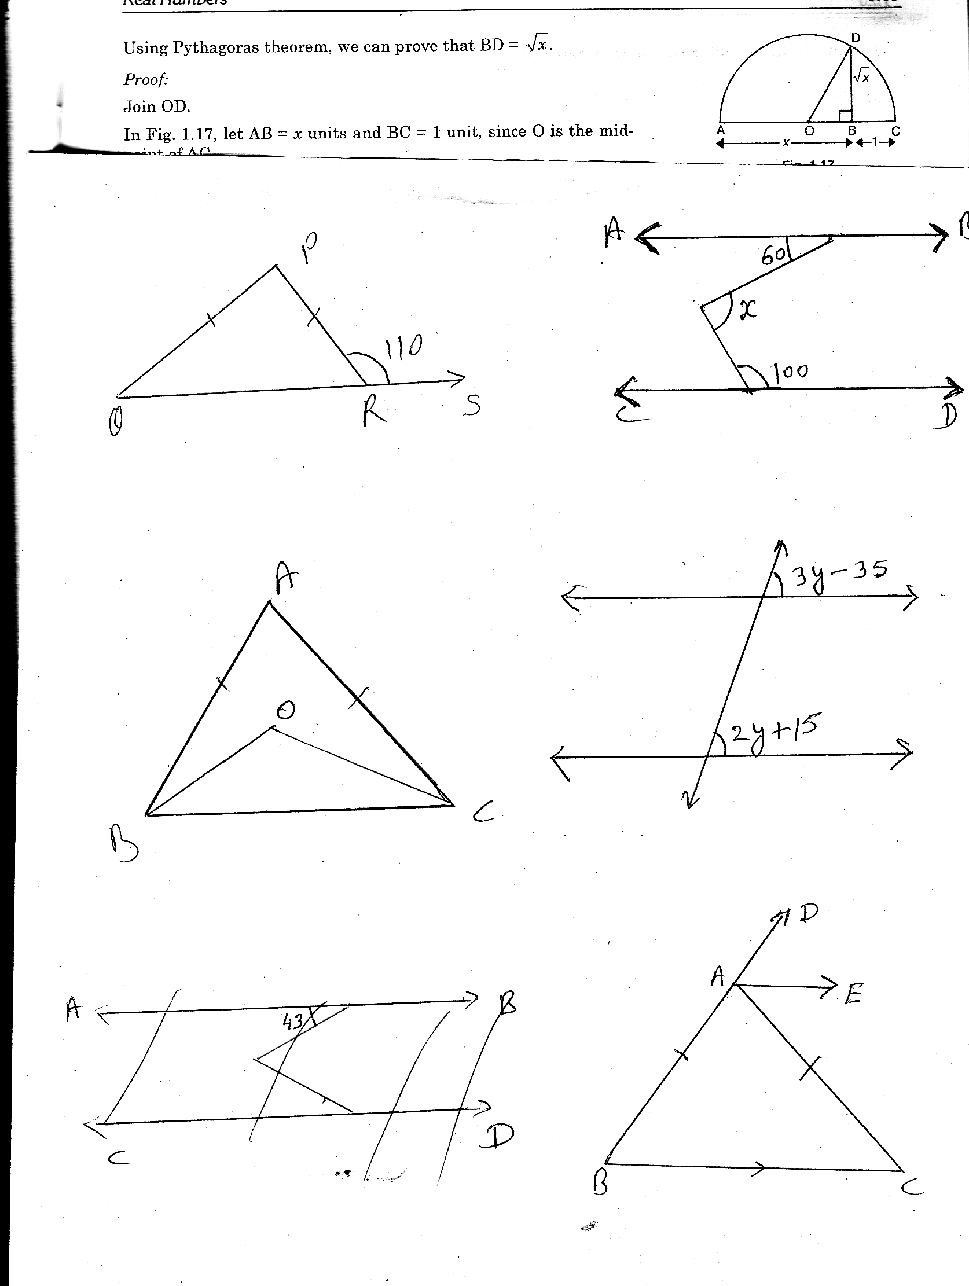
a. Zero b. Quadratic c. Constant d. none
Q.12 y3 + 729 is equal to
a. (y + 9)³ b. (y+9) (y²-9y+81)
c. (y-9) (y²-9y+16) d. (y+9) (y²+9y+81)
Q.13 In a given fig calculate the value of if PQ = PR. 7x2=14
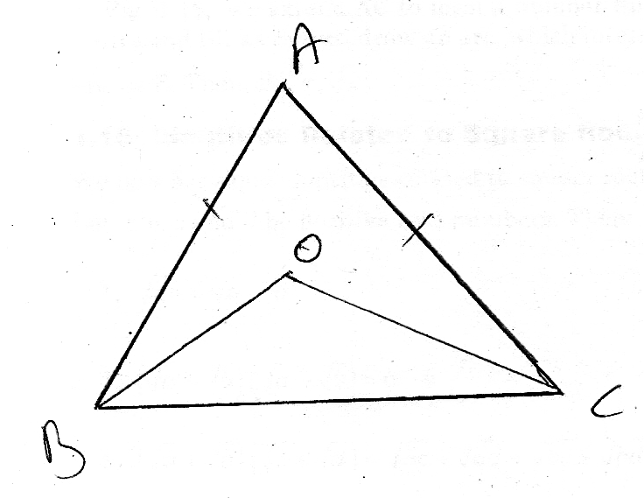
Q.14 Explain Euclid’s fifth postulate with diagram
Q.15 In a given fig AB = AC
and OB = OC prove that
Q.16 Represent on no line
Q.17 Factorize p³+27q³+125r³-45pqr
Q.18 Without actual calculation evaluate 35³+(-19)³+(-16)³ using suitable identity.
Q.19 Show that x-2 is a factor p(x) = x³-12x²+44x-48
Q.20 Find the area of rhombus where one side is 25m and on diagonal is 48m.
Find the length of another diagonal also. 10x3=30
Q.21 Simplify
Q.22 Factorize x³-2x²-5x+6
Q.23 Express as a rational no.
Q.24 If x+p is a factor of p(x) = x⁵-p²x³+2x+p+1 find the value of p
Q.25 If p = 1- Find
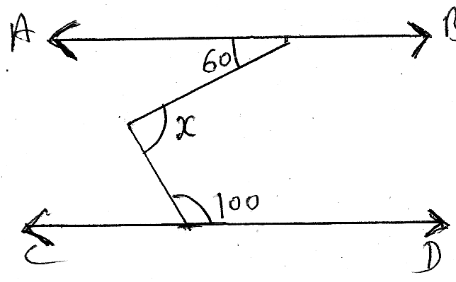
Q.26 Prove hat the two medians of equilateral triangle are equal.

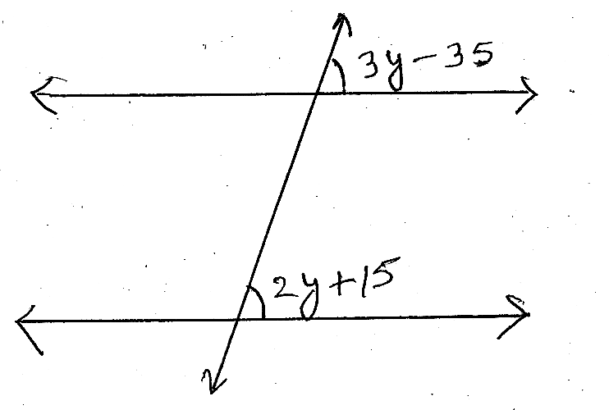
Q.27 In a given fig AB parallel CD determine .

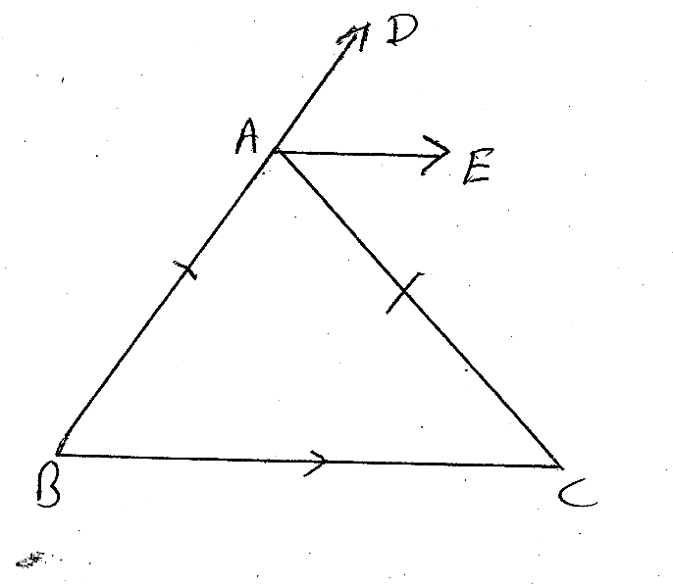
Q.28 For what values of y lines l and m are parallel in a given figure.

Q.29 In a given fig triangle ABC is an isosceles triangle in which
AB = AC and AE is a bisects of angle DAC prove that AE parallel BC.

Q.30 Prove the angle sum property of triangle. 5x4=20
Q.31 Plot the points A(4,3), B(4,-2), C(-3, -2) and D (3, 3) in Cartesian plan. Write the name of figure you obtained and find the area of fig.
Q.32 Simplify
Q.33 State RHS congruence rule using in a triangle ABC, D is a mid point of BC. The perpendiculars DE from D to AB and perpendicular DF from D to AC are equal. Prove that triangle BC is an isosceles triangle.
Q.34 Triangle ABC is an isosceles triangle AB=AC. Side BA is produced to D such that AD = AB. Prove that .

Pradeep Sahajwani Classes (BASE MAKER)

IX – X CBSE (Maths / Science)
S-20, Vivekanand Colony, Bhopal, Phone : 0755-2751377, 9893213700

