Sample Paper – 2011
Class – XII
Subject – Informatics Practices

- Answer the following questions:
(a) Define: i. IP address ii. Modem 2
(b) What is Denial-of-service? 2
(c) Write the purpose of the following: i. Infrared ii. Microwave 2
(d) The IIBM has to set up its new branch at Manipur for its office and web based activities. It has 4
Wings of buildings as shown in the diagram:

Wing Z
Wing Y

Wing X
Wing U

Center to center distances between various blocks

Wing X to Wing Z | 40m
Wing Z to Wing Y | 60m
Wing Y to Wing X | 135m
Wing Y to Wing U | 70m
Wing X to Wing U | 165m
Wing Z to Wing U | 80m

Number of Computers

Wing X | 50
Wing Z | 130
Wing Y | 40
Wing U | 15

(i) Suggest a most suitable cable layout of connections between the Wings and topology. 1
(ii) Suggest the most suitable place (i.e. Wing) to house the server of this organization with a suitable
reason, with justification. 1
(iii) Suggest the placement of the following devices with justification: 1
(a) Repeater (b) Hub/Switch
(iv) The organization is planning to link its head office situated in Delhi with the offices at Manipur.Suggest
an economic way to connect it; the company is ready to compromise on the speed of connectivity. Just
your answer. 1

- Answer the following questions:
(a) Expand the following terms (i) FSF (ii) W3C 2
(b) What are the following software used for (i) Linux (ii) Apache Server 2
(c) What is font ? Give two examples of font. 2
(d) Compare – phonetic text entry and keymap based text entry. 2
(e) What is Ogg Vorbis? 2

- Answer the following questions: 2×10
- What are iteration statements? Give examples of iteration statements which are supported by java.
- Explain conditional operator(?) of java with example.
- Explain the use of break statement with example.
- What is container control? Give example.
- Name two common properties which are available in both Text Area and Check Box of NetBaens IDE.
- What do mean by return statement of method ? Give example.
- What is Constructor? Explain with example.
- What are actual and formal parameter of java method? Explain with example.
- Define scope and lifetime of a variable.
- Write the purpose of void in a method definition.

- Answer the following questions:
- Rewrite the following code using IF statement without effecting the output of the code: 2
int a=1;
select case (a)
{
case 1:
System.out.print(“Sunday’);
break;
case 2 to 6:
System.out.print(“WeekDay’);
break;
case 7:
System.out.print(“Nearing Weekend’);
break;
default : System.out.print(“Wrong Number’);
}

- How many times are the following loop executed? 2
int num=5;
do
{
System.out.println(num+1);
num--;
} while (num !=0);

- Find out the errors, if any 2
int i=0;x=0;
while ( i < 10 )
{
if (i % 2 = 0)
{
x == x + i ;
System.out.print(x + 1);
}
i ++;
}

(d) Change the following code using For loop without effecting the out put: 2
int j=1,s=0;
while ( j < 10 ) {
System.out.print(j);
s = s + j;
j + =3;
}
System.out.print(s);

(e) Find the output of the following code: 2

double Number = 7583241;
int Firsr = 0, Second = 0, R;
do
{
R = Number % 10;
if ( R % 2 == 0 )
First += R;
else
Second += R;
Number = Number / 10;
} while (Number > 0);
System.out.print(First – Second );

5. Write a java method that takes an integer N as input parameter and displays the sum of all the digits in the number. 4
6. Design a class to represent a bank account. Include the following members: 6
Data Members:
    - Name of the depositor
    - Account number
    - Type of account(Savings/Current)
    - Balance amount in the account(Minimum balance is Rs.500.00)
Methods:
    - To read account number, Depositor name, Type of account
    - To deposit an amount ( Deposited amount should de added with it)
    - To withdraw an amount after checking balance(Minimum balance must be Rs.500.00)
    - To display the balance
( Assume necessary interface (with NetBeans IDE) for above program)

7. Read the following case study and answer the questions that follow:
Mr.Basu of MEGA MALL decided to computerize the billing department. The accounts manager at MEGA MALL is creating the billing software to generate the bill during the sale period. A new bill is generated for each item sold. The discount is given based on the item category. An additional discount of 5% is given to the MEGA MALL card holders. The following is data entry screen used at the MEGA MALL:

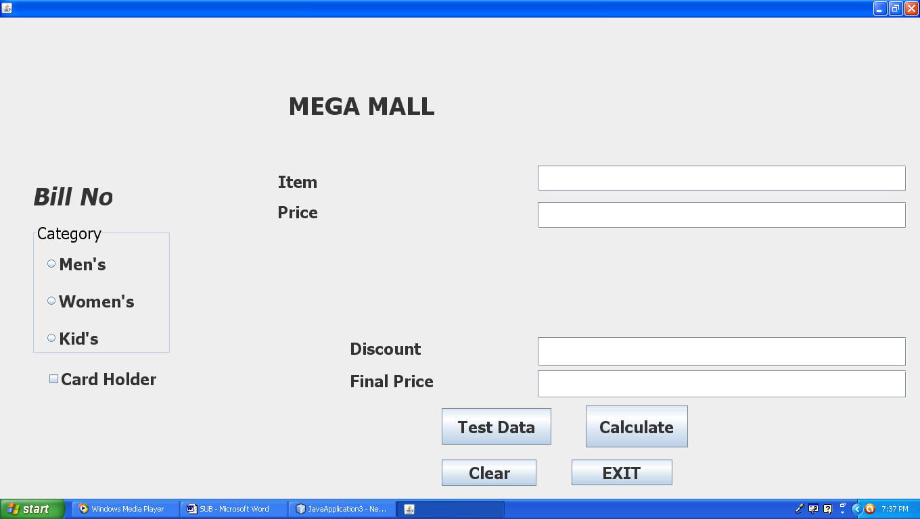

The list swing controls for the above is as follows:
Object Type | Object Name | Description
JFrame | MEGA MALL | The main form
JPanel | Category | To display different items category
JRadioButtons | MenRB | To select Men’s Category
JRadioButtons | WomenRB | To select Women’s Category
JRadioButtons | KidRB | To select Kid’s Category
JButtons | CalJB | To calculate discount and final price
JButtons | ClearJB | To clear all JTextFields
JButtons | ExitJB | To exit from the application
JButtons | TestJB | To test data validity
JTextFields | txtItem | To enter item name
JTextFields | txtPrice | To enter item price
JTextFields | txtDiscount | To display discount
JTextFields | txtFP | To final price
JCheckBox | CHCheck | To check card holders

(a) Write the code for the ClearJB Radio button to clear all the JTextFields. 2

(b) Write the code for the TestJB button to ensure that the user does not enter a negative or a zero value in txtItem JTextField.If a negative or a zero value is entered that txtItem should be made blank and a warning message should be displayed through a JOptionPalne. 3

(c) Write the code for the CalJB button to display the discount and final price in the txtDiscount and txtFP JTextFields respectively. Note that final price is calculated as (price – discount) and the discount is calculated based on the category and price according to the following table. Also remember to given an additional 5% discount for membership card holders i.e. if the CHCheck JCheckBox is checked. 4

Category | Price | Discount
Men’s | <10000 | 30%
Men’s | >=10000 | 50%
Women’s | <8000 | 40%
Women’s | >=8000 | 50%
Kid’s | <5000 | 20%
Kid’s | >=5000 | 30%

(d) Write the code for ExitJB button to exit from the application.

1

Paper Submitted By:

Name: Bhabajyoti S. Baruah
Email: bhabajyotisbaruah@yahoo.co.in

