Class – XII
INFORMATICS PRACTICES
SAMPLE PAPER

MARKS: 70 TIME: 3HR

  - What is Generalization and Specialization? 2
  - Explain the term Data Modeling. What does a UML mean? Give the name of two Available Object Modeling Technique 2
  - What is Software, Hardware and Firmware 2
  - Explain the term Data Dictionary, Data Warehousing, Data Mining, Meta Data 4.

  - Differentiate between the procedures and functions in VB? Give examples for each 4
  - Explain the recordset object of VB? What is its significance? 2
  - What are Arrays? How do we create an array whose lower and upper bounds are 5 and 25. 2
  - What are Date Arithmetic? Write a function that returns the number of days passed between two date parameters. 2.
- Consider the following interface designed for the homemakers to find out the requirement levels of the monthly ration. Assuming the names of items required write the code to implement the following:-
  - Items names and their monthly requirements should be read from respective arrays and added to the combo boxes cmbItemNames and cmbMonthlyRequirement when the form loads. 4
  - Whenever the user chooses an item, the corresponding requirement should be selected automatically. 2
  - Current stock is to be entered by user in the textbox txtCurrentStock. After the user has enetered the current stock, the text field txtCurrent should be set to the current requirement automatically, which the user is allowed to change. 2
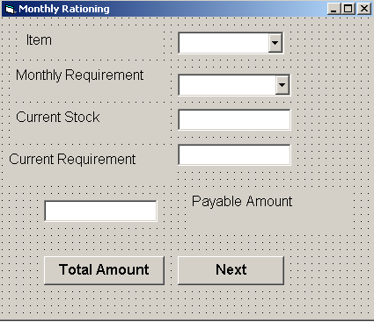
  - when, after enetring the cost, the user clicks the button TotalAmt, the payable amount should be displayed in the label LblPayable. 2.

- Consider the following table:-
Column | Data Type | Size | Constraints | Description
Empno | Number | 5 | Primary Key | Employee Number
EmpName | Varchar2 | 20
Designation | Varchar2 | 20
ManagerNo | Number | 5 |  | Manager Number
Salary | Number | 10,2
DA | Number | 8,2
  - Write an SQL statement to change the structure of the table such that the values in the field ManagerNo are restricted to valid employee number only. 2
  - Write a trigger that changes the value of DA to 10% of Salary before a fresh record is added to the employee table. 4
  - Write a PL/SQL procedure that takes Designation and Rasie_percent as parameters and changes the salary of all the employees with matching designations according to the parameters Raise_Percent. 4

- Find the errors in the following:- 4
  - Private Sub cmdDisplay() Dim c as integer c=1 While c<=10 Print iif(c mod 2,”$$$”,”??????????”) c=c+1 wend End Sub
  - Private Sub Command1_click() Dim a, b, c as Long a=5 b=6 c=add((a),(b)) Print “ The sum is : “&c End Sub Private Function add(x&, y as long) as long Print “the sum is “ &x+ y add=x+y+10 End Function
  - What is ADO control? TO which controls can we connect this? 2
  - Explain the Private Sub and Public Sub with example 4

  - What do you mean by alternate key and candidate key? 2
  - Differentiate between the CREATE TABLE and ALTER TABLE commands 2
  - What is the INSTEADOF trigger? Explain with example 4
  - Define Procedure? Give example 2

  - Write a Trigger that changes the value of the DA to 10% of Salary before a fresh record is added to the employee table. 4
  - Given table is

