Sample Paper – 2011
Class – XII
Subject – Informatics Practices
M. M.50

Q.1 Differentiate between <P> and <Br>. 2
Q2. How is HTML different from XML. 2
Q.3 What is the difference between for and while loop. 2

Q.4 Write HTML code to set background image and change color of a document . 2
Q.5 Write Java code to accept loan amount and time from the user .Calculate rate of
Interest based on the following criteria :
If loan >=10,000 rate is 2.2%
loan <10,000 rate is 2.4%
Also calculate the interest and display it in the textbox t4. 6
Q.6 . Define :
1) Relation 2) Candidate key 3) Transaction 3
Q.7 Name MYSQL command to : 2
1) display the structure of table
2) change the widthe of a column
Q.8 What are column constraints ? Explain any two with example. 3
Q.9 Give the value of x after executing following Java code. Also find how many times the
following loop will execute? : 3
int a=10;
int b=12;
int x=5;
int y=6;
while (a<=b)
{ if (a%2= =0)
x=x + y;
else
x=x-y;
a=a+1;
}
Q. 10 Write the equivalent switch case for the following code : 3
If (num1 = =1 )
jTextField1.setText(“Number is one”);
else If (num1 = =2 )
jTextField1.setText(“Number is two”);
else If (num1 = =3 )
jTextField1.setText(“Number is three”);
else
jTextField1.setText(“Number is more than three”);

Q.11 Rewrite the following Java code after underling the corrections made. 2
int x = = 0;
int n= Integer parseInt(Jlabel1.getText);
Q.12 Blue Valley Public School has computerised its registration for class XI students. Given below is the data entry form for same.
Answer the following questions using Java NetBeans IDE. 10
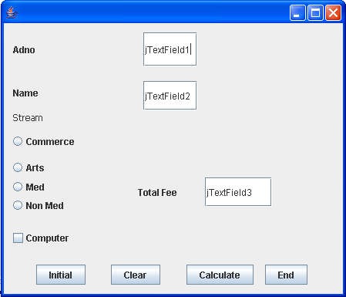
Control Name | Controls | Description
Text field | jTextField1 | To accept admission number of the student
Text field | jTextField2 | To accept Name of the student
Text field | jTextField3 | To display total fee of the student
Radio button | jOptArts | To choose Arts subject
Radio button | jOptMed | To choose Medical subject
Radio button | jOptNonMed | To choose Non Medical subject
CheckBox | jChkBox | To enter information whether the computer is opted
Button | jButton1 | To perform the different tasks which are mentioned below.
Button | jButton2 | To perform the different tasks which are mentioned below.
Button | jButton3 | To perform the different tasks which are mentioned below.
Button | jButton4 | To perform the different tasks which are mentioned below.

i) On clicking the initial button the jTextField1 and jTextField2 editable property should be set to false.
ii) On clicking the Calculate button the jTextField1 and jTextField2 editable property should be set to true. The Total Fee is calculated on the basis of the following criteria:
Stream Fee(Rs.)
Commerce 2500
Arts 2000
Medical 2900
Non Medical 2800
The Fee should be displayed in jTextField2.
iii) If the student has opted for Computers Rs. 200 will be added to the Total Fee. The Total Fee should be displayed in jTextField3.

iv) On Clicking the End button the application will be closed.

Q.13 Read the instructions given below and answer accordingly: (MySql) (10)
Note: Write MySql commands for (i) to (x) based on the following table.

SUPPLIERS
SCODE | SNAME | CITY | STATE | AMOUNT
 | RAJESH | BHIKHIWIND | PUNJAB | 5000
 | RAJAT | AMRITSAR | PUNJAB | 5400
 | PUNEET | SONIPAT | HARYANA | 6200
 | RACHNA | FARIDABAD | HARYANA | 8400
 | RAMAN | JAMUNANAGAR | HARYANA | 8940
 | PRAGTI | BISHRAMPUR | CHATTISGARH | 4800
 | PRAHALAD | BABRALA | UTTER PARDESH | 3000
 | KOCHER | LAKHERI | RAJASTHAN | 2500

- Show sname of suppliers whose name is starting with letter ‘P’
- Show sname, city of suppliers who belongs to ‘PUNJAB’
- Show sname of suppliers in descending order.
- Show sname, city of suppliers who belongs to either ‘HARYANA’ or ‘PUNJAB’
- Change the amount to 5000 where scode is 1008.
- Delete the suppliers from SUPPLIERS table who belongs to state ‘UTTER PARDESH’.
- Insert a new record in SUPPLIERS table with following description:
1009, ‘NEETA ARORA’,’DELHI’, ‘DELHI’,7500
viii) Add a new column (COMMISSION DECIMAL(7,2)) in the above table.
ix) Display total no. of records in table.
x) Display no. of employees in each city.

Paper Submitted by:
Name: Anubha
Email: anu_udit@rediffmail.com

