Sample Paper – 2011
Class – XII
Subject – Chemistry
Time: 3 hrs. .
General instructions:
All questions are compulsory.
Marks for each question are indicated against it.
Questions number 1to 8 are very short –answer questions, carrying 1 mark each. Answer these in one word or about one sentence each.
Questions number 9 to18 are short –answer questions, carrying 2 marks each. Answer these in about 30 words each.
Questions number19 to27 are short –answer questions, carrying 3 marks each. Answer these in about 40 words each.
Questions number28 to30 are long-answer questions of 5 marks each. Answer these in about 70 words each.
7 Use log tables, if necessary. Use of calculators is not permitted

Questions:

Q1. Which is a better nucleophilic addition reaction HCHO or C₆H₅CHO? (1)
Q2 .Why chloroform is needed to keep in brown colour bottle in dark. (1)
Q3 .How will you distinguish between CH₃COOH and 2-phenylethanal? (1)
Q4 .Write IUPAC name of the following compound:
CH₃COCOCH=CH-CONH-CH₃ (1)

Q5 .When uncalled egg is kept in common salt then what will happen (1)
Q6. Sodium chloride or calcium chloride is used to clear snow from the roads. Why? (1)
Q7 .What are solvate isomerim? (1)
Q8 .What are ambidentate nucleophile? (1)
Q9 (a) Write the mechanism of dehydration of alcohol. (2)
(b) Write Clemenson reduction. (1)
Q10 (a)Predict the the type of nucleophilic addition reaction when iso propyl bromide react with
KOH (aq) i.in the presence of Acetone ii.in the presence of Methanol (2)

Q11 Give reasons:
- Acid catalyzed dehydration of t-butanol is faster than that of n-butanol. ` (1)
ii.How you can distinguish between phenol and benzyl alcohol? (1)
Q12 How will you convert acetaldehyde into following compounds?
(i) Lactic acid (ii) but-2-enal (2)
Q13 (a) Arrange the following in increasing order of their basic strength: (1)
Methylamine, dimethylamine, N,N-dimethylamine,aniline (in aq medium)
(b) Distinguish between 1°,2°,3° amine and aniline. (1)
Q14 Answer the following:
- Although — NH2 group is an ortho and para directing group, nitration of aniline gives along with ortho and para, meta derivatives also. (1)
- Aniline does not undergo Friedel crafts reaction. (1)
Q15 Calculate the freezing point depressoion for 0.07 m aqeous solution of sodium sulphate ,if it is completely ionized in solution . if the freezing point of solution is -0.320 °C? (2)
(K_{f}=for water is 1.86°C)
Q16 .Show the octahedral spiliting of d subshell . How Δo is related with pairing energy . (2)
Q17 (a) Define the kohlrausch law. (1)
(b) Which will have greater molar conductivity? Solution containing 1 mol acetic acid in 200 ml or 1 mol of acitic acid in 500 ml. (1)
Q18.Calculate the Λ° for acetic acid .
if Λ°m of HCl,NaCl,CH₃COONa are 426,126,91 SCm²mol⁻¹ (2)
Q19 An organic compound (A) C₅H₁₁ Br on treatment with alcoholic caustic potash gives a hydrocarbon (B) C₇H₁₀. (B) on treatment with ozone and subsequent hydrolysis gives C and D.C does not give tollen’s reagent test ,both C&D gives idoform test. What are (A) ,(B),C and D. Explain reactions. (3)
Q20 .A.Write the chemical equations, when phenol react with Br_{2.} i. in the presence of CS₂ ii. in the presence of aq NaOH
B.When phenol react with Chloroform and NaOH. (3)
Q21 (a) An organic compound (A) having molecular formula C₃H₈O on treatment with Cu at 300⁰C gives (B). (B) does not reduce Tollen’s reagent but gives positive iodoform test. Write down the structures of A and B.(1)
(b) How will you convert?
(i) ethyl iodide to propanoic acid (ii) Propionic acid to acetic acid (2)

Q22(a) Assign a reason for each of the following statements:
- pKb of Alkyl amines are less than aryl amines.
- In aqueous solutions secondary Et₂NH₂>Et₃NH>EtNH₂. (2)
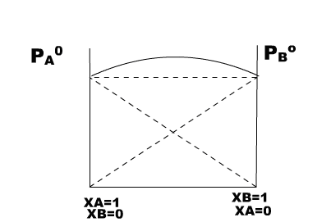
(b) Write one method used for the preparation of pure primary amines. (1)
Q23 Chloro acetic acid is a monoprotic acid and has Ka = 1.36 × 10–3. Calculate b. p. of 0.01 M aqueous soln ? (Kb = 0.51 k kg/mol) (3)
Q24 Answer the following questions: (3)
(a) What does the graph indicates?
(b) Give an example of such liquids, which results in the formation
of such graphs.
©Give reason for such behaviour.

Q25 (a) FeSO₄ solution mixed with NH₄(SO₄)₂solution in 1 : 1 molar ratio gives the test of Fe2+ ion butCuSO₄ solution mixed with aqueous ammonia in 1 : 4 molar ratio does not give the test of Cu²⁺ on. Explain why? (1)
(b) Explain crystal field theory on the basis of splitting in octahedral complexes. (2)
Q26 Write IUPAC names of the following coordination compounds:
- K₃[Cr(C₂O₄)₂] (ii) [Co(NH₃)₆]ClSO₄ (iii) [Co(en)₂(ONO)Cl]Cl (3)
Q27 Predict the direction in which the reaction will proceed if a cell is made by connecting silver electrode with mercury electrode.
E° = 0.80 V E° = 0.79 V

[Ag+] = 10–1 mol/l [Hg2+] = 10–3 mol/l
Also write cell representation. (3)
Q28 Explain why?
- Acetic acid is a stronger acid than ethyl alcohol.
- Trichloroacetic acid is a stronger acid than acetic acid.
- Formic acid shows reducing properties.
- Carboxylic acids with five or fewer carbon atoms are water soluble but, higher ones are insoluble.
- Acetic acid can be halogenated in the presence of phosphorous and chlorine but formic acid cannot be halogenated in the same way. (5)
OR
An organic compound (A) having molecular formula C₉H₁₀O forms an orange red precipitate (B) with , 2,4-DNP reagent. Compound (A) gives a yellow precipitate (C) when heated in the presence of iodine and NaOH along with a colourless compound (D). (A) does not reduce Tollen’s reagent or Fehling’s solution nor does it decolourises bromine water. On drastic oxidation of (A) with chromic acid, a carboxylic acid (E) of molecular formula (C₇H₆O₂) is formed. Deduce the structures of the organic compounds (A) to (E). (5)
Q29 Given below is the sketch of a plant for carrying out a process.

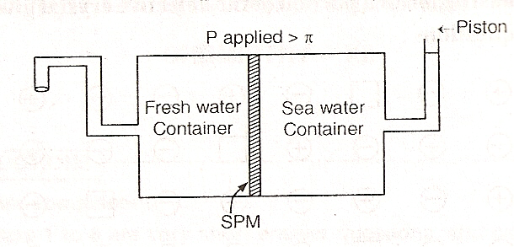

- Name the process occurring in the above plant.
- To which container does the net flow of solvent takes place?
- Name one SPM which can be used in this plant.
- Give one practical use of this plant.
- What will happen if the applied pressure is removed? (5)
OR
- What are azeotropes? What are their types? Give example in each case? (3)
- What is van’t Hoff factor? When it is used? (2)
Q30 (a) What are primary and secondary cells? Discuss Variation of molar conductivity with dilution. (4)
(b) What is abnormal molecular mass? (1)
OR
- What kind of complex should be formed in dry cell by NH₃. (5)
- How the corrosion is an electrochemical process ? give the reaction.
- During the silver plating on a metal plate having area 10 cm² in an electrolytic cell 15 A current is passed for one hour.What will be the thickness of silver plating if density of silver metal is 10.8 g/cm³ .

Paper Submitted by;
Omjeesingh
Phone no. 9859828945
omjeesingh@gmail.com

