Sample Paper – 2011
Class – XII
Subject – Mathematics
SECTION-A
- If A is a square matrix of order 3 such that =.
- If A = show that A - is a skew symmetric matrix.
- Write the value of 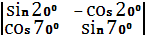.
- Find if y=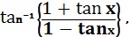x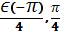 .
- At what point on the curve ,the tangents are parallel to y-axis.
- Evaluate 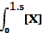dx (where).
- Write I.F. for - 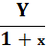 = (1+x).
- Find the projection of the vector i-j to the vector i+j
- If P(A) = , P(B)=0, then find P.
- If X has a Binomial distribution B=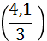 write P(X=1).
SECTION-B
- Show that the relation R onR defined as R = is reflexive and transitive but not symmetric. OR On R-a binary operation * defined by a*b =a+b-ab. Prove that * is commutative and associative . find identity element for * on R-
- Prove that 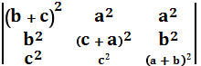 =2abc
- For what value of K the following is continous at x=0.
f (x)=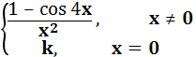.
OR If y=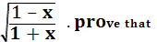 (1-) 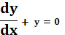.

- Verify the applicability of LMV Theorem for the following 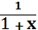 in
- Determine the interval ,where f(x)=, 0, is strictly increasing or strictly decreasing.
- Evaluate 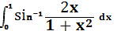 .
- Evaluate 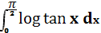.
- Evaluate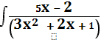 dx OR Find 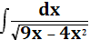 .
- Solve 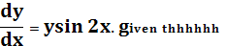hat y.
- For any vectors 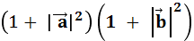 = . OR if the vector bisects the angle between the vector and the vector 3i+4j ,then find the unit vector in the direction of .
- A speaks truth in 60% of cases and B in 90% of cases .In what percentage of cases are they likely to contradict to each other in stating the same fact ? . OR Two cards are drawn without replacement from a well- shuffled pack of 52 cards . find the probability that one is spade and other is a queen of red colour
- Suppose X has a binomial distribution B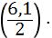 Show that X=3 is the most likely outcome. SECTION-C

- If A=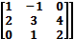 and B=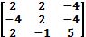 are two square matrices , find AB and hence solve the system of linear equation : x –y=3, 2x+ 3y +4z =17, y+2z =7. OR Obtain the inverse of the following matrix using elementary operation : A=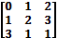

- Show that the height of the cone of maximum volume that can be inscribed in a sphere of radius 12 cm is 16cm.

- Find the area of the region OR Using the integration , find the area of ∆PQR where P is ,Q is and R is

- Solve :y
- Find the image of the point having position vector in the plane .

- A producer has 30 and 17 units of labour and capital respectively which he can use to produce two types of goods Xand Y .to produce one unit of X ,2 units of labour and 3 units of capital is required . similarly ,3 units of labour and 1 unit of capital is ree produquired to produce one unit of Y. If X and Y are priced at Rs 100 and Rs 120 per unit respectively ,how should the producer use his resources to maximize the total revenue ? solve the problem graphically.

29.Let X denote the number of hours you study during a randomly selected school days . the probability that X can take the values x ,has the following form ,where k is some unknown constant .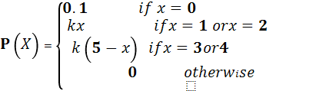

PAPER SUBMITTED BY:
Name : POONAM SINGH
Email : yashmragendra@gmail.com
Phone No. 07597453169

