Class – IX (2nd Term)
Subject – Mathematics
Time: 3 hours M.M: 80
General Instructions:
- All questions are compulsory.
- The question paper consists of 34 questions divided into four sections – A, B, C and D. Section A comprises of 10 questions of 1mark each, Section B comprises of 8 questions of 2 marks each, Section C comprises of 10 questions of 3 marks each and section D comprises of 6 questions of 4 marks each.
- Question numbers 1 to 10in section A are multiple choice question where you are to select one correct option out of the given options.
- There is no overall choice. However, internal choice has been provided in 1question of 2 marks, 3 questions of 3 marks each and 2 questions of 4 mark each. You have to attempt only one of the alternatives in all such question.
- Use of calculator is not permitted.

Section- A
1. Any angle in the semicircle is
(a) 90⁰ (b) 180⁰ (c) 270⁰ (d) 360⁰
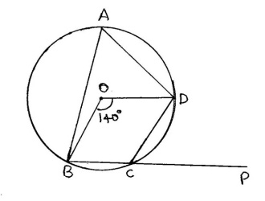
2 Curved surface Area of cone is
(a) Лr² (b) 2Лrl (c) 2Лrh (d) Лrl
3. CSA of solid hemisphere is
(a)2Лr² (b) 4Лrl (c) 3Лr² (d) Лrl
4. Median of 14, 15, 18,20,21,25 is
(a)18(b)19 (c) 20 (d) 21
5. Find angle ∠BCD
- 140⁰ (b) 110⁰ (c) 70⁰ (d) 60⁰
6. The mean of 16 numbers is 8. If 2 is added to every number, what will be the new mean.
(a) 14 (b) 12 (c) 10(d) 8
7. 1m³=? Liter
(a) 10 (b) 100 (c) 1000(d) 10000
8. In a cyclic quadrilateral sum of opposite angles are?
(a) 90⁰ (b) 180⁰ (c) 360⁰(d) None of these
9. Slant height of cone is equal to
(a) Лrl (b) r²+h² (c) r²-h² (d) √ r²+h²

10. Volume of cone = ...?.....Volume of cylinder
(a) 1/2 (b) 1/3 (c) 1/4 (d) 1/5

Section B

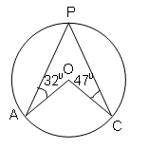
11. Find the median of 19, 25, 60, 49, 36, 31, 30, 32, and 56, if 25 is replaced by 52, what will be the new median

12. In the figure, O is the centre of the circle.
Calculate the magnitudes of ∠APC and ∠AOC.

¹³ A die is thrown 100 times, and the number of times each number turned up is recorded in the following table.
No. on the die | 1 2 3 4
Frequency | 15 55 16 14

Find the probability that the number turned up is a prime number.
- Find the volume of the sphere whose surface area is 154 sq. cm.
- The radius and height of a cone are in the ratio 4 : 3. The area of the base is 154 cm². Find the area of the curved surface.
- Construct a triangle ABC in which ∠B=75⁰, BC=5cm and AB =3cm

17. Find the value of a and b such that the following equations may have (3, -2) as a solution 5x + ay = 8; 7x+by = 4b

18 Find the value of k, if x=2,y=1 is a solution of the equation 2x+3y=k
OR
Draw the graph of the equation 2x + y = 4. From the graph, find the value of y when x = 2

Section C

- Write the four solutions for the equation 2x+y = 7
- A bag contains 4 red, 5 green and 3 blue marbles. A marble is selected at random from the bag. Calculate the probability of getting (a) a red ball (b) a blue ball (c) not a blue ball.
OR
Construct a triangle with base of length 5cm, sum of two sides 7.7cm and one of the angles of the base as 45⁰.

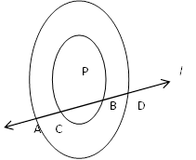
- In the figure, l is a line which intersects two concentric circles with centre P at points A,C, D and B, Prove that AC = DB

OR
P
R
T
O
S
Q
y⁰
y⁰
x⁰
In the figure, PT touches the circle whose Centre is
O at R. Diameter SQ when produced meets PT at P.
Given ∠SPR =x, ∠QRP=y, then show that x+2y = 90⁰.

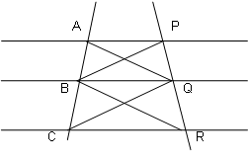
- In the following figure, AP||BQ||CR, Prove that ar(ΔAQC) = ar(ΔPBR)

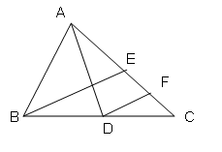
- Draw the graph of the equation 2x – 3y =5. From the graph, find the value of y when (i) x = 4 and (ii) x = 3

- In the figure, AD and BE are medians of a ΔABC and BE||DF.
Prove that CF = AC

- Here is a linier equation that converts Fahrenheit to Celsius:
F= ( ) C+32
- Draw the graph of the linier equation above using Celsius for x-axis and Fahrenheit for y-axis
- If the temperature is 30⁰ C, what is the temperature in Fahrenheit?

26 Find the missing frequency p for the following distribution whose mean is 7.68.
X | 3 | 5 | 7 | 9 | 11 | 13
F | 6 | 8 | 15 | p | 8 | 4

OR
The mean of 11 numbers is 35.If the mean of first 6 numbers is 32 and that of last 6 numbers is 37, find the sixth number

- ABCD is a quadrilateral. A line through D parallel to AC meets BC produced in P.
B
A
C
P
D
Prove that ar (ΔABP) = ar (quad ABCD)

28. Prove that the figure formed by joining the mid points of the pairs of consecutive sides of a rectangle is a rhombus
A
B
P
Q
C
D
R
S

Section D

29 The taxi fare in a city is as follows: For the first kilometer the fare is Rs 8 and for the subsequent distance.it is Rs 5 per km .Taking the distance covered as x km and total fare as Rs y, write a linear equation for this information and draw its graph.

30 Construct a triangle ABC, in which ∠A=30⁰, ∠B=90⁰ and AB+BC+AC=13 cm

31 2000 families with 3 children were selected at random and the following data is recorded
Girl child in family | 0 | 1 | 2 | 3
No. of families | 475 | 814 | 111 | 600
Find.
- probability of family having 0 girl
- probability of family having 1 girl
- probability of family having 2 girl
- probability of family having more than 1 girl
- probability of family at least 1 girl

32 Prove that the line segment joining the midpoint of the hypotenuse of a right angled triangle to the vertex of the right angle is half of the hypotenuse.
OR
Prove that the angle subtended by an arc at the centre is double the angle subtended by it at any point on remaining part of the circle. Using this prove that the angle subtended by a minor arc in the alternate segment is obtuse. .

33. A storage tank consists of a circular cylinder with a hemisphere adjoined on either end. If the external diameter of the cylinder is 1.4 m. and its length is 5m. What will be the cost of painting it on the outside at the rate of Rs.10 per square metre?
OR
A solid cube of side 24 cm is cut into 27 cubes of equal volume. What will be the side of the new cube?
34 Represent the following data by means of a frequency polygon and Histogram

Marks | 0-10 | 10-30 | 30-45 | 45-50 | 50-60
No. of students. | 8 | 20 | 18 | 10 | 6

