Guess Paper – 2011
Class – XII
Subject – Computer Science
Time: 3 Hrs. M.M. 70
General instructions:
- All questions are compulsory.
- Read all the questions carefully.
- Programming language C++.

Q.1(a) What do you mean by polymorphism? Explain with suitable example? [2]
(b) Name the header file associated with the following function: [1]
(i) randomize ( ) (ii) delay( )
(c) Find the output of the following program: [2]
#include<iostream.h>
#include <string.h>
#include <ctype.h>
void Convert (char Str[ ], int Len)
{
for (int Count =0; Count < Len; Count++)
{
if(isupper(Str[Count+]))
Str[Count] = tolower(Str[Count]);
else if (islower(Str[Count]))
Str[Count] = toupper(Str[Count]);
else if (isdigit(Str[Count]))
Str[Count] = Str[Count] + 1;
else Str[Count] = ‘*’;
}
}
void main ( )
{
char Text[] = “CBSE Exam 2005”;
int Size = strlen(Text);
Convert (Text, Size);
cout << Text << endl;
for(int C =0, R = Size -1; C< = Size/2; C++, R- - )
{
char Temp = Text[C];
Text[C] = Text[R];
Text[R] = Temp;
}
cout << Text <<endl;
}

(d) Rewrite the following program after removing all the syntax error(s), if any. [2]
include <iostream.h>
void main ( )
{
int P [ ] = {90, 10, 24, 15}; Q, Number = 4;
Q = 9;
for[ int I= Number -1; I > =0, I - -]
switch (I)
{
case 0:
case 3: cout >> P[I] *Q <<endl; break;
case 1:
case 2: cout << P[I] + Q;
}
}
(e) Write the output of the following program: [2]
#include <iostream.h>
int max (int &x, int &y, int &z)
{
if (x >y && y > z)
{
y ++;
z ++;
return x;
}
else
if (y >x)
return y;
else
return z;
}
void main ( )
{
int a = 10, b = 13, c = 8 ;
a = max (a, b, c);
cout << a << b << c << endl;
b = max (a, b, c);
cout << ++ a << ++ b << ++ c << endl;
c = max (a, b, c);
cout << a++ << ++b << ++c << endl;
}
(f) In the following program, if the value of N given by the user is 15, what maximum and minimum values the program could possible display? [2]
#include <iostream.h>
#include <stdlib.h>
void main ( )
{
int N, Guessme;
randomize( );
cin >> N;
Guessme = random(N) + 10;
cout << Guessme << endl;
}
Q.2(a) What do you understand by Copy Constructor? Explain with suitable example. [2]
(b) Answer the questions (i) and (ii) after going through the following class: [2]
class Travel
{
int days;
public:
Travel ( ) // Function 1
{
Days = 50; cout << “ Journey starts now” << endl;
}
void sightseeing( ) // Function 2
{
cout << “ Sightseeing in the journey starts” << endl;
}
Travel (int Duration) // Function 3
{
Days = Duration; cout << “ Journey starts now” << endl;
}
~ Travel ( ) // Function 4
{
cout << “ Happy journey” << endl;
}
};
- In Object Oriented Programming, what is Function 4 referred as and when does it get invoked/ called?
- In Object Oriented Programming, which concept is illustrated by Function 1 and Function 3 together? Write an example illustrating the calls for these functions.
(c) Define a class POWER in C++ with following description: [4]
Private Members:
MNO of type long (Meter Number)
Name of type string (Consumer’s Name)
Units of type long (Power Unit’s Consumed)
Charges of type float (Charges to be paid by Consumer)
A member function CALCCHARGE( ) to calculate Charges according to the following conditions:

Units Charges
Below 100 Units Rs. 2.00 per Unit
Below 200 Units and > = 100 Units Rs. 3.00 per Unit
> = 200 Units Rs. 5.00 per Unit
For Example:
If the Units are 132, Charges should be calculated as
Charges = 99 * 2 + (Units – 99 ) * 3;
If the Units are 392, Charges should be calculated as
Charges = 99 * 2 + 100 * 3 + (Units – 199) * 5;

Public Members
A Function Enterdata( ) to allow user to enter values for Mno, Name, Units & call the function CAlCCHARGES( ) to calculate the Charges.
A Function ShowBillI( ) to allow user to view the content of all the data members.
(d) Answer the questions (i) to (iv) based on the following code: [4]
class Car
{
char Model[10];
char Date_of_purchase[10];
char Company[20];
public( );
Car( );
void entercardetail( );
void showcardetail( );
};
class Accessories : public Car
{
protected:
char stereo_tape[30];
char sheet_cover[20];
public:
float Price;
Accessories( );
void enteraccessoriesdetails( );
void showaccessoriesdetails( );
};
class Dealer : public Accessories
{
int No_of_dealers;
char dealers_name[20];
int No_of_products;
public:
Dealer( );
void enterdetails( );
void showdetails( );
};
- How many bytes will be required by an object of class Car and an object of class Dealer.
- Write names of all the data members which are accessible from the objects of class Dealer.
- Write names of all the members accessible from member functions of class Accessories.
- Write names of all the member functions which are accessible from objects of class Dealer.
Q.3(a) Given two arrays a and b of sizes m and n respectively. Write a function mixab(int a[ ], int m, int b[ ], int m, int c[ ]); [3]
which takes two arrays and their sizes as arguments and creates an array c such that:
- all even nos. of array which are at even position are copied in c.
- after that all even nos. of b array which are at odd positions are copied in c.
- after that remaining elements of a are copied in c.
- after that remaining elements of b are copied in c.

(b) Each element of an array DATA[20][50] requires 4 bytes of storage. The base address of data is 2000. Determine the location of DATA[10][10] when the array is stored as : (a) row- major (b) column – major. [4]

(c) Define functions stackpush( ) to insert nodes and stackpop( ) to delete nodes, for a linked list implemented stack having the following structure for each node: [4]
struct node
{
char name[20];
int age;
node *LINK;
};
class stack
{
node *top;
public:
stack( ) { top = NULL; };
void stackpush( );
void stackpop( );
};
(d) Obtain the postfix notation for the following infix notation of expression showing the contents of the stack and postfix expression formed after step of conversion: [2]
A * B + (C – D / F)
(e) Write a function in C++ to print the sum of all the values which are divisible by 10 or 20 present in a two dimensional array passed as the argument to the function. [3]

Q.4(a) Observe the program segment given carefully, and answer the question that follows: [1]
class Joy
{
int Joy_id;
char Joy_name[20];
public :
// function to enter Joyians details
void enterdetails ( );
// function to display Joyians details
// function to return Joy_id
int AJoy_id( ) { return Joy_id; }
};
void Modify ( JOY NEW)
{
fstream File;
File.open (“JOY.DAT”, ios :: binary | ios :: in | ios :: out);
JOY OB;
int Recordsread = 0, Found = 0;
while (!Found && File.read (( char*) & OB, sizeof(OB)))
{
Recordsread++;
if(NEW.AJoy_id( ) = = OB.AJoy_id( ))
{
________________ // Missing Statement
File.write ((char * )&NEW.sizeof(NEW));
Found = 1;
}
else
File.write((char *)&OB, sizeof(OB));
}
if (!Found)
cout << “Record for modification does not exist”;
File.close ( );
}
If the function Modify( ) is supposed to modify a record in file JOY.DAT with the values of JOY NEW passed to its argument, write the appropriate statement for Missing Statement using seekp( ) and seekg( ), whichever needed, in the above code that would write the modified record at its proper place.

(b) Assuming that a text file Joy.TXT contains some text written into it, write a function named vowelwords, that reads the file JOY.TXT and creates a new file names JOY1.TXT which start with a lowercase vowel (i.e., with ‘a’, ‘e’, ‘o’, ‘i', ‘u’). For example if the file JOY.TXT contains [2]
Carry umbrella and overcoat when it rains
Then the file JOY1.TXT shall contain
Umbrella and overcoat it

(c) Write a function in C++ to search for a room-number (RoomNo) given by the user in an already existing binary is called ‘Hospital.Dat”. Also display complete record of the room-no searched if found otherwise display a message ‘not found”. [3]
class Hospital
{
int Room_No;
char Patient_N [30];
public :
void Input( ) { gets (Patient_N); cin >> Room_No; }
void Output( )
{
cout << “Patient’s Name:” << Patient_N << endl;
cout << ‘Room Number:” << Room_No << endl;
}
int Getroom( ) { return Room_No; }
};

Q.5 (a) What is key in RDBMS? What are different key constraints? [2]
(b) Write SQL commands for the statements (i) to (iv) and give outputs for SQL queries (v) to (viii): on the basis of the table [6]
BOOKS
Book_Id | Book_Name | Author_name | Publishers | Price | Type | Quantity
F0001 | The Tears | William Hopkins | First Publ. | 750 | Fiction | 10
F0002 | Thunderbolt | Anna Roberts | First Publ. | 700 | Fiction | 5
T0001 | MyFirstC++ | Brain & Brooke | EPB | 250 | Text | 10
T0002 | C++Brain | A.W. Rossaine | TDH | 325 | Text | 5
C0001 | Fast Cook | Lata Kapoor | EPB | 350 | Cookery | 8

ISSUED
Book_Id | Quantity_Issued
F0001 | 3
T0001 | 1
C0001 | 5

- To show Book name, Author name and Price of books of EPB Publishers.
- To list the names from books of Fiction type.
- To display the names and price of the books in descending order of their price.
- To increase the price of all books of First Publ. Publishers by 50.
- To display the Book_Id, Book_Name and Quantity_Issued for all books which have been issued. (The query will require contents from both the tables.)
- To insert a new row in the table Issued having the following data:
‘F0002’, 4.
- Give the output:
(i) SELECT COUNT (DISTINCT Publishers) FROM Books;
(ii) SELECT SUM(Price) FROM Books WHERE Quantity > 5;
(iii) SELECT Book_Name, Author_Name FROM Books WHERE Price <500;
(iv) SELECT COUNT (*) FROM Books;

Q.6(a) State and Verify Absorption law in Boolean Algebra. [2]
(b) Write the equivalent Boolean expression for the following Logic Circuit: [2]
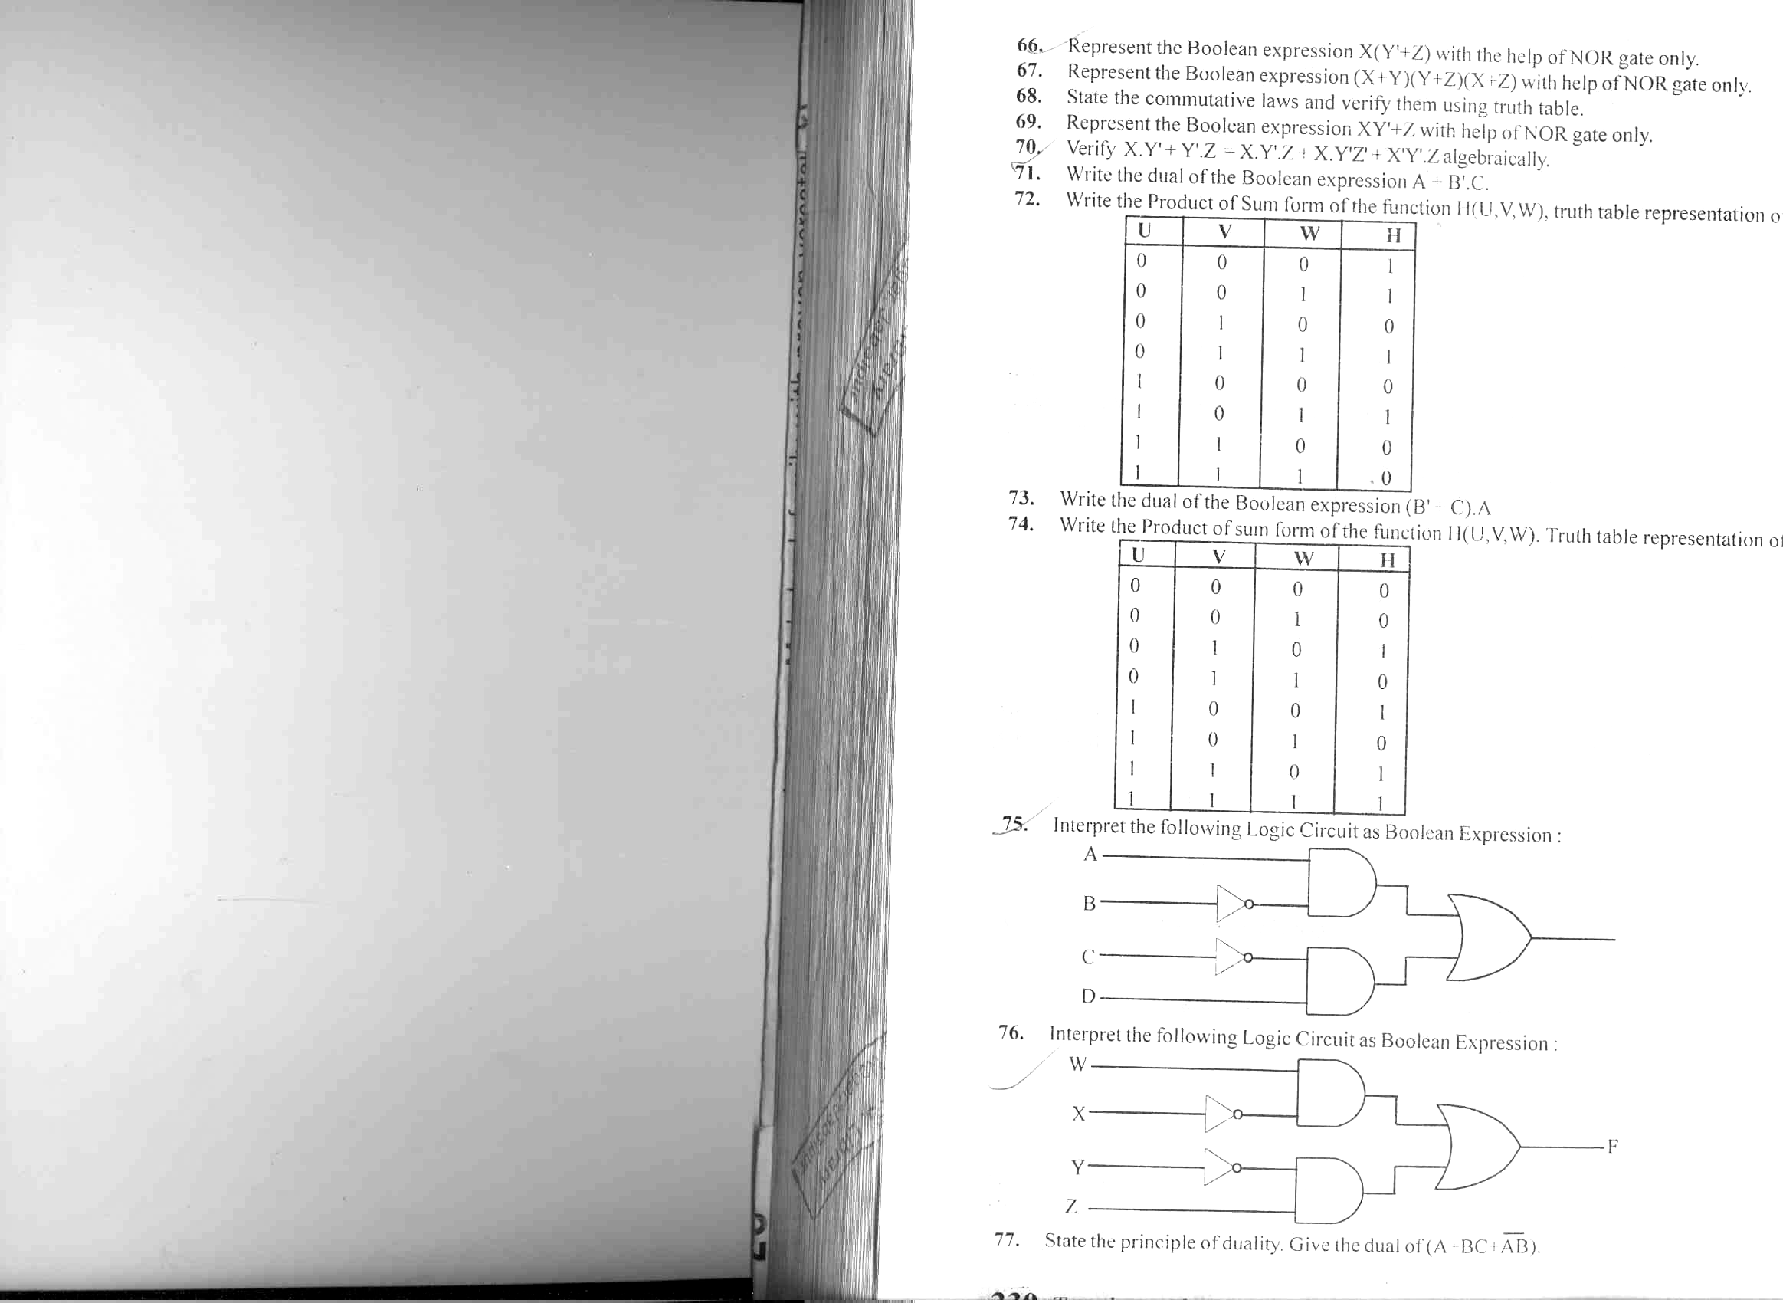
(c) A combinational circuit has 3 inputs and one output. Output is 1 if: [1]
(i) All the inputs are equal to 1.
(ii) None of the inputs are equal to 1.
(iii) An odd number of inputs are equal to 1.
- Obtain the truth table
- Find the simplified output function in POS form
(d) Reduce the following Boolean expression using K- Map: [3]
F (A, B, C, D) = ∑ (0, 1, 2, 3, 4, 5, 10, 11, 15)

Q.7(a) What is the difference between Absolute and Relative URL? [1]
(b) Expand the following terminologies: [1]
(i) CSMA / CD
(ii) WLL
(c) What is the utility of Cyber law? [1]
(d) What do you understand by the terms Gopher and Archie. [1]
(e) The Reliance Info Sys has set up its Branch at Srinager for its office and web based activities. It has 4 Zone of buildings as shown in the diagram:

Zone Z
Zone Y

Zone X
Zone U

Center to center distances various blocks
Zone X to Zone Z | 40 m
Zone Z to Zone Y | 60 m
Zone Y to Zone X | 135 m
Zone Y to Zone U | 70 m
Zone X to Zone U | 165 m
Zone Z to Zone U | 80 m

Number of Computers
Zone X | 50
Zone Z | 130
Zone Y | 40
Zone U | 15

(e1) Suggest a most suitable cable layout of connections between the Zones and topology. [1]
(e2) Suggest the most suitable place (i.e., Zone) to house the server of this organization with a suitable reason, with justification. [1]
(e3) Suggest the placement of the following devices with justification: [1]
- Repeater (2) Hub / Switch
(e4) The organization id planning to link its head office situated in Mumbai at the offices at Srinager. Suggest an economic way to connect it; the company is ready to compromise on the speed of connectivity. Justify your answer. [1]

SHEKHAR TRIPATHI
PGT Comp Sc
DELHI PUBLIC SCHOOL
BULANDSHAHR UP
E Mail : etwshekhar@gmail.com

