Sample Paper – 2011
Class – IX
Subject – Mathematics

Time: 3 hours M.M: 80
General Instructions:
- All questions are compulsory.
- The question paper consists of 34 questions divided into four sections – A, B, C and D. Section A comprises of 10 questions of 1mark each, Section B comprises of 8 questions of 2 marks each, Section C comprises of 10 questions of 3 marks each and section D comprises of 6 questions of 4 marks each.
- Question numbers 1 to 10in section A are multiple choice question where you are to select one correct option out of the given options.
- There is no overall choice. However, internal choice has been provided in 1question of 2 marks, 3 questions of 3 marks each and 2 questions of 4 mark each. You have to attempt only one of the alternatives in all such question.
- Use of calculator is not permitted.

Section- A
1. Any angle in the semicircle is
(a) 90⁰ (b) 180⁰ (c) 270⁰ (d) 360⁰
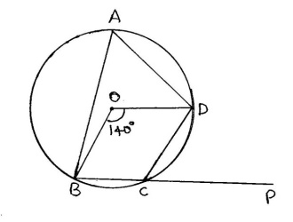
2 Curved surface Area of Cylinder is
(a) Лr² (b) 2Лrl (c) 2Лrh (d) Лrl
3. CSA of Dome (hemisphere) is
(a)2Лr² (b) 4Лrl (c) 3Лr² (d) Лrl
4. Mode of 14, 15, 15, 18, 20, 21,21,21,25 is
(a)18(b)19 (c) 20 (d) 21
5. Find angle ∠DCP
(a)140⁰ (b) 110⁰ (c) 70⁰ (d) 60⁰
6. The mean of 16 numbers is 8. If 2 is multiply to every number, what will be the new mean.
(a) 16 (b) 12 (c) 10(d) 8
7. 1m³ =……..cm³
(a) 1000(b) 10000 (c) 100000(d) 1000000
8. In a cyclic quadrilateral one angle is 60⁰ then exterior angle will be
(a) 102⁰ (b) 60⁰ (c) 360⁰(d) None of these
9. Height of cone is equal to
(a) Лrl (b) r²+h² (c) √l²-r² (d) √ r²+h²
10. Surface area of circle = ...?..... Surface area of Sphere
(a) 1/2 (b) 1/3 (c) 1/4 (d) 1/5

Section B

11. Find the mean of 13, 19, 25, 60, 49, 36, 30, 32, and 56? And if 13 is misread by 31, what will be the new mean?

12. . ABCD is a cyclic quadrilateral in which AC and BD are diagonals. If And . Find.
- . Two coins are tossed simultaneously. The outcomes of getting tails are recorded.
Number of tails | 0 | 1 | 2
Outcomes | 22 | 16 | 12
Calculate the probability of getting (a) exactly 1 tail (b) no tail (c) at least 1 tail

- How many liters of milk can a hemispherical bowl of diameter 10.5cm hold?
- A conical tent is 10m high and the radius of its base is 24m. Find area of cloth used.
OR
Construct a triangle in which QR = 5cm, ﮮ Q= 75⁰ and PR-PQ= 2.5 cm.

17. Find the value of a and b such that the following equations may have (5, -3) as a solution 5x + ay = -2 7x+by = 4b

18 If the point (3, 4) lies on the graph of the equation 3y=ax+7, find the value of a?
OR
Draw the graph of the equation 2x + y = 4. From the graph

Section C

- Write the four solutions for the equation x=4y-1
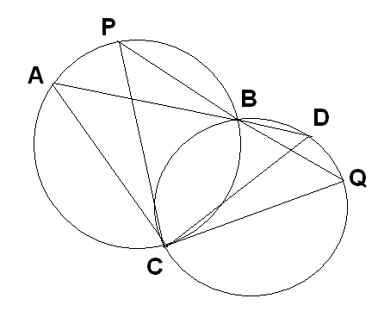

- Two circles intersect at two points B and C. Through B, two line segments ABD and PBQ are drawn to intersect the circles at A, D and P, Q respectively (See fig.). Prove that ےACP =ے QCD

OR

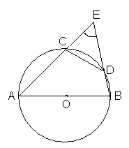
In Fig. , AB is a diameter of the circle; CD is a chord equal to the radius of the circle. AC and BD when extended intersect at a point E, Prove that ے AEB = 60⁰

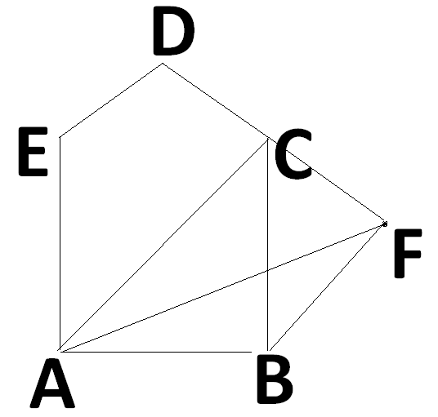
- ABCDE is a pentagon .and a line through B parallel to AC meets DC produced at F. Show that (i) ar(ACB)=ar(ACF) (ii) ar(AEDF)=ar(ABCDE)

- Draw the graph of the equation 2x – 3y =5. From the graph, find the value of x when (i) y = 1 and (ii) y = 3

- If E, F, G, H are respectively the mid points of the sides of a parallelogram ABCD, show that ar (EFGH) = ½ (ABCD).

- Here is a linier equation that converts Fahrenheit to Celsius:
F= ( ) C+32
- if the temperature is 950F, What is the temperature in Celsius?
- Is there temperature which is numerically the same in both Fahrenheit and Celsius if yes, find it?

- A bag contains 5 red, 3 green and 2 blue marbles. A marble is selected at random from the bag. Calculate the probability of getting (a) a red ball (b) a blue ball (c) not a blue ball.
OR
Construct a triangle with base of length 5cm, sum of two sides 7.7cm and one of the angles of the base as 75⁰.
26 If the mean of the following distribution is 21, find the value of x
x: 10 15 20 25 30
f: 6 10 x 10 8
OR
If the mean of five observations, x, x+2, x+4, x+6 and x+8 is 11. Find the mean of the first three observations

27 ABCD is a trapezium with AB || DC. A line parallel to AC intersects AB at X and BC at Y. Prove that ar (ADX) =ar (ACY).
28. Show that the bisectors of angles of a parallelogram form a rectangle.
Section D
29 If the work done by a body on application of a constant force is directly proportional to the distance travelled by the body. Express this in the form of an equation into variable and draw the graph of the same by taking the constant force as 5 units. Also from the graph the work done when the distance travelled by the body is
(1). 2 units (2). 0 units
30 Construct a triangle XYZ, in which ∠X=45⁰, ∠Y=60⁰ and XY+YZ+ZX=10.5cm

31 2000 families with 3 children were selected at random and the following data is recorded
Girl child in family | 0 | 1 | 2 | 3
No. of families | 475 | 814 | 111 | 600
Find.
- probability of family having 0 girl
- probability of family having 1 girl
- probability of family having 2 girl
- probability of family having more than 1 girl
- probability of family at least 1 girl

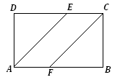
32 . In figure ABCD is a parallelogram and E, F is the midpoints of sides AB and CD respectively. Show that quadrilateral AECF is a parallelogram.
OR
A circular park of radius 20m is situated in a colony. Three boys Ankur, Syed and David are sitting at equal distance on its boundary each having a toy telephone in his hands to talk each other, Find the length of the string of each phone.

33. It costs Rs.2200 to paint the inner curved surface of a cylindrical vessel 10m deep. If the cost of painting is at the rate or Rs. 20 per m²,find the
(i) Inner curved surface area of the vessel.
(ii) Radius of the base.
(iii) Capacity of the vessel.
OR
In fig., you see the frame of a lampshade. It is to be covered with a decorative cloth. The frame has a base diameter of 20 cm and height 30 cm. A margin of 2.5cm is to be given for folding it over the top and bottom of the frame. Find how much cloth is required for covering the lampshade.

34 A random survey of the number of children of various age groups playing in a park are found as follows:
Age in years | No.of children
1-2 | 5
2-3 | 3
3-5 | 6
5-7 | 12
7-10 | 9
10-15 | 10
15-17 | 4

Draw a histogram to represent the above data.

Paper Submitted by

Name: M. VATS
Email: ms_knl@yahoo.co.in
Phone No. 9416201546

