Sample Paper – 2011
Class – XII
Subject - Informatics Practices
Time : 1 hour M.M : 25

- Richika is a programmer at Alpha Builders. To calculate wages to be paid to labourers she has developed the following GUI in Netbeans [8]
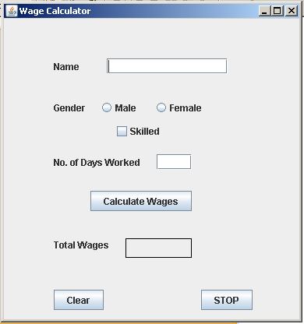
Male and Female labourers are respectively paid at the rate of Rs. 140/- per day and Rs. 160/- per day. Skilled labourers are paid extra at the rate of Rs. 50/- per day.
- What should be done so that only one of the radio button (Male and Female) can be selected at a time ?
- Write code to do the following :
  - Calculate and display the Total wages in corresponding label when the “Calculate Wages” button is pressed.
  - Clear the Name and No. of days worked text fields.
  - Close the application when the “STOP” button in pressed.
(Assume any suitable names for various controls on the form)
- Rewrite the following program code using for loop: [2]
int i = 1, sum = 0;
while (i < 10)
{ sum += i;
i += 2;
}

- Rakesh works in organization. He wishes to create controls on a form for the following functions. Choose appropriate controls from Text box, Label, Option button, Check box, List box, Combo box, Command button, and write in the third column. [2]

S.No | Control used to | Control
1 | Enter last name
2 | Enter Gender
3 | Choose City from a list of cities
4 | Submit form

- The following code has some error(s). Rewrite the correct code underlining all the corrections made. [2]
int p, q =15;
p= = q + 15;
if (p= =q)
{ jTextField1.setText(“p and q are unequal”);
jTextField2.setText(“they are not equal”); break;
}

- Consider the table Projects given below. Write commands in SQL for i) to iv) and output for v) to viii
PROJECTS [8]
ID | ProjName | Projsize | StartDate | EndDate | Cost
1 | Payroll-MMS | Medium | 2006-03-17 | 2006-09-16 | 60000
2 | Payroll-ITC | Large | 2008-02-12 | 2008-01-11 | 500000
3 | IDMgmt-LITL | Large | 2008-06-13 | 2009-05-21 | 300000
4 | Recruit-LITL | Medium | 2008-03-18 | 2008-06-01 | 50000
5 | IDMgmt-MTC | Small | 2007-01-15 | 2007-01-29 | 20000
6 | Recruit-ITC | Medium | 2007-03-01 | 2007-06-28 | 50000

- To display all information about projects of Medium ProjSize.
- To list the ProjSize of projects whose ProjName ends with LITL.
- To list ID, name, size and cost of all the projects in descending order of StartDate.
- To count the number of projects of cost less than 100000.
- SELECT sum(Cost) FROM projects.
- SELECT DISTINCT(Projsize) FROM projects.
- SELECT MAX(Cost) FROM projects.
- SELECT AVG(Salary) FROM projects group by ProjSize.
6 Consider the table DOCTORS and PATIENTS given below. [3]
DOCTORS
DocID | DocName | Department | OPD_Days
101 | M. Pandey | ENT | TTS
102 | G.P. Gupta | Paed | MWF
201 | C.K. Sharma | Ortho | MWF

PATIENTS
PatNo | PatName | Department | DocID
1 | Neeraj | ENT | 101
2 | Mohit | Ortho | 201
3 | Ragini | ENT | 101
4 | Mohit | Paed | 102
5 | Nandini | Ortho | 201
With reference to these tables, write commands in SQL for (i) and (ii) and output for (iii) below.
- Display the PatNo, PatName, and corresponding DocName for each patient.
- Display the list of all patients whose OPD_days are MWF.
- Select OPD_Days, Count(*)
From Doctors, Patients
Where Patients.Department = Doctors.Department
Group by OPD_Days
DELHI PUBLIC SCHOOL, RAIPUR
Paper Sumitted By:
Name Manoj John
Email write2manojjohn@yahoo.com
Phone No. 9826183138

