Guess Paper – 2011
Class – XI
Subject – Informatics Practices
Set A
Q1. Answer the following questions:
- What are the differences between hardware, software and firmware?
- What is the difference between an interpreter and a compiler?
- What do you understand by a message and an event?
- Write all Operator Names in Java with short description?
- What is meant by implicit and explicit type conversion?
- What is Selection Statement? Describe each statement with syntax?
- What are iteration statements? Name the iteration statements provided by java?
- Write Name the component classes of Swing API for the following components-
- frame (ii) button
(i)What is the difference between a text field and a password field when both obtain
text from user ?
(j)What is Focus? When do FOCUS_GAINED AND FOCUS_LOST occur?
(k)What is a list ? How is it different from combo box?
(l) What is return statement describe with example ?
(m) Which keyword retains duplicate output rows in a query result?
(n) What is Alter Statement? Describe with example?

Section b
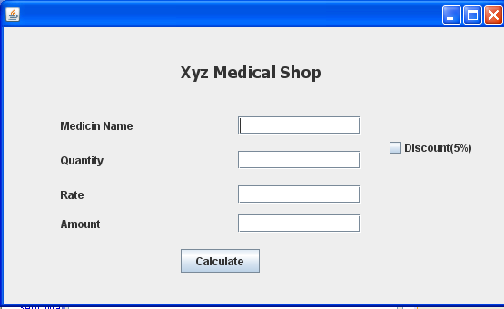
Develop an Application in javanetbeans for calculating Amount (5)

Develop an Application in javanetbeans (5)
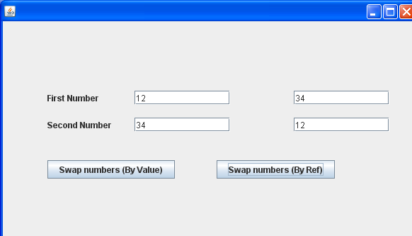

Give the output of the following code: (2)
int m=100;
while(m>0)
{
if (m<10)
break;
m=m-10;
}
System.out.println(“m is “+m);
Give the output of the following code: (2)
int f =1,i=2;
while (++i <5)
f *=i;
System.out.println(f);
Rewrite following while loop into a for loop (2)
int stripes =0;
while(stripes<=13)
if(stripes%2==2)
{
System.out.println(“colour code red”);
}
else
{
System.out.println(“colour code blue”);
}
System.out.println(“new stripe”);
stripes =stripes +1;
}
Rewrite following for loop into a while loop (2)
int sum=0;
for(int i =1;i<=5;++i)
{
sum=sum+c;
}
Find the errors, if any.. (2)
int m=1;
int n=0;
for(; m+n <19;++n)
System.out.println(“Hello \n”);
m=m+10;
Q. 6(a) Create table Customer as per following Table Instance Chart. (2)
Column Name | Cust_id | Cust_Name | Cust_Address1 | Cust_Address2 | PinCode | Cust_Phone
Data Type | Number | Varchar | Varchar | Varchar | Number | Varchar
Length | 7 | 30 | 20 | 30 | 6 | 10

(b) Create table Employee as per following Table Instance Chart. (2)
Column Name | Id | First_Name | Last_Name | Dept_Id
Data Type | Number | Varchar | Varchar | Number
Length | 8 | 25 | 25 | 8
(c) Insert all those records of table Accounts into table pending where amt_outstanding is more than 10000. (2)
(d) Use the following in a query (2)
(a) CONCAT (b)ROUND
(e)Write Elements of MYSQL.
Q7 (a).Explain the alter command in MYSQL. (2x5)
(b) Differentiate between
(i) TRUNCATE COMMAND (ii)DROP DATABASE
(c) Increase salary of employee records by 10%
(d)What is Describe commands?
(e)Write the constraints name with their uses ?

Paper Submitted by
Name devendra sharma
Email devendramgps@gmail.com
Phone No. 9425646162

