HALF YEARLY EXAMINATION (2006 – 07)
GUESS PAPER PHYSICS
CLASS - XII
M M :70 Time : 3 h

General Instructions:
- All questions are compulsory.
- There is no overall choice. However, an internal choice has been provided in one question of two marks, one question of three marks and one question of five marks. You have to attempt only one of the choices in such questions.
- Question numbers 1 to 5 are very short answer questions, carrying one mark each.
- Question numbers 6 to 12 are short answer questions, carrying two marks each.
- Question numbers 13 to 24 are short answer questions, carrying three marks each.
- Question number 25 to 27 are long answer questions, carrying 5 marks each
- Use of calculators is not permitted. However, you may use log tables if necessary.
- You may use the following values of physical constants wherever necessary :
c = 3 x 10 ⁸ ms ^{–1}
h = 6.6 x 10 ^{–34} Js
e = 1.6 x 10 ^{–19} C
μ ₀ = 4π x 10 ^{–7} T m A⁻¹

1. What is the geometrical shape of the wave front in each of the following cases:
(a) light diverging from a point source.
(b) light emerging out of a convex lens when a point source is placed at its
focus. 1

2. What is the de- Broglie wavelength of a 3 kg object moving with a speed of
2 ms ⁻¹? 1
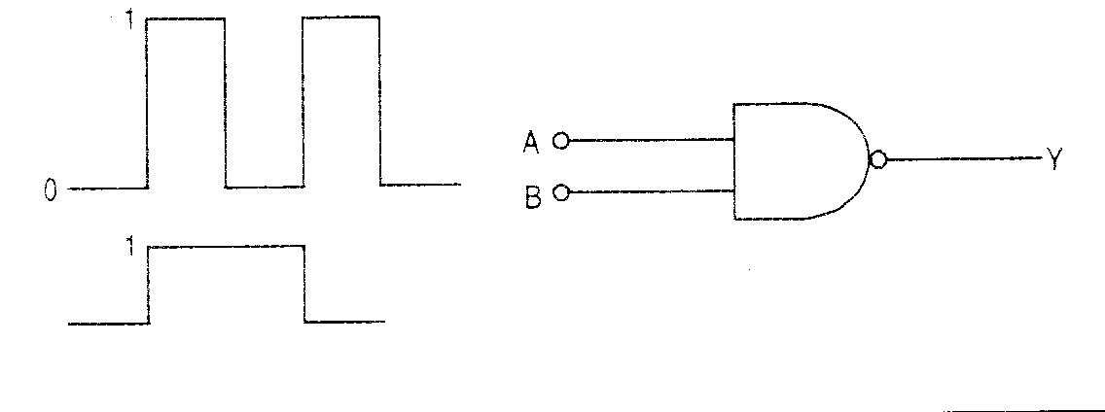
3. Draw the output waveform for the gate shown below:1

4. Why ground wave propagation is not suitable for high frequencies? 1

5. Find the capacitance of the capacitor that would have a reactance of 100 ohm when used with an ac source of frequency of 5/ π Hz. 1

6. Force of attraction between two point charges placed at a distance d apart in a
medium is F. What should the distance in the same medium so that the force of
attraction between them is F / 3? 2

7. Define the tem Self Induction. Give its unit. 1
Write an expression for the energy stored in an inductor when a steady current is passed through it. Is this energy electric or magnetic? 1

8. What is meant by coherent sources of light ?
Can two identical independent sodium lamps act as coherent sources? Give reason for your answer. 2

9. Two heaters are marked 200 V, 300 W and 200 V, 600 W. If the heaters are combined in series and the combination is connected to a 200 V dc supply, which heater will produce more heat? 2

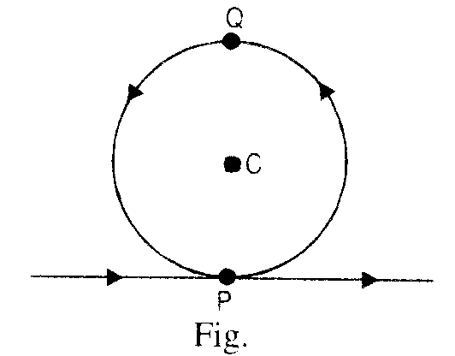
10. A charged particle having charge q is moving with a speed v along x axis. It enters a region of space where an electric field along y axis and a magnetic field are both present. The particle, on emerging from this region, is observed to be moving along x axis only. Obtain an expression for the magnitude of in terms of v and E and give its direction.
OR

A long wire is bent into the shape as shown in the figure. A current is passed through it, calculate the magnetic field at the centre C.. 2
11. Draw a diffraction pattern due to a single slit illuminated by a monochromatic source of light.
Light of wavelength 500 nm, falls from a distant source on a slit 0.50mm wide. Find the distance between the two darks bands, on either side of the central bright band, on the diffraction pattern observed on a screen placed 2 m from the slit. 2

12. Distinguish between n and p type of semiconductors on the basis of the energy band diagram. 2

13. Explain briefly the elements required to specify the Earth’s magnetic field at a given place. 3

14. Draw labeled diagram of a co-axial cable. Mention (i) one advantage of this cable over a two wire transmission line. (ii) the reason for there being an upper limit of frequency up to which a co-axial cable can be effectively used. 3

15. A 4 μF capacitor is charged by a 200 V supply. It is then disconnected from the supply and is reconnected to another uncharged 2 μF capacitor. What is the potential difference across the combination?
How much electrostatic energy is lost in the form of heat and electromagnetic radiation? 3

16. With an unknown resistance in the left gap and a resistance of 8 ohm in the right gap, null point is obtained on the meter bridge wire. On putting another 8 ohm resistor in parallel with the 8 ohm resistor in the right gap, the null point is found to shift by 15 cm. Find the value of X from these observations. 3

17. State the Faraday’s laws of electrolysis. Define Faraday constant.
How would you test the accuracy of a given ammeter by using Faraday’s first law?
3
18. State the Ampere’s Circuital Law and hence use it to calculate the magnetic field intensity inside a current carrying toroidal solenoid. 3

19. Identify the constituent radiations of the electromagnetic spectrum which :
(a) is used for studying mineral samples,
(b) is used to produced nuclear reactions and
(c) produces intense heating effect.
Mention one more application for each of these radiations. 3

20. Obtain the Einstein’s photoelectric equation. Explain how it enables us to understand:
(a) the linear dependence of the maximum kinetic energy of the emitted photoelectrons, on the frequency of incident radiations.
(b) existence of a threshold frequency for a given photoemitter. 3

21. Obtain the binding energy of a nitrogen nucleus ( ) from the following data :
m_{H} is the mass of a proton, m_{n} is the mass of a neutron & m_{N} is mass of nitrogen nuclei.

OR

Draw the general shape of the plot of binding energy per nucleon versus the mass number for different nuclei. Hence explain why we must expect a release of nuclear energy during the process of nuclear fission and fusion? 3

22. (a) Define the activity of a radioactive nucleus and state its SI unit.
(b) Two radioactive nuclei X and Y initially contain equal number of atoms. Their half life is 1hour and 2 hours respectively. Calculate the ratio of their rates of disintegration after two hours. 3

23. (a) Distinguish between FAX and e-mail. 1
(b) A microwave telephone link operating at the central frequency of 10 GHz has been established. If 2% of this is available for microwave communication channel, then how many telephone channels can be simultaneously granted if each telephone is allotted a bandwidth of 8 kHz? 2

24. Use the Gauss’s Law to calculate the electric field intensity due to a charged spherical shell at a point (a) inside the surface, (b) just on the surface & (c) outside the surface. 3

25. A circuit containing an 80 mH inductor and a 60 μF capacitor in series is connected to a 230V, 50 Hz supply. The resistance of the circuit is negligible.
(a) Obtain the rms current in the circuit. 2
(b) Obtain the rms values of the potential drops across each element. 2
(c) What is the average power transferred to the inductor ? ½
(d) What is the average power absorbed by the circuit ? ½

26. Draw a ray diagram to show the formation of image of a point object placed in rarer medium of refractive index μ₁, on the principle axis of a convex spherical refracting surface of radius of curvature R and refractive index μ₂ . 1
Derive the relation , u and v have the usual meaning. 2
A converging lens of focal length 50 cm is placed coaxially in contact with another lens of unknown focal length. If the combination behaves like a diverging lens of focal length 50 cm, find the power and the nature of the second lens. 2

OR

Draw a ray diagram to show the formation of image of a distant object by an astronomical telescope in the normal adjustment . 1
Obtain the expression for magnifying power. 2
Define the resolving power of a telescope. How would it change with the increase of (a) aperture of the objective &
(b) wavelength of light? 2

27. With the help of a circuit diagram explain the working of a npn transistor as an amplifier. 3
A transistor has a current gain of 50. In a common emitter amplifier circuit, the collector resistance is chosen as 5 kΩ and the input resistance is 1kΩ. Calculate the output voltage if the input voltage is 1.01V. 2

