Guess Paper – 2011
Class – XII
Subject – Mathematics
ANSWERS
- A= 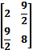 2. 3.
4. Fof (n) = {3-(f (n) ³)} ³, = {3-(3-n ³)^{1/3}*³}³, = {3-3+x³}^{1/3}, = x
5. For increasing f¹ (n) >0 => a (1+com)>0 => a>o
6. F (n) = sine⁵x, f (-n) = {sine (-n)} ⁵ = -sine⁵ n f (n) is an odd function => 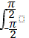 sin⁵ x dx =0.
7. dy/dn +i/x log x * y = 2/x p=1/ x log x if = e ^{p dx} =e ^{log (log x)} = log x
8. Find a vector in the direction of vector = - that has magnitude
8. Ans. 8 =8 =8 (i-2j /√5) = 8 (1/√5 I – 2/√5 j)
9. Here p=1/3, q= 2/3, n=4 p(x=1) = 4_{c1} p¹ q³ =32/81
10. P = prob. that event does not occur = 1- 0.4 = 0.6. Therefore, prob. that event will not happen at least once = 1- 0.6 * 0.6 * 0.6 = 0.784.

SECTION B
11. Solve tan⁻¹ (n-1) + tan⁻¹n + tan⁻¹ (n+ 1) =tan⁻¹ 3x. tan⁻¹ (n-1) + tan⁻¹ (n+ 1) = tan⁻¹3n - tan⁻¹n
tan⁻¹ (2x/1-(n²-1) = tan⁻¹ 1+3x² => x² = ± ½, 0
12. Let A= B= and C= find a matrix D such that CD-AB=0 Ans. Let D = 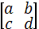 then CD-AB=0 put D in it then 2a+5c=3, 3a+8c- 43=0, 2b+5d =0, 3b+8d- 22=0 D = 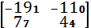
13. dy/dx = 1/tan (). Sec² ().1/2 = cot (). Sec² ().1/2 = 1/2sin () cos (). = 1/sin² (). = ¹/sin (). = 1/ cosx =secx
14. f(x) =x +1/x = x² +1 / x, (1) f (x) is a rational function such that Dr. ≠0 for any value in (1, 3) it is cont. (2) f¹ (n) = 1-1/n² exists in (1,3) so f is differential (1, 3) hence by Lagrange’s mean value thermo, there exist a point C such that f1(C)= f(b) –f(a)/b-a = f(3) –f(1)/3-1 1-1/c² = 2/3 => c=± √3 c= √3 E{1, 3} Hence Lagrange’s mean value thermo verified
15. L.H.L = = 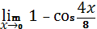x² = sin² 2x/8x² = (sin 2x/2x)² * ½ =1 RHS /8x² =1 = LHL = f (0) since f is cont. at x=0 1=1=k
16. I = 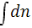 / l + √ using property 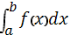 = 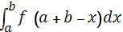 = 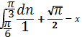 =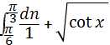 = 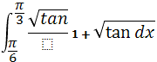------- (1) given 1= 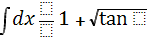-------------- (2) adding (1) and (2) we get 2± = 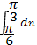 =
(or)
I = 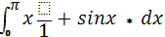
= 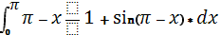 by using property 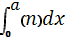 = 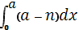
I + 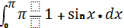 - 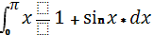
_{17) Evaluate}
I = let x – 4x = t
I = 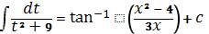
18) ( (or)
) = - + 5 = 0 (given)
() (-) = -15
=
- (++) => +.+.
+ (+)+) + (+)=0
= 9 + 16 + 25 =50
=
19. 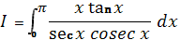
= 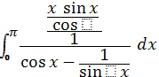 = 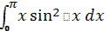 ----- (i)
= 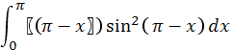
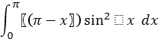 ----------- (ii)
Adding (i) and (ii) we get 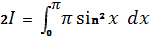
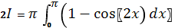
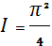

20) = 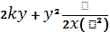 (homogeneous equation)
Put y = vx , dy/dx = v + x dv/dx.
= integrating both sides
-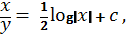 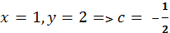
Required solution log )
(Or) 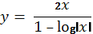
21. Let E₁ and E₂ be the events of selecting the bags.
P (E₁) = P (E₂) = .
Let A be an event of getting one white ball.
P (A/E₁) = P (A/E₂) = P (E₁/A)?
By using Bayes’ theorem find P (E₁/A) = .
22A. When X= 0 , P(X) = 5/6. 5/6 = 25/36.
X= 1 , P(X) = 1/6. 5/6 + 5/6 . 1/6 = 10/ 36.
X=2 , P(X) = 1/6.1/6 = 1/36.
X 0 1 2
P(X) 25/36 10/36 1/36 is the prob. Distn.
Mean = p_{i}x_{i} = 1/3,
Variance = Σ (µ - X)².p_{i} = 5/18.
(23ANS) Now system of equation x + 2y + z = 4 , -x + y + z = 0 , x – 3y + z = 2
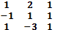 = A X B => X = A⁻¹B
= 1/10 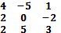 =
Therefore, X = 9/5, Y = 2/5 , Z = 7/5.
24A. given 2x = y = z or x/1= y/2 = z \2 and passing through the point P (3, 4, 5) so, (x-3)/1 = (y-4)/2 = ( z -5)/2 = k
Then any point on the line is given by A =- ( k+3, 2k+4, 2k+5), it also lies on the plane x + y + z = 2 by substituting the point we get k = -2 ie. A(1,0,1) then by using distance formula PA = 6 units.
25A. y=3/4x² 1 is upward having vertex at o(0,0) & y-axis as axis
Y=3/2x+6 2
Intersection point of curve & line
C=(-2,3) , d(4,12)
(by solving 1 and 2)
Required area = area CEFDC – area CODFEC
= 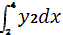 - 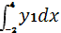 = 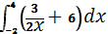 - 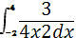
=27 square units
(OR)
X2/a2+y2/b2=1 1 => y=b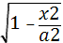
x/a + y/b =1 2 => y=b(1-x/a)point of intersection of 1 and 2 are (0,b) , (a,0)
required area = area OACBO – area of triangle OAB
= 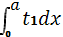 - 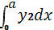
= 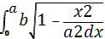 - 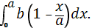
=ab(∏-2)/4, sq.units.
26A. I = 3x-2/(x+1)² (x+3) = A/x+1 + B/ (x+1)² + C/ x+3
= A(x+1)(x+3) + B(x+3) + C(x+1).
Putting x = -1, B = -5/2.
X= -3, then C = -11/4.
On comparing coefficients of x² we get A = 11/4
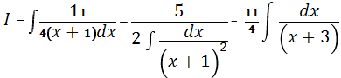 = log 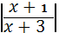+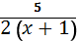 +c
Type equation here. (27ANS) x + y = 8 , x = 5 , y = 5, x + y = 4 Is CEPQFD
Value of z = x – 7y + 190.
At C = 194
E =195
P = 174
Q = 158
The min values is 158 at X = 3 , Y = 5 at Q
(28 ANS) a, b, c are drs of the normal to the required plane.
If passing through (0, 1, 0 ) its equation given by
a(x-0) + b(y-1) + c(2-0) = 0
ax + b (y-1)+cz = 0 -① also passes through (3, 4, 1)
- 3a +3b + c = 0 -②
Plane ① parallel to the line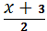 = =
- 2a + 7b = 5c = 0 -③
On solving ② & ③ 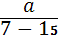 = 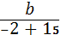 = 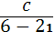 = k
- A = -8k, b = 13k, c=-15k. putting the values
In ① we get required plane equation 8x – 13y + 15z + 13 = 0
(or) A
A(1,3,4) in equation B(X,Y,Z) in the plane 2x – y + z +3 = 0.
N lies on the plane (midpoint of AB)
drs of AB are (x, -1) , (y,-3) , (2,-4)
drs Normal plane (2,-1,1).
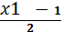 = 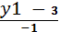 = 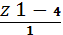 =
X = 2 k +1 , y = -k +3, z = k +4
B (2 k+ 1, - k+ 3 , k + 4).
Coordinates of N = ( k+ 1, 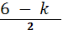 , 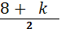 ) , N lies on the plane
2x – y + z + 3 = 0 => = -2 , B (-3 , 5 , 2)
(29 ANS) One line is = =
x₁ = 3 , y₁ = 8 , z₁ = 3 . a₁= 3 , b₁ = -1 , c₁ = 1
And ( x_{2,} y₂ ,z₂ ) = (-3 , 7, 6)
(a₂ , b₂ , c₂ ) = (-3 , 2 , 4)

= x₂ – x₁ y_{2 –} y₁ z₂ – z₁ = 270
a₁ b₁ c₁
a₂ b₂ c₂

d=√ (b₁c₂ – b₂c₁)² + (c₁a₂ – c₂a₁)² + (a₁b₂ – a₂b₁) = 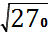 SD = = 3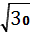 units

Prepared by:
Name kalavathi gupta potnuru
Email kalavathigupta@gmail.com

