Guess Paper – 2011
Class – XII
Subject – Mathematics
INVERSE TRIGONOMETRIC FUNCTIONS
- Find the principal value of each following:
- 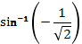

- Find the value of
- 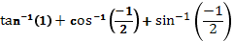
- )
- 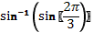
- 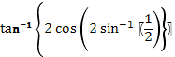

- Evaluate:
- 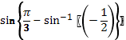

- Prove that:
- 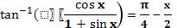
- 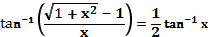
- 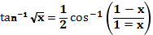
- Solve:- Find the value of x

Prepared by:

Name Abhishek singhal
Email abhishek1990000@gmail.com

