Sample Paper – 2011
Class – IX
Subject –Science
Physics & Chemistry
Time :- 2 hrs M.M.-60
Q.1 Why do we hear sound of approaching aeroplane before it reaches us? (1x3)
Q.2 If an electric bulb of 60w lighted for 10 hrs. How much is the electric energy consumed in joules?
Q.3 How many electrons are present in P^{3-?}
Q.4 The speed of an arrow shooted from the bow is square root of its Kinetic Energy. What is the mass of an arrow? (2x7)
Q.5 A girl vibrates her scale 20 cycles per minute. What is the time period of wave?
Q.6 What should be angle between force and displacement to get (a) Maximum Work (b) Minimum Work
Q.7 What is the meaning of “ECHOLOCATION” give example?
Q.8 State Atomicity and polyatomic ion in one sentence with example?
Q.9 An element X form its oxide X₂O₃ what will be formula of its phosphate?
Q.10 How many atoms are present in 0.024 g of Ca atom?
Q.11 If a source of sound produces 10 crests and 10 troughs in 2 sec. then calculate the frequency of the wave. (3x7)
Q.12 Explain the transformation of energy in hydroelectric power plant?
Q.13 A bag of wheat weighs 50 kg, find the height to which it should be raised so that Potential Energy is 5000 J (g: 10ms⁻²)?
Q.14 Tortoise A argue with argue with tortoise B according to A we weigh lens in water than Air but B oppose it. Who is correct A or B and which principal use by correct one?
Q.15 Which one has greater mass 0.1 mole of CO₂ or 0.2 mole of NH₃?
Q.16 An element X of electronic configuration 2,4 react with Y of which ion is Y²⁻ form compound which is responsible for pollution of environment. Identify X,Y, compound formed and calculate the molecular mass of compound.
Q.17 How and related to each other and why ? If abundance of and is 90% & 10% respectively then calculate the average atomic mass of Z?
(5x2)
Q.18 (a) Calculate the power of pump which raises 50 kg of water through a height of 25 m in 5 sec.
(b) Derive Kinetic energy formula, using the formula find the ratio of KE of two objects of masses 4 m, m with velocities v,2v respectively.
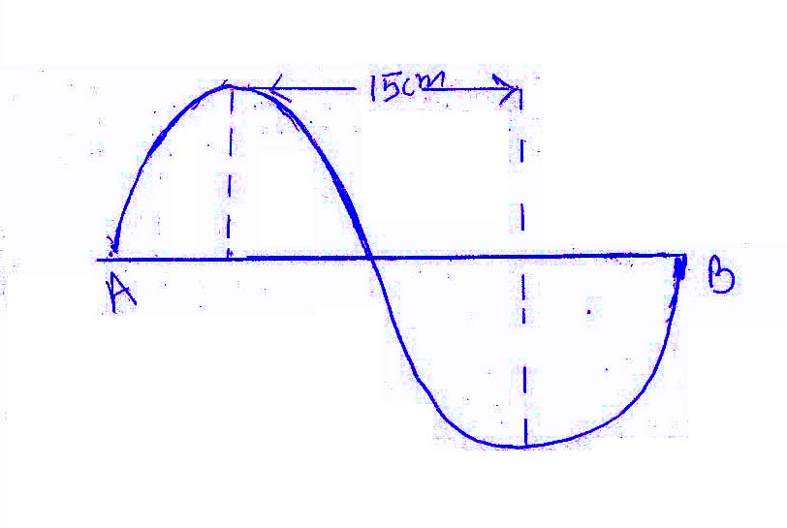
(c) According to given diagram if 20 such ripples produced per second then calculate (i) frequency (ii) wave length (iii) wave velocity.

Q.19 (i) Discuss the Rutherford’s model of an Atom with keeping following points in mind-
(a) Diagram (b) Observations (c) Conclusions.
Write also major drawback of Rutherford’s model of an atom and how the drawbacks was rectified?
- The mass of an atom X is 2.0x10⁻²³ g Calculate the approx atomic mass of X and what could be X.
MCQ (Chose the correct the answer & write in your Ans. sheet) (1x12)

Q.20 Cricket match held in Sydney between India and Australia. One person who is sitting in stadium at 200 m from commentary Box and his friend is watching the live telecast on T.V. set sitting in front of it in Bhopal, then the person who hear the commentary first.
(a) Person sitting in Bhopal.
(b) Person sitting in Stadium.
(c) Both will hear at a time.
(d) Can not said.
Q.21 A man standing between two parallel cliffs and fires a gun and hears two successive echoes after 4 second and 6 second the distance between the cliffs is (Speed of sound 330 ms⁻¹)
(a) 1600 m (b) 1650 cm (c) 1650 m (d)1590 m
Q.22 Some astronauts from India and Russia went at moon for some research work. The sound of explosion will reach the earth.
(a) After 8 hrs. (b) After 8 min
(c) Distance between earth and moon is not given for calculations
(d) The sound of explosion never reach the earth.
Q.23 On slinky you can produce
(a) Transverse wave but not longitudinal wave.
(b) Longitudinal wave but not Transverse wave.
(c) Transverse wave as well as longitudinal wave.
(d) Neither Transverse wave nor longitudinal wave.
Q.24 A longitudinal wave is produced on slinky produced a pulse of frequency 50 Hz at the speed of 40cm/s The separation between consecutive compression is
(a) 0.8cm (b) 200cm (c) 2.5cm (d) None
Q.25 An object of weight W₁ displaces an amount of water W_{2,} object floats when.
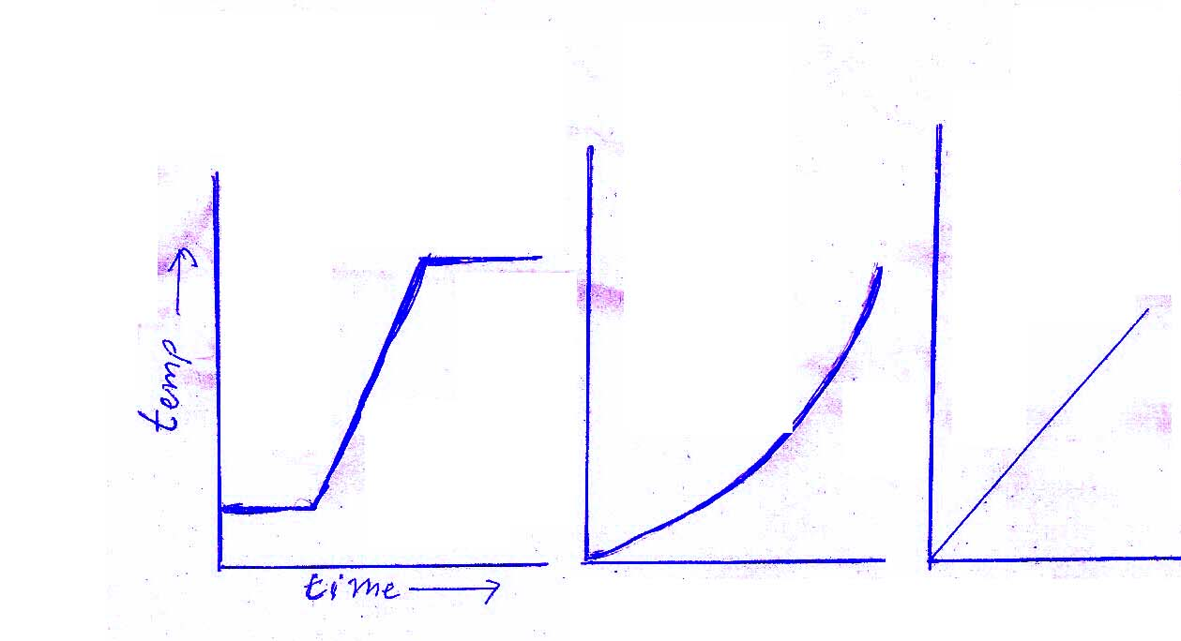
(a) W₁>W₂ (b) W₁<W₂ (c) W₁=W₂ (d) Can not said
Q.26 If we plot a graphs A, B, C, for an experiment between rise in temperature and time, the graph will be:

(a) A (b) B (c) C (d) None of the above
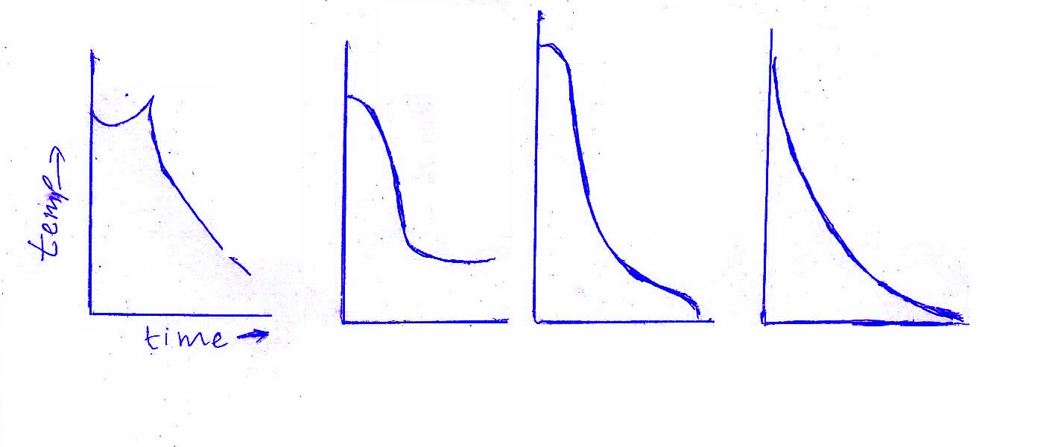
Q.27 The temperature-time variation graphs, as obtained by four students A,B,C and D are as shown. The graph, likely to be correct is that of student.

(a) A (b) B (c) (d) D
Q.28 The reactions which takes place on burning Magnesium in air.
(1) 2Mg+O₂ 2MgO (2) 3Mg +N₂ Mg₃N₂
(3) Both (1) & (2) (4) None of the above
Q.29 The gas evolved when lead nitrate is heated
(1) N₂ and O₂ (2) NO₂ and CO₂
(3) NO₂ and O₂ (4) NO₂ and N₂
Q.30 Match column I with column II and select the correct option
Column I Column II
- Valency (i) Same atomic number, different mass number
- Isotopes (ii) Combining capacity of an atom

- Ions (iii) Same mass number, different atomic number
- Isobars (iv) Formed by loss or gain of electrons
- (a) (i), (b)-(iii), (c)- (iv), (d)-(ii)
- (a)- (iii), (b)-(i), (c)-(ii), (d)-(iv)
- (a)-(ii), (b)-(i), (c)-(iv), (d)-(iii)
- (a)-(iv), (b)-(iii), (c)-(ii), (d)-(i)

Q.31 A body is thrown upwards from a point A. it reaches upto the highest point B and returns, its:
(a) Kinetic energy at A = Kinetic energy at B
(b) Potential energy at A= Potential energy at B
(c) Potential energy at B= kinetic energy at B
(d) Potential energy at B= Kinetic energy at A.

Pradeep Sahajwani Classes (BASE MAKER)

IX – X CBSE (Maths / Science)
S-20, Vivekanand Colony, Bhopal, Phone : 0755-2751377, 9893213700

