SAMPLE PAPER 2006 - 07
Informatics Practices

Time: 3hrs. Sub : MM :70

General Instructions:
- This Question Paper is divided into 3 sections
- Section - A consists of 30 marks
- Section - B and Section – C are of 20 marks each
- Answer the questions after carefully reading the text.

Section – A

Q1.Answer the following questions:
a) Name any four areas where Business Computing can be used. [2]
b) What is the Entity Relationship model? Explain the concept of ER model using the case study of a school that has three entities STUDENT, TEACHER and SUBJECT. Assume that each student can study more than one subject while each teacher can teach only one subject. [4]
c) What is Open Source Software? [2]
d) What is an OpenOffice? [2]

Q2. Answer the following questions:
a) What are intrinsic controls? Name any two [2]
b) What is Container? How can a picture box be used as a container? [3]
c) What do you understand by the term Record Source of an ADO data control? [2]
d) State The reason why len(str(20)), gives an output 3. [2]
e) How would you determine whether a string str1 contains leading and trailing spaces or not? [1]

Q3.Answer the following Qustions:
a) Define SQL. Name the different SQL sub categories [2]
b) Explain the IN operator in SQL. Specify its syntax and usage. [2]
c) What is TCP/IP [2]
d) Differentiate between Single Row Functions and Multiple row functions of SQL. Give example for both. [2]
e)Can you place some controls on the MDI form? [2]

Section - B

Q4. What are the various ways of creating variable that can be used in Pl/SQL? Write an anonymous code block that adds all the natural numbers within a given range, the range is to be set using substitution variables. [4]

Q5. Teach Well institute offers two postgraduate courses, one in computers and the other in Management. The students can avail certain optional facilities. The Basic Interface for accepting the details of facilities availed by a student is as follows:

.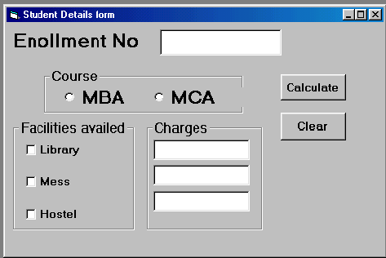
Write the code and event procedures for incorporating the following functionality:
a) The LIBRARY facility should be selected by default [1]
b) The default course choice should be Computers course. [1]
c) Whenever user selects the HOSTEL facility, the MESS facility should get selected automatically, which the user can deselect later if desired. [2]
d) Give that the charges for library, mess and hostel are Rs. 500, Rs.1500and Rs. 2000 respectively per month. Write a function that calculates The charges per semester, for the facilities availed.[4]
e)The function should be called when user clicks the calculate button and the results should be displayed in message box. [2]

Q6.Write a function in VB to toggle(invert) the case of each character of a string i.e characters in uppercase should be converted to lowercase and vice versa.(Note : You are not allowed to use UCASE or LCASE functions) [3]

Q7.What is the role of a MID statement ? How is it different from MID Function? [3]

Section - C

Q8. Read the question given below and answer accordingly:
a)Write the output produced by the following part of code in PL/SQL : [2]

DECLARE
X NUMBER
SUM NUMBER:=0;
BEGIN
FOR X IN 1..5 LOOP
IF MOD(X,2)=1 THEN
SUM:=SUM –X;
ELSE
SUM :=SUM – X;
END IF;
DBMS_OUTPUT.PUT_LINE(TO_CHAR(I*10));
END LOOP;
END;

b) NAME SAL COMM
Allen 1600 300
Ward 1250 500
Martin 1250 1400
Turner 1500 0
Look at the above table and give the output produced by the following PL/SQL code on expression : [2]

DECLARE
V_name emp.ename%TYPE;
V_sal emp.sal%TYPE :=1500;
V_counter number(2) :=1;
BEGIN
LOOP
Select Ename into V_Ename from emp where sal<v_sal;
Dbms_output.put_line(v_ename);
V_sal:= 1800;
V_counter:=v_counter+1;
Exit when v_counter >2;
End loop;
End;

Q9. Write a PL/SQL function checkdiv( ) that takes two numbers as arguments and returns the value 1 if the first argument passed to it is divisible by the second argument else will return the value 0. [4]

Q10 Explain the different types of variable declaration in PL/SQL. [3]

Q11.What is cursor? What are its different types? [4]

Q12.Write a PL/SQL script to input a number. If the number n is odd and positive, print its square root otherwise print n^{5.} [3]

Q13.What are the advantages of stored procedures ? [2]

