Guess Paper – 2011
Class – XII
Subject – Physics
Time : Three Hours Max. Marks : 70

General Instructions
(a) All questions are compulsory.
(b) There are 30 questions in total. Questions 1 to 8 carry one mark each; questions 9 to 18 carry two marks
Each, questions 19 to 27 carry three marks each and questions 28 to 30 carry five marks each.
(c) There is no overall choice. However, an internal choice has been provided in one question of two marks,
One question of three marks and all three questions of five marks each. You have to attempt only one of
The give choices in such questions.
(d) Use of calculators is not permitted.
(e) You may use the following physical constants wherever necessary:
c = 3 x 10⁸ms⁻¹
h = 6.6 x 10⁻³⁴Js
e = 1.6 x 10⁻¹⁹ C
Boltzmann constant k = 1.38 x 10²³ JK⁻¹
Avogadro’s number NA = 6.023 x 10²³/mole
Mass of neutron mn = 1.6 x 10⁻²⁷ kg
Mass of electron m_{e} = 1.6 x 10⁻³¹ kg

1. An electron, an alpha-particle and a proton have the same kinetic energy. Which one of these particles has the
largest d- Broglie wavelength.
2. Write an expression for resistivity of a metallic conductor showing its variation over a limited range of
temperature.
3. Magnetic field lines can be entirely confined with in the core of a toroid, but not with in a straight solenoid why?
4. How much average power dissipates, over a complete cycle of an A.C. source supply when connected to a
capacitor?
5. A glass lens of refractive index 1.45 disappears when immerse in a liquid. What is the value of refractive index
of the liquid?
6. The radioactive isotope D decays according to the sequence

D…ẞ DECAY………..D1……ἁ DECAY………..D2
If the mass number and atomic number of D₂ are 176 and 71 respectively, what is the (i) mass number and (ii)
atomic number of D

7. Two lines A and B in the plot given below show the variation of de Broglie wavelength, λ versus 1/√v, where V
is accelerating potential difference, for the two particles carrying the same charge. Which one of two represent a
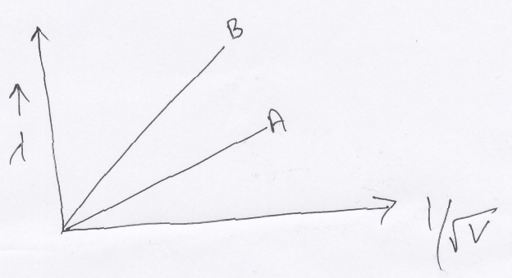
particle of smaller mass?

8. Two nuclei have mass number in the ratio 1: 2 what is the ratio of their nuclear densities?
9. A uniformly charged conducting sphere of 2.4 m diameter has a surface charge density of 80 µ c/m²
(a) Find the charge on the sphere.
(b) What is the total flux leaving the surface of the sphere?
10. An electric lamp having coil of negligible inductance connected in series with a capacitor and an AC source is
glowing with certain brightness. How does the brightness of the lamp change on reducing the (I) capacitance (ii)
frequency? Justify.

11. A convex lens of refractive index 1.5 has a focal length of 18 cm in air. Calculate the change in its focal length
when it is immersed in water of refractive index 4/3.
12. Draw a block diagram of a simple amplitude modulation. Explain briefly how amplitude modulation is
achieved.
13. A charge q moving along x axis with a velocity v is subjected to a uniform magnetic field B acting along the Z
axis as it crosses the origin O.
- Trace its trajectory
- Does the charge gain kinetic energy as it
enters the magnetic field? Justify your answer.

14. In a single slit diffraction experiment, a monochromatic source of light of wavelength λ illuminates a narrow slit
of width a. Show, giving appropriate reasoning that the half angular width of the central maximum in the
observed pattern is nearly equal to λ/a
OR
Plot a graph showing variation of stopping potential (V_{o}) with the frequency (v)of the incident radiation for a
given photosensitive material. Hence state significance of thereshold frequency in photo electric emission.
15. Draw a ray diagram for the formation of image by compound microscope and hence write its linear magnification
Formula.
16. State Bohr’s postulate. Using these postulates, derive an expression for total energy of an electron in nth orbit
of an atom. What does negative of this energy signify?
17. State the working principal of p-n junction diode as a rectifier. Explain with the help of the circuit diagram, the
use of p-n junction as full-wave rectifier. Draw its output wave form also.
- Write Einstein’s photoelectric equation. Explain the term threshold frequency and stopping potential.
- The two plates of a parallel plate capacitor are 5 mm apart. A slab of a dielectric, of thickness 4mm is introduced between the plates with its faces parallel to them. The distance between the plates is adjusted so that the capacitance of the capacitor become equal to its original value. If the new distance between the plates equals 8mm, what is the dielectric constant of the dielectric used?
- Three identical capacitors c₁, c₂ and c₃ of capacitance 6 µf each are connected to a 12 v battery as shown.
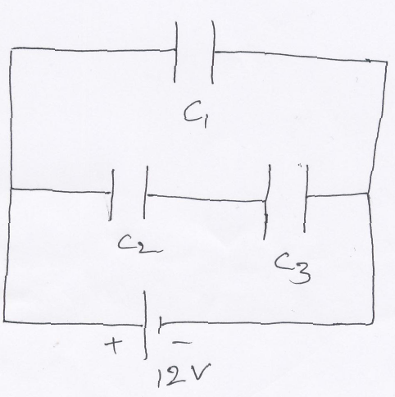
- charge on each capacitor
- equivalent capacitance of the network
- energy stored in the network of capacitors.

21.
The figure shows experimental set up of a meter bridge. When the two unknown resistance X and Y are
inserted, the null point D is obtained 40 cm from the end A. when a resistance of 10 ohm is connected in series
with X, the null point shifts by 10 cm. find the position of the null point when the 10 ohm resistance is inserted
connected in series with resistance Y. Determine the vale of resistance X and Y.
22. Give the principle of working of a Van –De – Graff generator. With the help of a labeled diagram
describe its construction and working. How is the leakage of charge minimized from the generator?
23. Derive a formula for the force between two parallel straight conductors carrying current in the opposite
direction and write the nature of the force. Hence define an ampere.
OR
Explain how will you convert a galvanometer into a voltmeter to read a maximum potential V volt. And
explain the conversion to ammeter also

24. Explain with the help of the labeled diagram the underlying principle, construction and working of a cyclotron.
OR
Explain with the help of the labeled diagram the underlying principle, construction and working of a moving
coil galvanometer. Hence explain the use of radial magnetic field.
25. Derive the relation for N = N₀e^{-λt} for radio active decay and what do you mean by activity of a radio active
substance.
26. Explain the working of npn transistor as an oscillator. How the frequency can be varied.
27. Draw a digram to show the variation of binding energy per nucleon with mass number for different nucei. State
with reason why light nuclei usually undergo nuclear fission.
28. Use Gauss’s law to obtain an expression for the electric field due to an infinitely long straight uniformly
charged wire.

(b) Electric field in the given figure is directed along + X direction and given by
E_{x} = 5Ax + 2B, where E is in NC⁻¹ and A = 10 and B = 5 in SI units. x is in metre.
calculate.
(i) the electric flux through the cube.
(ii) net charge enclosed within the cube.

OR
State kirchhoff’s rules for an electrical networks. Explain their use by drawing a simple circuit
29. A shot bar magnet has a magnetic moment of 0.48 J/T. Give the direction and magnitude of the
magnetic field produced by the magnet at a distance of 10 cm from the centre of the magnet on (a) the
axis, (b) the equatorial lines (normal bisector) of the magnet
OR
A power transmission line feeds input power at 2300V to a step-down transformer with its primary
windings having 4000 turns. What should be the number of turns in the secondary in order to get
output power at 230V.
30. A small town demands of 800KW of electric power at 220 V is situated 15 km away from an electric
plant generating power at 440 V. The resistance of the two wire line carrying power is 0.5 ohm per km.
The town gets power from the line through a 4000-220V step-down transformer at a sub-station in the
town.
(a) Estimate the line power loss in the form of heat
(b) How much power must the plant supply , assuming there is neglihible power loss due to leakage
(c) Characterise the step up transformer at plant.
OR
A 600 pf capacitor is charged by a 200v supply. It is then disconnected from the supply and is connected to
another un charged 600pf capacitor how much electrostatic energy is lost in this process.

GOENKA PUBLIC SCHOOL
Prepared by:
Name santosh kumar tiwari
Email santosh_sarini@yahoo.com
Phone No. 09660386417

