Guess Paper 2011
Class – XII
Subject – Physics(Set :1)
MM: 70 TIME : 3h

General Instructions
(a) All questions are compulsory.
(b) There are 30 questions in total. Questions 1 to 8 carry one mark each, questions 9 to 18 carry two marks each, questions 19 to 27 carry three marks each and questions 28 to 30 carry five marks each.
(c) There is no overall choice. However, an internal choice has been provided in one question of two marks, one question of three marks and two questions of five marks each. You have to attempt only one of the given choices in such questions.
(d) Use of calculators is not permitted.
(e) You may use the following physical constants wherever necessary :
c = 3 x 10⁸ms⁻¹ ; h = 6.6 x 10⁻³⁴Js ; e = 1.6 x 10⁻¹⁹ C
μ_{o} = 4 π x 10⁻⁷T m A⁻¹ ; Boltzmann constant k = 1.38 x 10²³ JK⁻¹
Avogadro’s number N_{A} = 6.023 x 10²³/mole
Mass of neutron m_{n} = 1.6 x 10⁻²⁷ kg

1. Two electrically charged particles having of different magnitude, when placed at a distance apart experience an attractive force. These charges are now put in contact and again placed back at the same distance, what is the nature of the force between them now? 1

2. If an electron and a proton having same momenta enter perpendicularly to a magnetic field, how will you compare the nature of the path followed by them? 1

3. A 50 Hz ac source of 20V is connected to a series combination of resistor R and capacitor C. The voltage across R is 12V, what is the voltage across C? 1

4. Let the wavelengths of electromagnetic waves used quite often for:
a. killing of germs in a household water purifiers,
b. remote sensing &
c. treatment of cancer
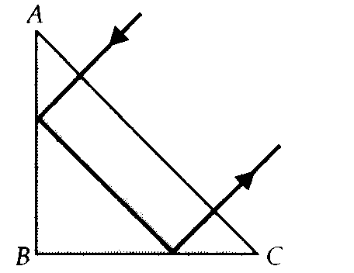
be labelled as λ₁, λ₂ & λ₃. Arrange λ₁, λ₂ & λ₃ in increasing order. 1

5. A ray falls on a prism ABC ( AB = BC ) and travels as shown in the fig 1. What is the least value of refractive index of material of the prism? 1

6. When photons energy hν are incident on the surface of photosensitive material of work function hν_{o}, what is the kinetic energy of the ejected electrons? 1
Fig 1
7. Complete the following block diagram depicting the essential elements of a basic communication system.
Fig 2 1
Fig 2

8. The TV signals have a bandwidth of 4.7MHz. What is the number of channels in a bandwidth of 4700GHz? 1

9. Find the amount of work done in rotating an electric dipole, of dipole moment 3x10⁻⁸Cm, from its position in stable equilibrium to the position of unstable equilibrium, in a uniform electric field of intensity 10⁴ NC⁻¹. 2

10. Answer carefully: 2
a. What is the work done by the field of a nucleus in a complete circular orbit of the electron? What if the orbit is elliptical?
b. We know that electric field is discontinuous across the surface of a charged conductor. Is electric potential also discontinuous there?

11. Three identical resistor, each of resistance R, when connected in series with a d.c.. source, dissipate power X. If the resistors are connected in parallel to the same d.c. source, how much power will be dissipated ? 2

12. An ammeter reads upto 1A. Its internal resistance is 0.81Ω. Calculate the shunt required to increase its range to 10A. 2

13. A conducting loop carrying a current I in clockwise direction as seen from top, is placed in a uniform magnetic field pointing into the plane of the paper. Will the loop have a tendency to
(a) contract or (b) expand? Justify. 2

14. A rectangular wire loop of sides 8 cm and 2 cm with a small cut is moving out of a region of uniform magnetic field of magnitude 0.3 T directed normal to the loop. What is the emf developed across the cut if the velocity of the loop is 1 cm s^{–1} in a direction normal to the longer side of the loop? For how long does the induced voltage last? 2

15. The oscillating electric field of an electromagnetic wave is given by
E_{Y} = 30 sin[2 x 10¹¹ t + 300] Vm⁻¹
    - Obtain the value of the wavelength of the electromagnetic wave and
    - Write down the expression for the oscillating magnetic field. 2

16. What percentage of the incident light is transmitted if the angle between the polarizer and analyser is 60⁰? 2
OR
What two main changes in the diffraction pattern will you observe when the monochromatic source of light is replaced by a source of white light?

17. Why is a photodiode connected in reverse bias mode? Fig 3, shows reverse bias current under different illumination intensities I₁, I₂, I₃, and I₄, for a given photodiode. Arrange the intensities in decreasing order of magnitude. 2
Fig 3
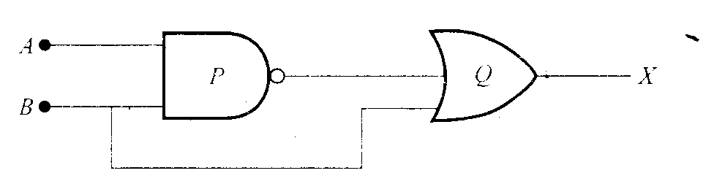
18. Identify the logic gates P and Q. Fig 4. Write down the output at X for the inputs (i) A=0, B=0 & (ii) A=1, B=1. 3
Fig 4

19. A parallel plate capacitor, each with plate area A and separation d is charged to a potential difference V. The battery used to charge it is then disconnected. A dielectric slab of thickness d and dielectric constant K is now placed between the plates. What change, if any, will take place in a. charge on plates b. electric field intensity between plates &
c. capacitance. 3

20. A small magnet of magnetic moment M, is placed at a distance r from the origin O with its axis parallel to x axis as shown in fig 5 . A small coil, of one turn is placed on the x axis at the same distance from the origin, with the axis of the coil coinciding with x axis. For what value of current in the coil does a small magnetic needle. Kept at the origin, remain undeflected? What is the direction of the current in the coil? 3
Fig 5

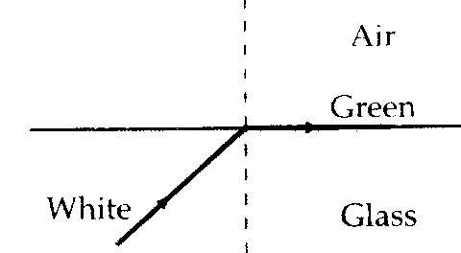
21. A beam of white light is incident on glass – air interface from glass to air such that green light just suffers total internal reflection. Fig 6. Which colours of the white light would come out to the air justify. 3

22. What is the effect on the interference pattern observed in a Young’s
double slit experiment in the following cases:
Fig 6
a. screen is moved away from the plane of slits,
b. separation between the slits is increased and
c. widths of the slits is doubled. Justify your answer. 3

23. What reasoning led deBroglie to put forwards the concept of matter waves? The wavelength λ of a photon and the deBroglie wavelength associated with a particle of mass m has the same value. Show that the energy of the photon is times the kinetic energy of the particle. 3

24. Which of these transitions corresponds to emission of radiation of (i) maximum and (ii) minimum wavelength?
The energy levels of an atom are shown in fig 7 , which of these transitions will result in the emission of a photon of wavelength 275nm? 3

25. State the radioactive decay law. Write its mathematical form.
Fig 7
Two radioactive nuclei X and Y initially contain an equal number
of atoms. Their half life is 1 hour and 2 hour respectively. Calculate
the ratio of their rates of disintegration after two hours. 3

26. Discuss the working of a common emitter (npn transistor) amplifier, clearly showing the reasons for amplification as well as phase reversal. 3
OR
Discuss the working of a common emitter (npn) transistor as switch.

27. Discuss a method to propagate radio waves of frequencies from a few MHz to 30 MHz. Why is there an upper limit to the frequency in this mode of communicaion? 3

28. In the meter bridge experiment, a student observed a balance point at the point J, where AJ = l. The values of R and X are both doubled and then interchanged. What would be the new position of the balance point? Fig 8 3
Draw the current versus potential difference characteristics of a cell. How can the internal resistance of the cell be determined from this graph? 2
Fig 8

OR
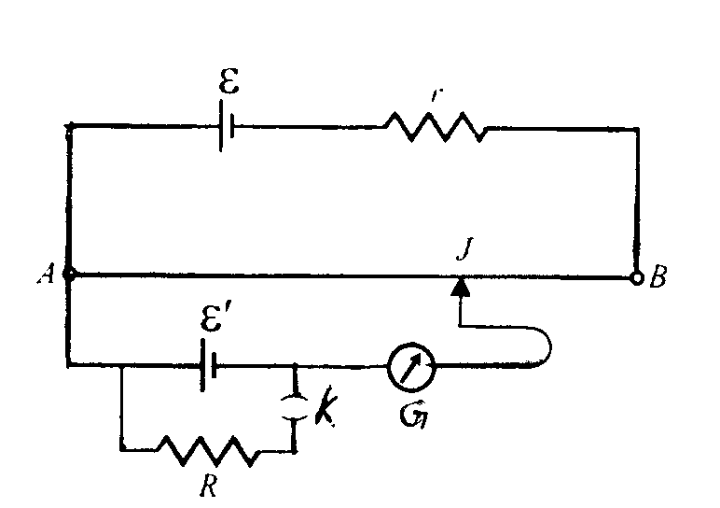
The following circuit, Fig 9, shows the use of potentiometer to measure the internal resistance of a cell:
a. When the key K is open, how does the balance point charge, if the current from the driver cell decreases?
b. When the key K is closed, how does the balance point change if R is increased, keeping the current from the driver cell constant ?
The coil of a heater is cut into two equal halves and only one half is used into the heater. What is the ratio of the heat produced by this half of the coil to that by the original coil?
Fig 9

29. Derive an expression for the power in a series LCR circuit. 3
Mention the factors on which the resonant frequency of a series LCR circuit depends. Plot a graph showing variation of impedance of a series LCR circuit with the frequency of the applied a.c. source 2
OR
When a circuit element ’X’ is connected across an a.c. source, a current of √2 A flows through it and this current is in phase with the applied voltage. When another element ‘Y’ is connected across the same a.c. source, the same current flows in the circuit but it leads the voltage by π/2 radian.
  - Name the circuit elements of X and Y.
  - Find the current that flows in the circuit when the series combination of X and Y is connected across the same a.c. voltage.

  - Plot a graph showing variation of the net impedance of this series combination of X and Y as a function of the angular frequency of the applied voltage.

30. A concave lens of glass of refractive index 1.5, has both surfaces of the same radius of curvature R. It is immersed in a medium of refractive index 1.75, how would the nature of the lens be affected?
2
Draw ray diagram of compound microscope. Derive an expression for its magnifying power when the final image is formed at the least distance of distinct vision. 3

OR
A plot between the angle of deviation (δ)angle of incidence (i), for an equilateral prism is shown below: Fig 10
Explain why any given value of δ corresponds to two values of angle of incidence?
State the point of significance of the point P on the graph. Use this information to derive an expression for the refractive index of the material of the prism.
Fig 10

ARMY SCHOOL JAMMU CANTT
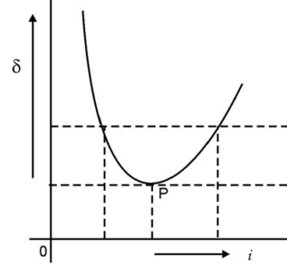

SUBMITED BY

Kundan Lal Dogra
Phone : 09419106552
kld.69@rediffmail.com

