Guess Paper 2011
Class – XII
Subject – Physics Set : 2
MM: 70 TIME : 3h

General Instructions
(a) All questions are compulsory.
(b) There are 30 questions in total. Questions 1 to 8 carry one mark each, questions 9 to 18 carry two marks each, questions 19 to 27 carry three marks each and questions 28 to 30 carry five marks each.
(c) There is no overall choice. However, an internal choice has been provided in one question of two marks, one question of three marks and two questions of five marks each. You have to attempt only one of the given choices in such questions.
(d) Use of calculators is not permitted.
(e) You may use the following physical constants wherever necessary :
c = 3 x 10⁸ms⁻¹ ; h = 6.6 x 10⁻³⁴Js ; e = 1.6 x 10⁻¹⁹ C
μ_{o} = 4 π x 10⁻⁷T m A⁻¹ ; Boltzmann constant k = 1.38 x 10²³ JK⁻¹
Avogadro’s number NA = 6.023 x 10²³/mole
Mass of neutron mn = 1.6 x 10⁻²⁷ kg

1. What is the nuclear radius of ¹²⁵Fe if that of ²⁷Al is 3.6 fermi? 1

2. A diverging lens of focal length ‘F’ is cut into two identical parts each forming a plano-concave lens. What is the focal length of each part? 1

3. How does resolving power of an astronomical telescope get affected on
    - increasing the aperture of objective lens?
    - increasing the wavelength of light used? 1

4. How does the stopping potential applied to a photocell change, if the distance between the light source and the cathode of the cell is doubled? 1

5. A $\text{500}μC$charge is at the centre of a square of side 10 cm. Find the work done in moving a charge of $\text{10}μC$between two diagonally opposite points on the square. 1

6. Zener diodes hhave higher dopant densities as compared to ordinary p-n junction diodes. How does it affect the
(a) Width of the depletion layer? (b) Junction field? 1

7. Name the characteristics of electromagnetic waves that
- increases (b) remains constant
in an electromagnetic spectrum as one moves from radio wave region towards ultraviolet region. 1

8. An electrical element X, when connected to an alternating voltage source, has the current through it leading the voltage by $\frac{π}{2}$rad. Identify X and wire an expression for its reactance. 1

9. State the law of radioactive decay. If N₀ is the number of radioactive nuclei in the sample at some initial time, t₀, write the relation to determine the number N present at a subsequent time.
Draw a plot of N as a function of time.

OR
Draw a plot of the binding energy per nucleon as a function of mass number for a large number of nuclei. Write a typical nuclear reaction in which a large amount of energy is released in the process of nuclear fission. 2

10. Why do we need carrier wave of very high frequency in the modulation of signals.
A carrier wave of peak voltage 20 V is used to transmit a message signal. What should be the peak voltage of the modulating signal, in order to have a modulation index 80%? 2

11. Using the Gauss’s Law derive an expression for the electric field intensity at any point near a uniformly charged thin wire of charge /length as λ Cm⁻¹. 2

12. A cell of e.m.f. (E) and internal resistance (r) is connected across a variable external resistance (R). Plot graphs to show the variation of
(a) E wit R & (b) Terminal p.d. of the cell (V) with R. 2

13. What is meant by the transverse nature of the electromagnetic waves? Draw a diagram showing the propagation of en electromagnetic wave along x axis, indicating clearly the directions of the electric and magnetic fields. 2

14. A right angled isosceles glass prism is made from glass of refractive index 1.5. Show that a ray of light incident normally on
(a) one of the equal sides of this prism is deviated through 90⁰.
(b) the hypotenuse of this prism is deviated through 180⁰. 2

15. A cylindrical metallic wire is stretched to increase its length by 5%. Calculate the percentage change in its resistance. 2

16. Define the term magnetic dipole moment of a current loop. Write the expression for the magnetic moment when an electron revolves at a speed v around an orbit of radius r in hydrogen atom.
2
17. In a single slit diffraction experiment, the width of the slit is made double the original width. How does it affect the size and the intensity of the central diffraction band? Explain.
Draw a graph showing intensity distribution. 2

18. A jet plane is traveling west at 450 ms⁻¹. If the horizontal component of earth’s magnetic field at that place is 4 × 10⁻⁴ Tesla and the angle of dip is 30⁰, find the e.m.f. induced between the ends of wings having a span of 30 m. 2

19. What does the term ‘LOS communication mean? Name the types of waves that are used for this communication. Give typical examples, with the help of a suitable figure, of communication systems that use space wave mode propagation. 3

20. Draw a plot showing the variation of power of a lens, with the wavelength of the incident light. A converging lens of refractive indices 1.5 and of focal length 15 cm in air, has the same radii of curvature for both sides. If it is immersed in a liquid of refractive index 1.7, find the focal length of the lens in the liquid. 3

21. Draw V I characteristics of a Zener diode. With a circuit diagram, explain how can it be used as voltage regulator.
OR
Draw a circuit diagram of a full-wave rectifier. Explain its working principle. Draw the input/output wave-forms indicating clearly the function of the two diodes used. 3

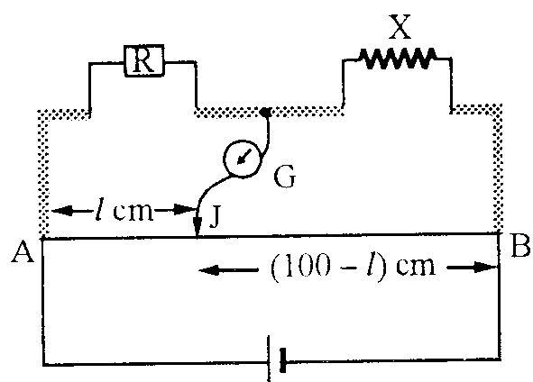
22. A resistance $R=4Ω$is connected to one of the gaps in a metre bridge, which uses a wire of length 1 m. An unknown resistance $X>4Ω$is connected in the other gap as shown in the figure. The balance point is noticed at ‘l’ from the positive end of the battery. On interchanging R and X, it is found that the balance point further shifts by 20 cm (away from end A). Neglecting the end correction, calculate the value of unknown resistance X used.
3

23. State the postulate for the Bohr’s frequency condition for an hydrogen atom.
Write the Rydberg formula and calculate the shortest as well as the longest wavelength of the in the Lyman series of the hydrogen spectrum. 3

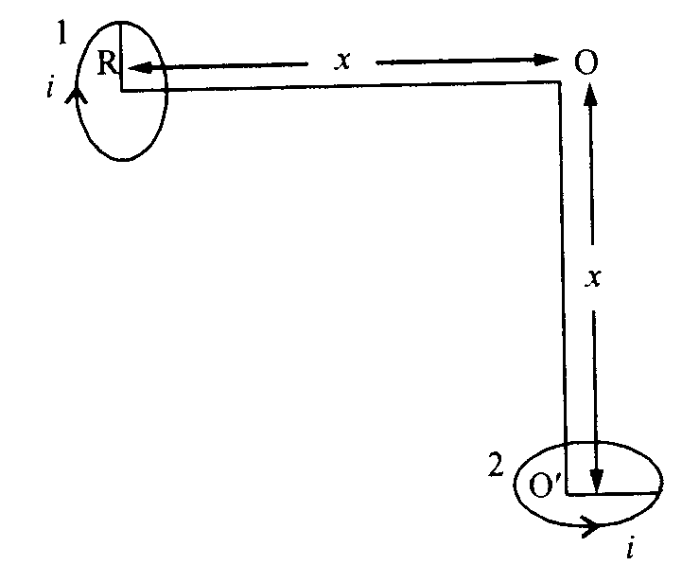
24. If a particle of charge q is moving with velocity v along the y-axis and the magnetic field B is acting along the z-axis, use the expression $\vec{F}=q(\vec{v}×\vec{B})$to find the direction of the force F acting on it.
Two small identical circular coils market 1, 2 carry equal currents and are placed with their geometric axes perpendicular to each other as shown in the figure. Derive an expression for the resultant magnetic field at O. 3

25. Distinguish between isotopes and isobars. Give one example for each of the species. A radioactive isotope has a half-life of 5 years. How long will it take the activity to reduce to 3.125%? 3

26. Distinguish between paramagnetic and diamagnetic substances.
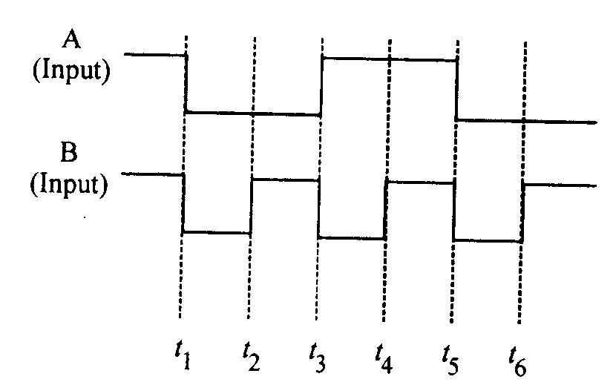
The vertical component of Earth’s Magnetic field at a place is $\sqrt{3}$times the horizontal component. What is the value of angle of dip at this place? 3

27. Two signals A, B as given below, are applied as input to (i) AND (ii) NOR (iii) NAND gates. Draw the output wave-form in each case. 3

28. Draw a labeled ray diagram showing the image formation by a compound microscope. Write the expression for its magnifying power.
The ratio intensity of maxima and minima in an interference pattern is 100 : 64. Calculate the ratio of intensities of the coherent sources producing this pattern. 5
OR

Draw a labeled ray diagram of an astronomical telescope used in the normal adjustment position. Write the expression for its magnifying power.
A beam of light converges to a point P. A lens is placed in the path of the convergent beam 12 cm from P. At what point does the beam converge if the lens is
(a) a convex lens of focal length 20 cm
(b) a concave lens of focal length 6 cm?

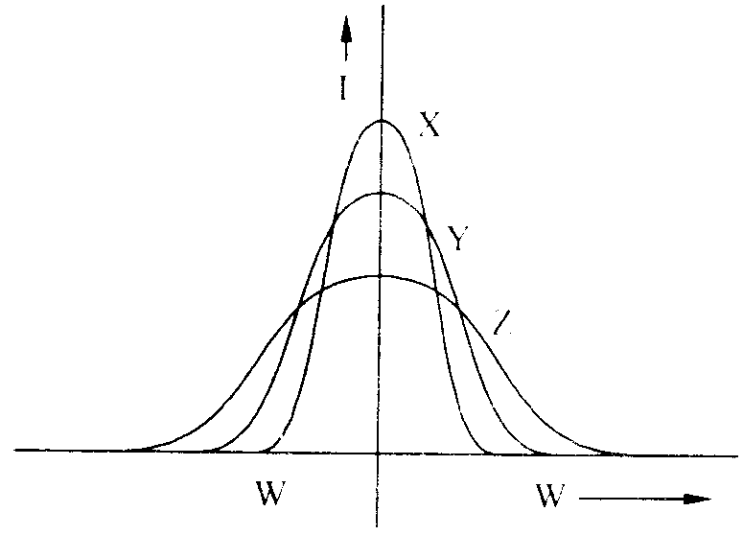
29. Three students X, Y and Z performed an experiment for studying the variation of alternating currents with angular frequency in a series LCR circuit and obtained the graph shown below. They all used a.c. sources of the same root mean value and inductances of the same value. What can we (qualitatively) conclude about the
(a) capacitance value
(b) resistance values
used by them? In which case will the quality factor be maximum? What can we conclude about nature of the impedence of the set up at frequency $ω_{0}$? 5
OR

Draw a labeled circuit arrangement showing the windings of primary and secondary coil in a transformer. Explain the underlying principle and working of a step-up transformer. Write any two major sources of energy loss in this device.
How much current is drawn by the primary coil of a transformer which steps down 220 V to 22 V to operate device with an impedance of 220 ohm?
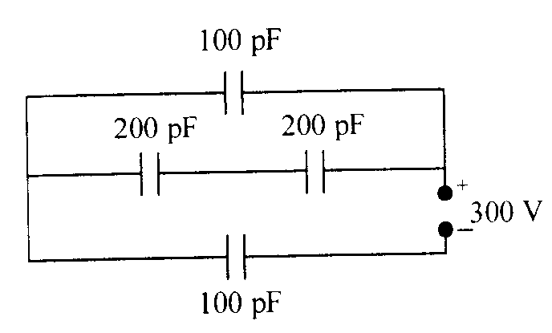
30. (a) Derive an expression for the energy stored in a parallel plate capacitor, C to a potential difference V.
(b) Obtain the equivalent capacitance of the network given below. For a supply 300 V, determine the charge and voltage across C₄.
OR

Explain the principle on which Van-de-Graaff generator operates. Draw a labeled schematic sketch and write briefly its working.
A van-de-Graaff type generator is capable of building up potential difference of 15 × 10⁶ V. The dielectric strength of the gas surrounding the electrode is 5 × 10⁷ V m⁻¹. What is the minimum radius of the spherical shell required? 5

SUBMITED BY

Kundan Lal Dogra
Phone : 09419106552
kld.69@rediffmail.com

