Guess Paper – 2011
Class – XII
Subject – Physics
MM: 70 TIME : 3h

General Instructions
(a) All questions are compulsory.
(b) There are 30 questions in total. Questions 1 to 8 carry one mark each, questions 9 to 18 carry two marks each, questions 19 to 27 carry three marks each and questions 28 to 30 carry five marks each.
(c) There is no overall choice. However, an internal choice has been provided in one question of two marks, one question of three marks and two questions of five marks each. You have to attempt only one of the given choices in such questions.
(d) Use of calculators is not permitted.
(e) You may use the following physical constants wherever necessary :
c = 3 x 10⁸ms⁻¹ ; h = 6.6 x 10⁻³⁴Js ; e = 1.6 x 10⁻¹⁹ C
μ_{o} = 4 π x 10⁻⁷T m A⁻¹ ; Boltzmann constant k = 1.38 x 10²³ JK⁻¹
Avogadro’s number NA = 6.023 x 10²³/mole
Mass of neutron mn = 1.6 x 10⁻²⁷ kg

1. What is the equipotential due to an electric dipole at an equatorial point? 1

2. In a certain arrangement a proton does not get deflected while passing through a magnetic field region. Under what condition is this possible? 1

3. Define self induction of a coil. Write its S I unit. 1

4. Name the radiations which are next to IR radiations in electromagnetic spectrum having
  - Shorter wavelength & (ii) Longer wavelength 1
5. Two thin lenses of power +6D and -2D are in contact. What is the focal length of the combination? 1

6. The stopping potential in an experiment on photoelectric effect is 1.5V. What is the maximum kinetic energy of the emitted photoelectrons? 1
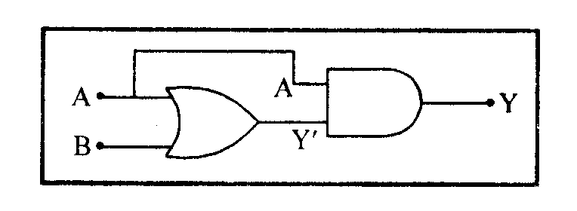
7. Draw the voltage current characteristics of a Zener diode. 1

8. Write the truth table for the following combination of gates. Fig 1 1
Fig 1

9. Define electric field intensity. Write its S.I. unit. Write the magnitude and direction of electric field intensity due to an electric dipole of length 2a at the mid point of line joining the charges. 2
10. A wire of 15 Ω is gradually stretched to double its original length. It is then cut into two equal parts. These parts are then connected in parallel across a 3 V battery. Find the current drawn from the battery. 2
11. Define the term magnetic dipole moment of a current loop. Write the expression for the magnetic moment when an electron revolves at a speed v around an orbit of radius r in hydrogen atom.
2
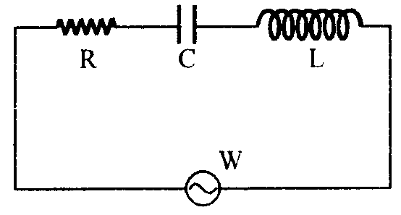
12. In the circuit shown below, R represents an electric bulb. If the frequency v of the supply is doubled, how should the values of C and L be changed so that the glow in the bulb remains unchanged? Fig 2 2

13. Define the term electric flux. Write its SI unit.
Fig 2
A charge q is enclosed by a spherical surface of radius R. If the radius is reduced
to half, how would the electric flux through the surface change?
2
14. The oscillating field in a plane electromagnetic wave is given by
$$B_{y}=(8×{\text{10}}^{−6})\text{ sin }[2×{\text{10}}^{\text{11}}t+\text{300}πx]\text{ T}$$
- Calculate the wavelength of the electromagnetic wave.
- Write down the expression for the oscillating electric field. 2
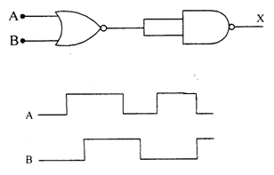
15. The slit of width ‘d’ is illuminated by light of wavelength $\text{5000 \{}\overset{˙}{A}$. For what value of ‘d’ will the first maxima fall at an angle of diffraction of 30⁰. 2

16. Draw the output wave form at X, using the given inputs A, B for the logic circuit shown below. Also identify the gate. Fig 3 2
Fig 3

OR
Why are n and p type semiconductors neutral even if they have excess of electron and holes respectively?

17. Define the term ‘modulation index’ for an AM wave. What would be the modulation index for as AM wave for which the maximum amplitude is ‘a’ while the minimum amplitude is ‘b’?
2
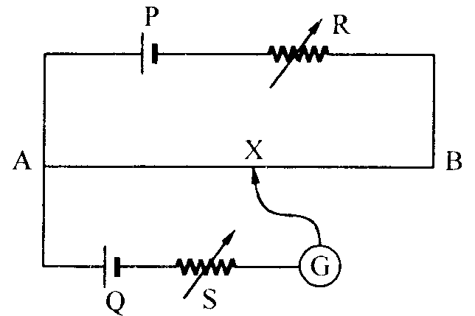
18. A voltage of 30 V is applied across a carbon resistor with first, second and third rings of blue, black and yellow colours respectively. Calculate the value of current, in mA through it.
2
19. In the potentiometer circuit shown, the balance (null) point is at X. State with reason, where the balance point will be shifted when (i) resistance R is increased, keeping all parameters unchanged (ii) resistance S is increased, keeping R constant (iii) Cell P is replaced by another cell whose e.m.f. is lower than that of cell Q. Fig 4
3
Fig 4
OR
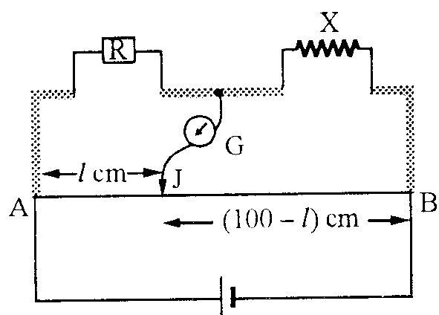
A resistance $R=4Ω$is connected to one of the gaps in a metre bridge, which uses a wire of length 1 m. An unknown resistance $X>4Ω$is connected in the other gap as shown in the figure. The balance point is noticed at ‘l’ from the positive end of the battery. On interchanging R and X, it is found that the balance point further shifts by 20 cm (away from end A). Neglecting the end correction, calculate the value of unknown resistance X used. Fig 5

Fig 5
20. An inductor 200 mH, capacitor $\text{500}μF$, resistor $\text{10}Ω$are connected in series with a 100 V, variable frequency a.c. source. Calculate the
  - Frequency at which the power factor of the circuit is unity
  - current amplitude at this frequency &
  - Q-factor. 3
21. A converging lens has a focal length of 20 cm in air. It is made of material of refractive index 1.6. If it is immersed in a liquid of refractive index 1.3, what will be its new focal length? How does the nature of the lens change if this lens is immersed in a liquid of refractive index 1.8?
3
22. What is plane polarized light?
(i) Two polaroids are placed at 90⁰ to each other and the transmitted intensity is zero. What
happens when one more Polaroid is placed between these two, bisecting the angle
between them?
(ii) How will the intensity of transmitted light vary on further rotating the third Polaroid?
3
23. Draw a schematic diagram of the experimental arrangement used by Davison and Germer to establish the wave nature of electrons. Express the de-Broglie wavelength $λ$associated with electrons in terms of the accelerating voltage V.
An electron and a proton have the same K.E .Which of the two will have larger wavelength and why? 3

24. Draw a plot of binding energy per nucleon as a function of mass number for a large number of nuclei.
Explain the energy release in the process of nuclear fission from the above plot. Write a typical nuclear reaction in which a large amount of energy is released in the process of nuclear fission. 3

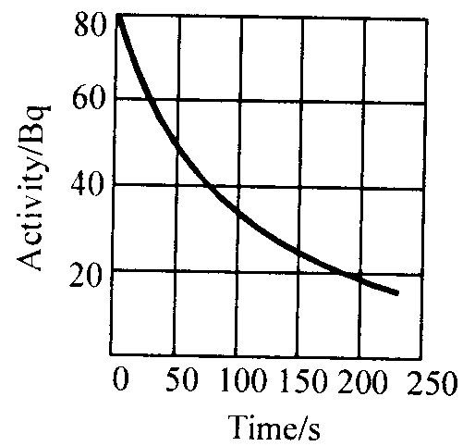
25. Complete the following decay process for $β−\text{decay}$ of Phosphorus 32 :
Fig 6

The graph in fig 6, shows how the activity of a radioactivity nucleus changes with time. Using the graph, determine (i) half-life of the nucleus and (ii) its decay constant. 3

26. Draw a labeled diagram of a transistor as an amplifier and discuss its working. 3

27. (i) What does the term ‘LOS communication mean? Name the
types of waves that are used for this communication.
(ii) A carrier wave of peak voltage 20 V is used to transmit a message signal. What should be the peak voltage of the modulating signal, in order to have a modulation index 80%?
3
28. Explain the principle on which Van-de-Graaff generator operates. Draw a labeled schematic sketch and write briefly its working.

A parallel plate capacitor is to be designed with a voltage rating 1 kV, using a material of dielectric constant 3 and dielectric strength about 10⁷ Vm^{–1}. (Dielectric strength is the maximum electric field a material can tolerate without breakdown, i.e., without starting to conduct electricity through partial ionisation.) For safety, we should like the field never to exceed, say 10% of the dielectric strength. What minimum area of the plates is required to have a capacitance
of 50 pF? 5

OR
Using Gauss’ law, derive an expression for the electric field intensity at any point outside a uniformly charged thin spherical shell of radius R and charge density $σ{\text{ C/m}}^{2}$. Draw the field lines when the charge density of the sphere is (i) positive, (ii) negative.

The electric field and electric potential at any point due to a point charge kept in air is 30 N C⁻¹ and 10 J C⁻¹. Compute the magnitude of charge.

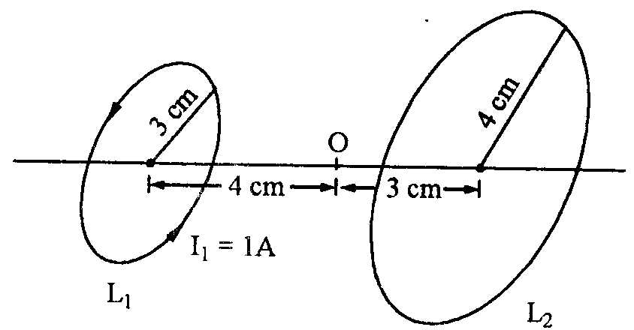
29. Derive an expression for the magnetic field at a point
on the axis of a current carrying circular loop.

Two coaxial circular loops L₁ and L₂ of radius and 4 cm are placed as shown. What should be the magnitude and direction of the current in the loop L₂ so that the net magnetic field at the point O be zero? Fig 7 5
Fig 7
OR
Draw a schematic diagram of cyclotron. Explain its
underlying principle and working, stating clearly the function of the electric and magnetic fields
applied on a charged particle.

A bar magnet of magnetic moment 1.5 JT⁻¹ lies aligned with the direction of a uniform magnetic
field of 0.22 T. Calculate the amount of work done to turn the magnet so as to align
its magnetic moment
(i) normal to the field direction &
(ii) opposite to the field direction.

30. (a) With the help of a labeled ray diagram, show the image formation by a compound
microscope. Derive an expression for its magnifying power.
(b) How does the resolving power of a compound microscope get affected on
(i) decreasing the diameter of its objective?
(ii) increasing the focal length of its objective? 5

OR
Does short-sightedness (myopia) or long-sightedness (hypermetropia) imply necessarily that the eye has partially lost its ability of accommodation? If not, what might cause these defects of vision?
A man with normal near point (25 cm) reads a book with small print using a magnifying glass: a thin convex lens of focal length 5 cm. What is the closest and the farthest distance at which he should keep the lens from the page so that he can read the book when viewing through the magnifying glass?

SUBMITED BY

Kundan Lal Dogra
Phone : 09419106552
kld.69@rediffmail.com

