Sample Paper – 2011
Class – IX
Subject – Mathematics

Sec A
(1x10)
Q.1 (-2,5) is a point which is a solution of .
a) x-y=7 b) y-x=3 c) y-x=7 d) x-y=3
Q.2 The angle of quadrilateral are in ratio 2:4:5:7 then four angle are.
a) 40⁰ , 80⁰,100⁰,140⁰ b) 30⁰,80⁰,100⁰,150⁰
c) 120⁰,90⁰,80⁰,70⁰ d) None
Q.3 If AB CD is a Parallelogram with AE perp to DC, & CF perp to AD, AB=15cm, AE=8 cm and CF= 10cm then AD equal to.
a) 6 cm b) 12 cm c) 3 cm d) 9 cm
Q.4 The data 29,32,48,50,2x,2x+4,72,78,84,95 is in ascending order and has median=63.The value of x is
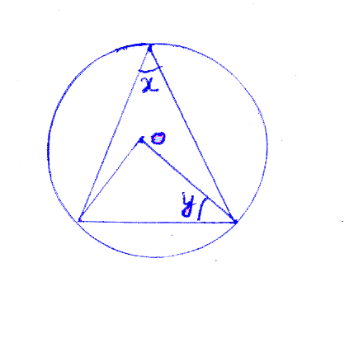
a) 62 b) 31 c) 124 d)None
Q.5 In a fig. the value of is.

a) 50⁰ b) 80⁰ c) 100⁰ d) 90⁰
Q.6 The ring formed by two concentric circles is 7cm wide. The difference between circumferences of the two circles is.
a) 44 cm b) 3.5cm c) 7 cm d) None
Q.7 The mean, median and mode of 3,4,2,5,7,3,3 are
a) 3.8,3,3 b) 3,4,3 c) 3,3,3 d) 4,3,3
Q.8 The ratio of volume and surface area of sphere of unit radius is.
a) 3:4 b) 3:1 c) 1:3 d) None
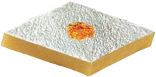
Q.9 On 14th birthday Twinkle went to sweet shop to purchase some 'burfis' for her friends, she saw there two types rectangle and parallelogram shape burfis. Which shape she must purchase to accommodate more pieces in 1 Kg if perimeter & thickness of both shape are same.

a) Rectangle shape burfi b) Parallelogram shape burfi
c) No matter the shape , No of Pieces will same d) Cannot said
Q.10 Cone of height 9cm and radius 7cm is melted into cuboid with sides 11cm and 6cm. Its third side.
a) 6cm b) 7cm c) 5 cm d) 10 cm
(2x8)
Sec-B
Q.11 Solve 7y+15=2y +5 and represent on (a) Number line (b) in the Cartesian plane.
Q.12 If the diagonals of quad. biscct each other then prove that quad. is parallelogram
Q.13 PQ is chord of a circle with centre O and prove that PQ is of radius length.
Q.14 Surface area of sphere is 154 sq.cm. calculate its volume.
Q.15 Find the median of 2,7,9,13,22,20,25,24,28,27,35,40
Q.16 Complete P(E) +-------------=1 using it find the probability of students passed if 10 students are failed and total students are 40.
Q.17 Find the length of chord of a circle which is at distance of 5cm from the center of circle and radius of circle is 13 cm.
Q.18 Find the radius of circle if its area is equal to its circumfrence.
(3x10)
Secc C
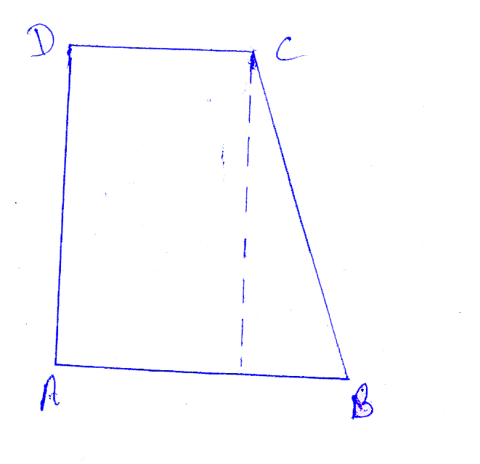
Q.19 In figure ABCD is trapezium. BC=17 cm AB=16, DC=8cm, then find area of trapezium.

Q.20 Find the quantity of cold milk (in litre) served in glasses of radius =10cm and height =15 cm to 350 people.
Q.21 What is the cyclic quad. write its property and what is the value of angle in semi circle using these concept find the value of in cyclic quad. ABCD if AB is a Diameter a circle

Q.22 In the given bar graph shows the annual production of food grains in a state during the period

Answer the following questions
- Find the ratio between the maximum production and the minimum production during the given period.
- After which year was there a sudden fall in the production & calculate the % of fall
Q.23 Prove that parallelogram on the same base and between same paralle are equal in area.
Q.24 Sonu has x rupees more than Monu has and together they have total y rupee. Form the equation that represent the amount that Monu has.
Q.25 Construct a triangle ABC in which and its perimater is 11 cm.
Q.26 Cards marked with No.s 2 to 101 are mixed in a box. If one card is drawn from box then find the probability that no in card is prime no. less than 20.
Q.27 Show that the bisectors of angles of parallelogram form a rectangle.
Q.28 Prove that the median of a triangle divided into two triangle of equal area.
SEC-D
4x6

Q.29 Temparature relation between C and F can be represent by
- Form the equation in terms of x and y draw on graph paper
- Find the temp. in C for 95 F
- Calculate the temp. which is numarically same in F and C

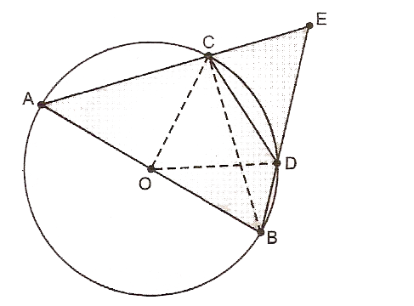
Q.30 Prove that the angle subtended by an arc at the centre is double the angle subtended by it at any point on the remaining part of the circle. Using this theorem calculate in fig if AB is a diameter and chord CD is equal to radius of circle AC and BD are produced to intersect at E.

Q31. Draw a frequency polygon for the following data:

Classes | 0-20 | 20-40 | 40-60 | 60-80 | 80-100
Frequency | 4 | 10 | 15 | 8 | 3

Q.32 A hemispherical dome of a stupa needs to be painted if the circumference of the base of the dome is 17.6 m, find the cost of painting it, given the cost of painting is Rs. 250 per sq metre.
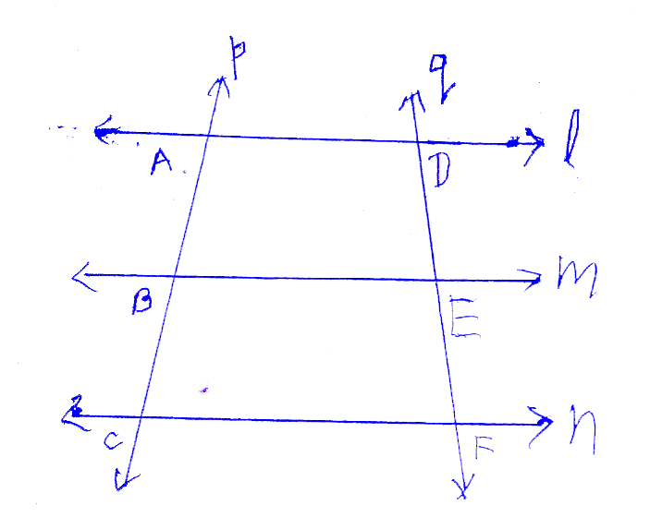
Q.33 In a given fig. is DE=EF ? (Given that AB=BC and l//m//n) if yes
Justy it and state the theorem which used to justy it.

Q.34 A piece of ice 3x3x12cm is placed in a hemisphemical bowl of diameter 7 cm If ice melt inot bowl will it over flow on not.
Pradeep Sahajwani Classes (BASE MAKER)

IX – X CBSE (Maths / Science)
S-20, Vivekanand Colony, Bhopal, Phone : 0755-2751377, 9893213700

