Sample Paper – 2011
Class – IX
Subject – Science

PHYSICS / CHEMISTRY

1x3=3

Q.1 Is the motion of moon around earth uniform or accelerated? Explain in one sentence.
Q.2 The property of diffusion is very fast in gases why? Explain in short
Q.3 A particle size of substance X presenting water is 89nm. What will be nature of solution expected.

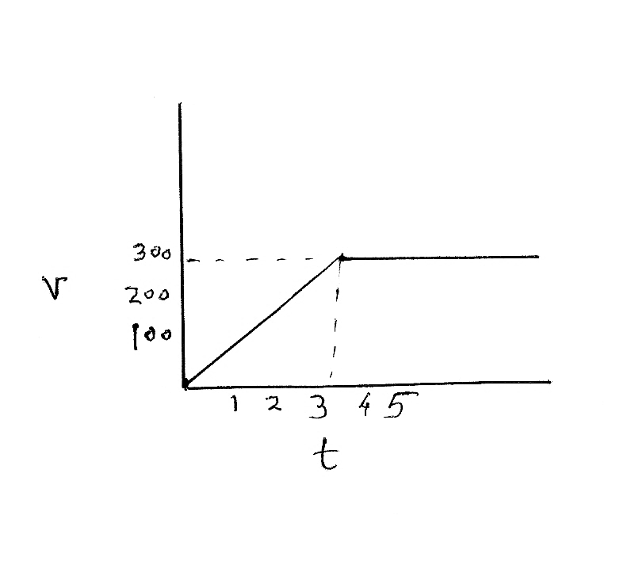
Q.4 Define 1 Newton force.
2x7=14
Q.5 An object moving on straight line shown by graph.
Calculate the distance traveled in 3 sec.

ms⁻¹

sec
Q.6 Write the boiling point of water in C and K.
Q.7 What would be force of gravitation between two objects if both masses become halved?
Q.8 A scooter is moving with a velocity of 40km/hr. What will the velocity after 2 hrs. if motion isuniform
Q.9 How will you separate cream from milk? Write the principle of this method.
Q.10 What is Tyndall effect? Why it is not shown by true solution.
3x7=21
Q.11 (a) State the universal law of gravitation (b) Drive the relation between g and G.
Q.12 A ball thrown up is caught back by thrower after 6 sec. Calculate the velocity with which the ball was thrown up and maximum height attained by ball.
Q.13 Consider the two objects of masses m1 and m2 with velocities u1 and u2 they collide and velocity changes v1 and v2. State e the law associated with change in momentum and prove is expression.
Q.14 Draw the flow chart showing the separation of gases of AIR.
Q.15 100ml alcohol has been dissolved in 400ml of water. Calculate the concentration by volume percentage of solution.

Q.16 Write all three equations of motion and drive the second equation of motion.
Q.17 Test tube A contained 10ml water in test tube and kept near a window, Test tube B contained same quantity of water in china dish and kept near a window, Test tube C same quantity of water in china dish kept inside shelf. After 2 days it was observed hat some quantity of water was remain in test tube A and water of testtube B evaporated quickly than that of testtube C. What did you conclude by this experiment explain.
5x2=10
Q.18 Give reasons in brief.
a. While catching a fast moving ball why a fielder pulls his hands back wards?
b. Why a fireman holds the hose pipe very tightly when he directs a powerful stream of water on fire.
c. Why it is advised to tie any luggage kept on the roof of the bus with rope.
d. Why Naphthalene balls disappear with time without leaving any solid.

Q.19 Explain in brief :
a. Function of loading tank in water purification system.
b. What is latent heat of fusion? Why flow of cold water is allowed on burnt part of skin?
c. Basic difference between distillation and fractional distillation.

MCQ 1x9=9

Q.20 Four students were provided the test tube holders, test tubes and some chemical. The teacher asked them to take some quantity of chemical in the test tube in heat in correct way. The correct way of heating is shown in set up is:
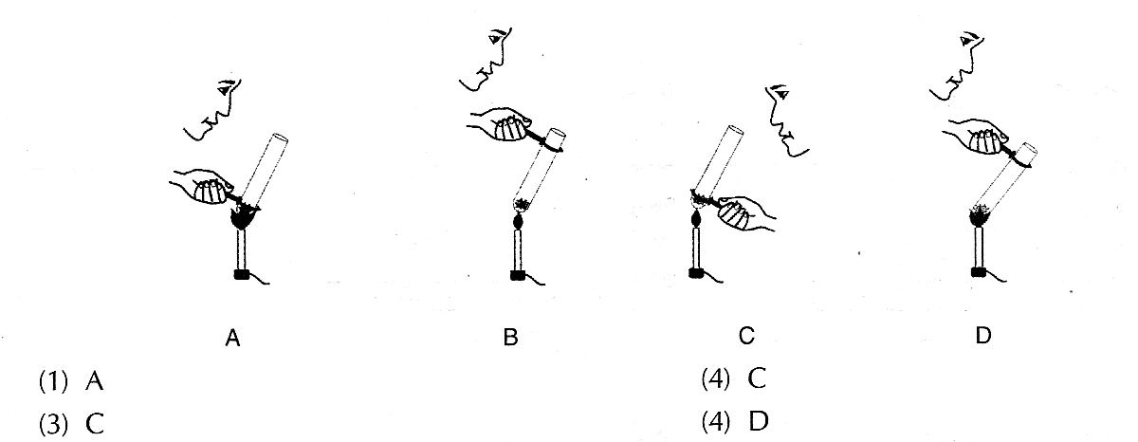

a. A b. B c. C d. D

Q.21 Which one of the statements is a correct statement regarding he mass an object.
a. It changes from place to place
b. It is more at the pole than at the equator
c. It remains same at all places.
d. It increases when we displace a body from earth to moon.

Q.22 Which of the following is not a mixture?
a. Brass b. 22-carat gold jewellery
c. 24-carat gold ring d. Alum

Q.23 To prepare a colloidal solution of egg albumin in water, you will add
a. A small amount of the white of the egg in water and stir.
b. A small amount of yellow of the egg in water and sir.
c. Mix the yellow and white of the egg and then add a small amount of it to water and stir.
d. Use the method (b) but take hot water.

Q.24 The value of acceleration due to gravity depends on the
a. mass of the earth b. mass of the body
c. shape and the size of the body d. none of the above

Q.25 Action and reaction act on
a. The same body in opposite direction.
b. The same body in same direction.
c. The different bodies in same direction
d. The different bodies in opposite directions.

Q.26 A little soil was stirred into water taken in a breaker. The breaker was allowed to stand. The mud was found to settle down The contents were filtered. The filtrate will be.
a. A colloidal solution b. A true solution
c. A suspension d. Can be a true solution or a colloidal solution

Q.27 Which one of the following set represents same type of solution
a. Milk emulsion, Sugar b. Fog, Milk, Salt
c. Gel, Cheese, Chalk Powder d. Boot Polish, Butter, Cheese

Q.28 Two balls A and B of masses m and 2m are in motion with velocities 2v and v respectively. Their momenta are in the ratio.
a. 1 :2 b. 2 :1 c. 1 : 1 d. 4 :1

IX – BIOLOGY

Q.1 The ……………………. Tissue is found
a. in flowers b. at the tip of the leaves
b. below the epidermis d. at root tip
Q.2 The long narrow thick cells which are not living are
a. part of xylem b. collenchyma
c. sclerenchyma d. parenchyma

Q.3 Murrahis a high yielding variety of
a. cow b. pig c. poetry d. buffalo

Q.4 The cellular component not seen in the temporary mount of onion peel under a compound microscope is :
a. Cell wall b. Nucleus c. Chromosomes d. Cytoplasm

Q.5 Smooth ER helps in the
a. Synthesis of proteins b. Protecting the cells
c. Synthesis of fat d. Performing cell respiration

Q.6 Which of the following play an important part in cell respiration.
a. Lysosomes b. Ribosomes
c. Golgibodies d. Mitochondria

Q.7 a. What is the advantage of inter cropping and mixed cropping.
b. What is green revolution
c. How is prokaryotic cell different from a eukaryotic cell?

Q.8 a. What are cell organelles. Explain ER, GA, mitochondria, Lysosomes in detail. Draw
the diagram of plant cell.
- Give a small account of meristenative cells.

Q.9 What are the functions of chromosomes. State the differences between leucoplast and chromoplast and why is plasma membrane called selectively permeable.

Paper Submitted By:
sanjeev_29nov@rediffmail.com
9897632688

