Sample Paper 2011
Class - XI
Subject - Physics (theory)
Time : Three Hours Max. Marks : 70

General Instructions
(a) All questions are compulsory.
(b) There are 30 questions in total. Questions 1 to 8 carry one mark each, questions 9 to 18 carry two marks each, questions 19 to 27 carry three marks each and questions 28 to 30 carry five marks each.
(c) There is no overall choice. However, an internal choice has been provided in one question of two marks, one question of three marks and all three questions of five marks each. You have to attempt only one of the given choices in such questions.
(d) Use of calculators is not permitted. Use log tables for necessary calculations.
--------------------------------------------------------------------------------------------------

1. Can a vector be zero, if one of its component is not zero?(1 mark)
2. A heavy and a light ball are projected with the same velocity and at the same angle with the horizontal. How do their ranges and maximum heights attained differ from each other? ( 1 mark)
3. To cut a tree, we often make a cut on the side facing the direction in which we wish the tree to fall, Why?(1 mark)
4. An astronaut orbiting in a spaceship around the earth releases a spoon. Will the spoon fall to the earth? ( 1 mark)
5. Gravitational force between point masses m and M separated by a distance is F. Now if a point mass 2m is placed next to m, what will be the force on M due to m?
(1 mark)
6. If an electric fan be switched on in a closed room, will the air of the room be cooled? If not, why do we feel cold? ( 1 mark)
7. You are given four tuning forks; the lowest frequency of the fork is 300 Hz. By striking two tuning forks at a time, 1,2, 3,5,7 and 8 Hz beat frequencies are heard. What are the possible frequencies of the other three forks? ( 1 mark)
8. A cake of mud is thrown on a wall where it sticks. What happens to its initial kinetic energy? ( 1 mark)
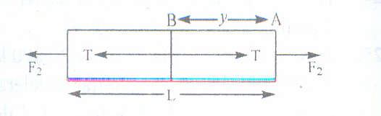
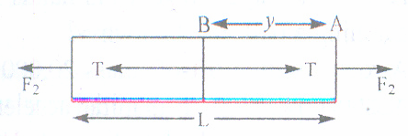
9. What is the tension in a rod of length L and mass M at a distance y from F₁. when the rod is acted on by two unequal forces F₁ and F₂ (<F₁) as shown in fig.( 2 marks)

10. Polishing beyond a certain limit may increase the friction between surfaces. Why? ( 2 marks)
11. State and derive work energy principle.( 2 marks)
12. Fig. shows the strain versus stress graph for two materials say A and B. Answer the following questions.
(i)Which material has greater value of young modulus? Explain. (ii) Which material is more ductile? Explain. (iii) Which material is more brittle? Explain.
(iv)Which material is stronger? Explain. (2 marks)
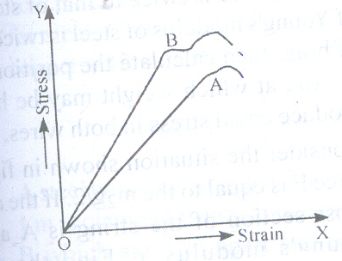

13. (a)Can the temperature of a system be increased without heating it?
(b) Can heat be added to a system without increasing its temperature? ( 2 marks)
14. A carnot engine whose heat sink is at 27⁰C has an efficiency of 40%.By how many degree should the temperature of source be changed to increase the efficiency by 10 % of the original efficiency? (2 marks)
OR
Refrigerator A works between – 10⁰C and 27 ⁰ C, while refrigerator B works between -27⁰ C and 17 ⁰ C, both removing heat equal to 2000 J from the freezer. Which of the two is better refrigerator? (2 marks)
15. What is meant by degree of freedom? State law of equipartition of energy. Hence calculate specific heats of mono, di and tri atomic gases. ( 2 marks)
16. State Newton’s formula for velocity of sound in air. Point out the error and hence discuss laplace’s correction.(2marks)
17. Determine whether or not the following quantities can be in the same direction for a simple harmonic motion: (a) displacement and velocity (b) displacement and acceleration. (2 marks)
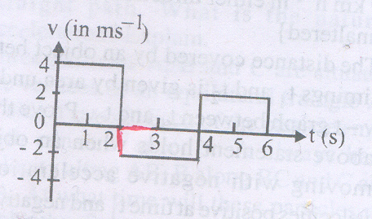
18. The velocity – time graph of a body moving in a straight line is shown in fig. Find the displacement and the distance traveled by the body in 6 seconds. (2 marks)

19. In a new system of units called star unit 1 kg * = 10 kg; 1 m*=1 m and 1 s*= 1 minute. What will be the value of 1 J of energy in this new system? (3 marks)
20. You may have seen in a circus a motorcyclist driving in vertical loops inside a ‘death – well’ (a hollow spherical chamber with holes, so the spectators can watch from outside).Explain clearly why the motorcyclist does not drop down when he is at the uppermost point, with no support from below. What is the minimum speed required at the uppermost position to perform a vertical loop if the radius of the chamber is 25m? (3 marks)
21. Find (a) time of flight (b) maximum height ( c) horizontal range of projectile projected with speed v making an angle θ with the horizontal direction from ground.
( 3 marks)
Or
State parallelogram law of vector addition. Find analytically the magnitude and direction of resultant vector. ( 3 marks)
22. Obtain expression for velocities of the two bodies after elastic collision in one dimension.( 3 marks)
23. Three particles each of mass m are placed at the corners of an equilateral triangle of side d. Calculate the work done on this system if the side of the triangle is changed from d to 2d. (3 marks)
24. A tank filled with fresh water has a hole in its bottom and water is coming out of it. If the hole size be increased, what will be the change in : (a) Volume of water flowing out per second? (b) Velocity of the out coming water ? (c) If in the above tank, the fresh water is replaced by sea water, will the velocity of out coming water change?(3 marks)
25. The pressure of a given mass of a gas is halved at constant temperature. What will be the volume of the gas in comparison to its initial volume? Explain on the basis of kinetic theory. (3 marks)
26. Assuming the length of a chain to be L and coefficient of static friction µ, calculate the maximum length of the chain which can be held outside a table without sliding?( 3 marks)
27. Derive an expression for the maximum velocity of vehicle on a banked road, when coefficient of friction is also taken in to consideration.( 3 marks )
28. (a)Derive an expression for moment of inertia of a uniform circular disc about an axis passing through its centre and perpendicular to the plane of the disc.
(b)Three point masses of 1 kg, 2 kg and 3 kg lie at (1,2), (0,-1) and (2,-3) respectively. Calculate the co-ordinates of the centre of mass of the system.
( 5 marks)
OR
(a)Discuss rolling without slipping of a cylinder down a rough inclined plane and obtain an expression for the coefficient of friction necessary for the same.
(b) Three mass points m₁,m₂,m₃ are located at the vertices of an equilateral triangle of length a. What is the moment of inertia of the system about an axis along the altitude of the triangle passing through m1? ( 5 marks)
29. (a)Derive an expression for excess pressure inside a liquid drop.
(b) In a car lift, compressed air exerts a force F₁ on a small piston having a radius of 5 cm. This pressure is transmitted to a second piston of radius 10 cm. If the mass of the car to be lifted is 1350 kg, Calculate F₁.What is the pressure necessary to accomplish this task? (5 marks)
OR
(a)State and Establish Equation of continuity.
(b)Eight spherical rain drops of equal size are falling vertically through air with a terminal velocity of 0.10 m/s. What should be the velocity if these drops were to combine to form one large spherical drop? (5 marks)
30. (a) Obtain an expression for apparent frequency of sound when source and listener are approaching each other.
(b) The equation of a progressive wave is given by
Y= a sin (628 t – 31.4 x), if the distances are expressed in cms and time in seconds then what will be the wave velocity? ( 5 marks)
OR
(a)Give analytical treatment of formation of standing waves on strings.
(b)A source of sound emitting a note of frequency 200 Hz moves towards an observer with a velocity v equal to the velocity of sound. If the observer also moves away from the source with the same velocity v , What is the apparent frequency heard by the observer? ( 5 marks)

any doubt
arun joshi
09414827275
arunjoshi_67568@rediffmail.com

